Note: 1
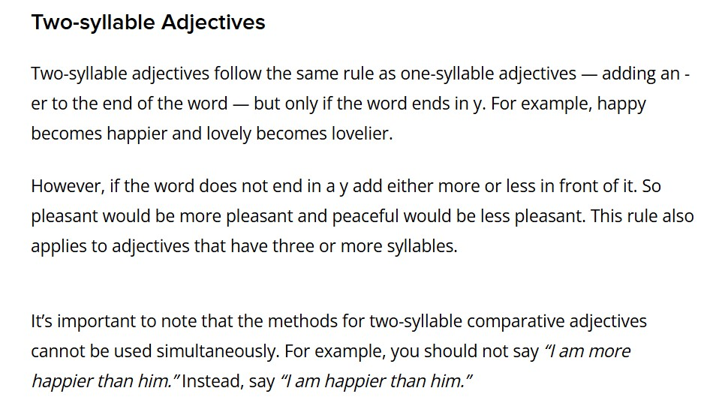

Note: 2

✅ Why do some 2-syllable adjectives use more/most instead of -er/-est?
Because English follows patterns, not only syllable rules.
Let’s break it down:

🔍 1. “Honest”
- Syllables: 2 (hon-est)
- Type of adjective: Does not end in -y, -le, or -ow.
- These kinds of 2-syllable adjectives usually use more/most.
👉 That’s why we say:
- more honest
- most honest

🔍 2. “Gentle”
- Syllables: 2 (gen-tle)
- Ends in -le, and many -le adjectives form comparative and superlative with -er / -est.
👉 So we say:
- gentler
- gentlest
(This pattern is similar to simple → simpler → simplest.)

🔍 3. “Narrow”
- Syllables: 2 (nar-row)
- Ends in -ow, and many -ow adjectives also take -er / -est.
👉 So we say:
- narrower
- narrowest
(Like shallow → shallower, yellow → yellower.)

