
Grade & Section: ____ ( ) Unit: ___
Student's Name: __________________________ Date: ___ / ___ /2025
Skill/Lesson: Comparison Structures: Adjectives
Educational Outcome: To form the comparative and superlative adjectives correctly *****************************************************************************************************************************

Comparative and Superlative Adjectives
In English, adjectives are used to describe nouns. When we compare two or more things using adjectives, we use comparative and superlative forms.

1. Comparative Adjectives
The comparative form of an adjective is used to compare two things or people. It generally shows that one thing has more of a quality than the other.

2. Superlative Adjectives
The superlative form is used to compare three or more things or people, showing that something has the most or least of a particular quality.

3. Irregular Comparative and Superlative Forms
Some adjectives do not follow the regular rules. They are irregular.
- Good → Better → Best
- Bad → Worse → Worst
- Far → Farther/Further → Farthest/Furthest
- Many → More → Most
- Little → Less → Least

Key Points to Remember:
- Comparative adjectives compare two things.
  - Example: "My house is bigger than your house."
- Superlative adjectives compare three or more things.
  - Example: "That is the fastest car in the race."

Remember:

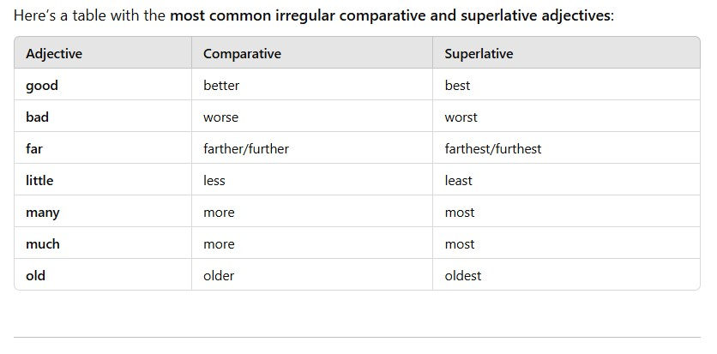

Thank You!

