

English Language
1st Semester 2025/2026
8th Grade
Unit (3) Aguinaldo Handout
(Key Answers)

Name:

Section:

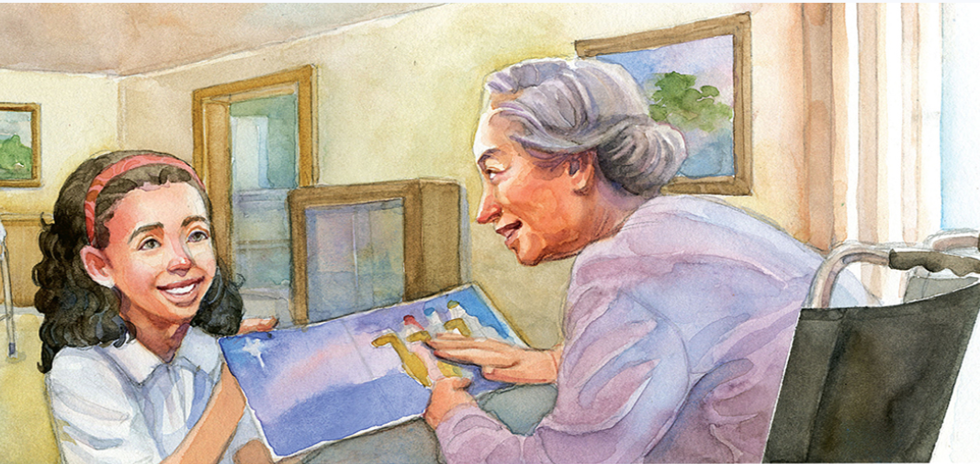

1. Unit’s Content:
Topic : | Students’ Book Pages:
1. The Big Question | 126
2. Vocabulary (Literary words, academic words, word study) | 127-128-129
3. Reading Aguinaldo | 130-137
4. Grammar:
Comparison Structure : Adjectives | 46
5. Writing: Compare and Contrast essay | 174+175

1. The Big Question:
How are relationships with others important??
Writing Task (1)
There is an old saying that when you help someone, you are really helping yourself. What do you think that means? Do you think it is important to reach out to others?
This saying means that helping someone can make you feel happier and more confident, because kindness often brings a sense of purpose. Moreover, reaching out to others is important since it strengthens friendships and makes the community better for everyone.

2. Vocabulary:
NO. | Word | Meaning | Example
 | Distribute | (v.) Give something to different people | The teacher will distribute the books to the students tomorrow.
 | Positive | (adj.) Good or useful | She always tries to stay positive even when things go wrong.
 | Residents | (n.) people who live in a place | The residents of the town were all invited to the meeting.
 | Reluctant | (adj.) feeling uncomfortable about doing something | He was reluctant to leave the party early.
 | Field trip | (n.) trip students take with their classmates and teacher | The class is going on a field trip to the museum next week.
 | Firmly | (adv.) strictly | She held the book firmly in her hands.
 | Infirm | (adj.) sick or weak | The infirm man needed help crossing the street.
 | Concern | (n.) / (v.) to worry | There was concern about the weather during the outdoor event.
 | Dizzy | (adj.) unsteady or shaky | After spinning in circles, he felt dizzy and had to sit down.
10 | Mumbled | (v.) speak quietly and unclearly | She mumbled her answer when the teacher asked her a question.
11 | Scattered | (v.) / (adj.) spread out | The leaves were scattered all over the yard after the storm.
12 | Vivid | (adj.) very clear and specific | The painting had vivid colors that made it stand out.
13 | Caressed | (v.) touch in a gentle way | He gently caressed the puppy’s soft fur.
14 | Mischievously | (adv.) playfully | The boy smiled mischievously as he hid the cookies.
15 | Gestured | (v.) made a motion | She gestured toward the door, signaling that it was time to leave.
16 | Suitors | (n.) men who want to marry a woman | The suitors were all waiting for her answer to the proposal.
17 | Collage | (n.) work of art made by sticking pictures, photographs, cloth, etc. onto a surface | She created a beautiful collage of family photos for the wall.

Academic Words

A. Read the paragraph below. Pay attention to the underlined Academic Words.:
There is a non-profit organization in our town that distributes free lunches to the elderly. Volunteers bring the lunches to elderly residents’ homes every day at noon. No elderly person who requests a free lunch is ever turned down, although some feel reluctant to ask for help. Both volunteers and the elderly find delivering and receiving free lunches a very positive experience
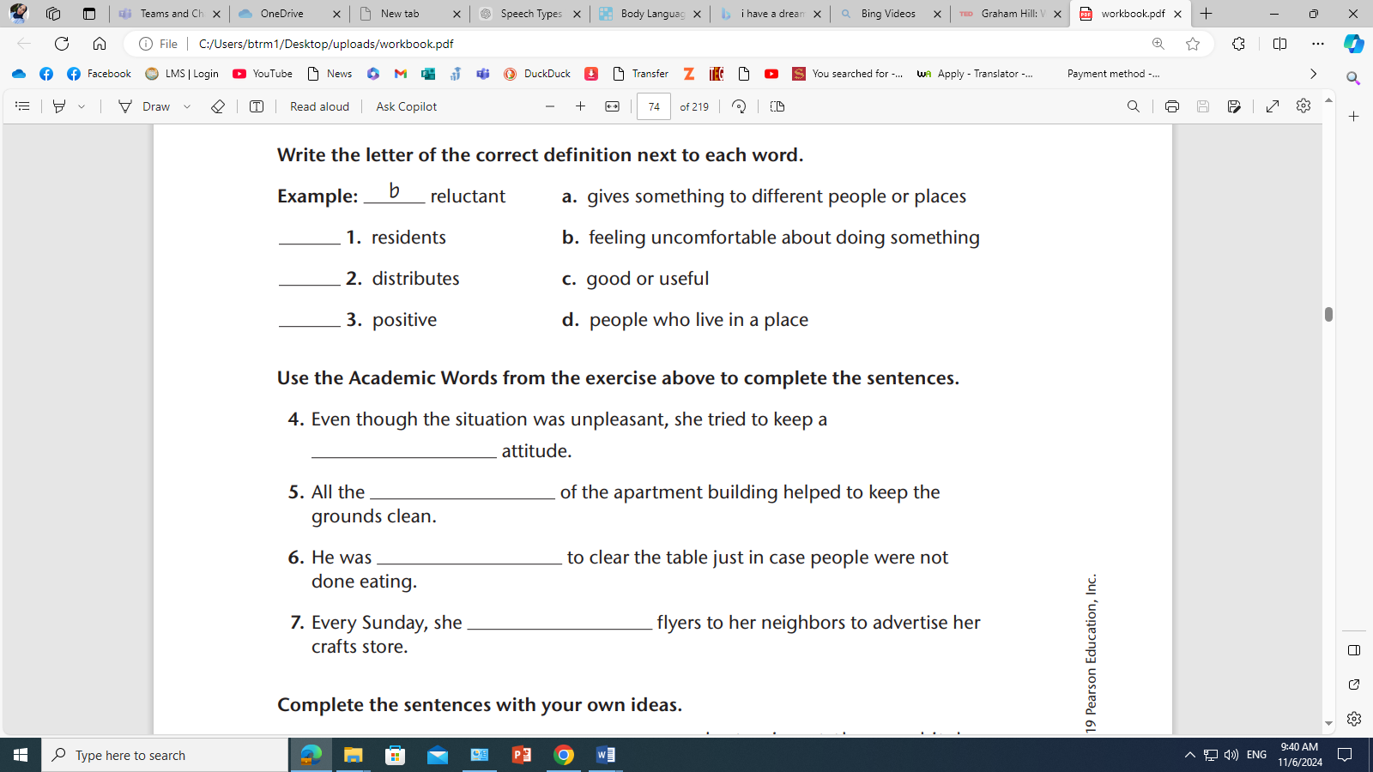
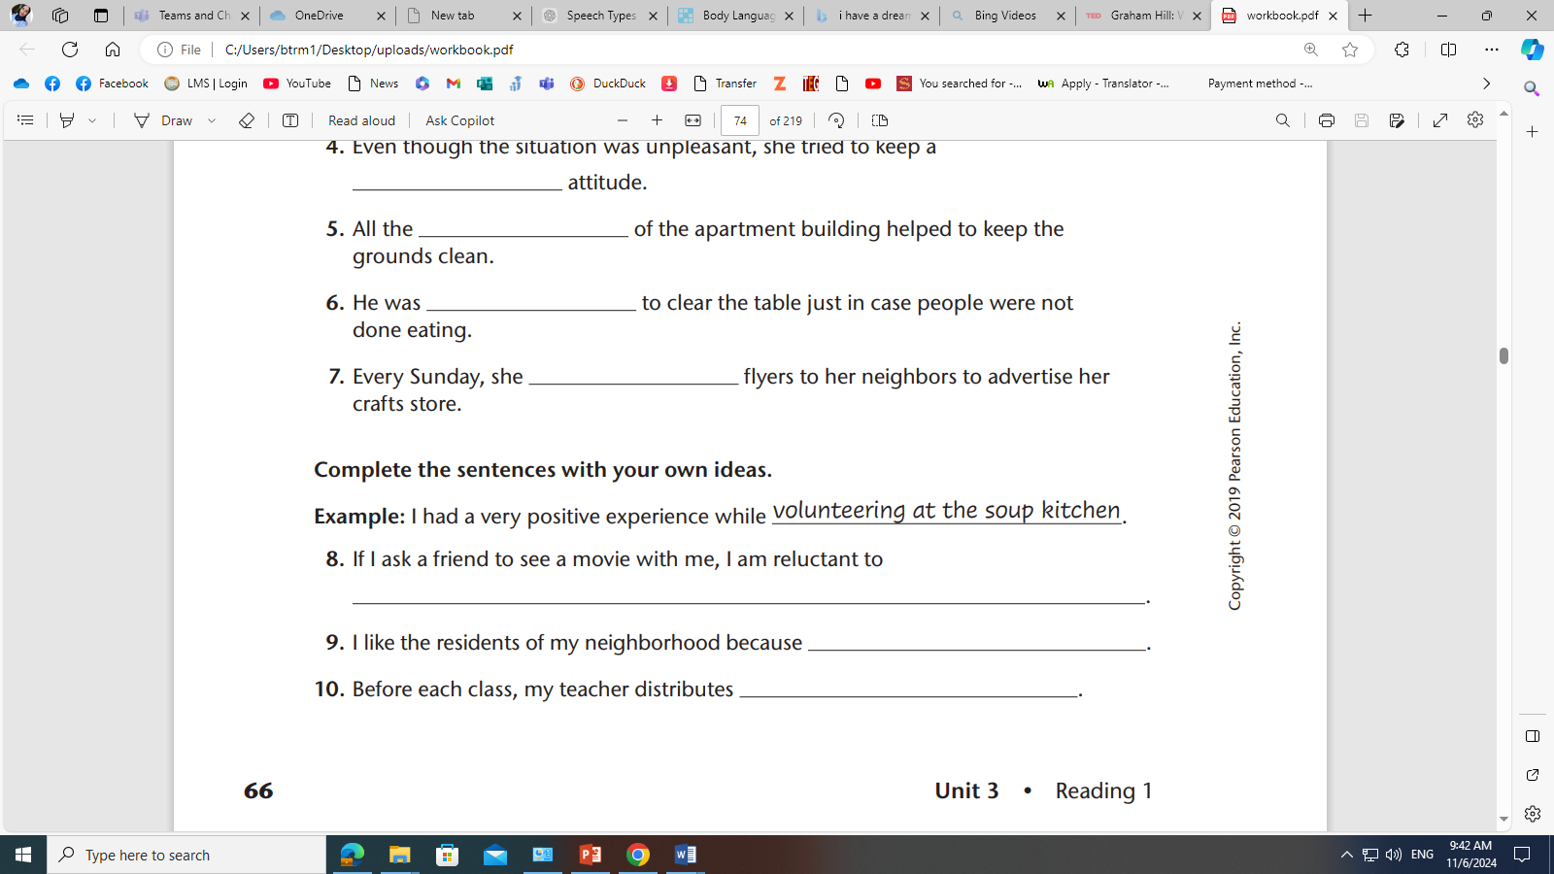

Key answers
1 d 2 a 3 c 4 -positive 5 -residents 6 -reluctant 7 -distributes
8, 9, 10 (open answers)
_______________________________________________________

B. Fill in the gaps with the most suitable answer:
reluctant / vivid / infirm / concern / residents / distribute / positive

- The teacher will distribute the worksheets to the students after lunch.
- He has a positive attitude that makes everyone feel better.
- She was reluctant to try the new food because she didn't like its smell.
- Despite feeling worried, the infirm elderly woman caressed her cat gently, finding comfort in its warmth.
- The residents of the neighborhood were reluctant to change their old traditions.
- She gave a vivid description of her vacation to her friends, making them feel like they were there.
- Her primary concern was making sure everyone arrived safely to the event.

B. Choose the best answer:
- He was (reluctant) to speak in front of the large crowd, even though he had prepared his speech.
- Her (positive) attitude helped the team overcome many challenges.
- The teacher will (distribute) the worksheets to the students in class.
- The artist used (vivid) colors in the painting to bring the landscape to life.
- The child smiled (mischievously) as he hid the gift under his bed, planning a surprise for his parents.
3. Literary Words:
- Irony: is the difference between what the reader expects to happen and what actually happens in a story. Writers include ironic situations in stories to create surprise and amusement.


A. Read these examples and identify the irony:

1. Samantha always dreamed of being a writer, but she was terrified of public speaking.
She enrolled in a creative writing class, thinking it would be a quiet, solitary experience. However, at the first session, the teacher handed out a form for everyone to present their work in front of the class. Samantha’s heart raced. A month later, after presenting her story with trembling hands, she realized she loved the attention and started signing up for more public speaking events.

Samantha was terrified of public speaking. By the end she started signing for more public speaking events (which was unexpected to happen)
____________________________________________________________________________________
2. Ethan hated running, but he joined the track team to impress his friends.
On the first day of practice, he found himself gasping for breath after just a few laps around the field. He spent the entire practice thinking how ridiculous it was to join something he didn’t even enjoy. By the end of the season, Ethan had won two races and was disappointed when the season ended, wishing it had lasted longer.

Ethan hated running and didn`t enjoy it. Hence it wasn`t expected to win the two races by the end and enjoy the season.
____________________________________________________________________________________
3. Katie wasn’t interested in the new coffee shop opening in town, thinking it was just another trend.
Her friend insisted they go for coffee, but Katie was certain she would hate the place. She’d rather stay home with a cup of tea. Three weeks later, Katie was there every morning before work, ordering the same coffee as her friend and chatting with the baristas like an old regular.

Katie started to go to the new coffee shop even though she wasn`t interested at the beginning.

____________________________________________________________________________________

B. Foreshadowing is the author’s use of clues to hint at what might happen later in a story. Writers use foreshadowing to engage readers in wondering about what might happen and to create suspense.
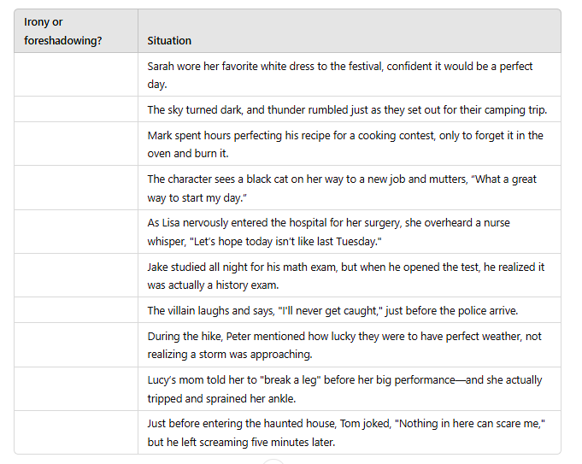
- Determine if the following examples are foreshadowing or irony:

Key Answers
1-foreshadowing 2-foreshadowing 3-irony 4-irony 5-foreshadowing 6- irony 7-irony 8-irony 9-irony 10- irony


4. Reading Comprehension:

After reading the text in p. 130-137, answer these reading comprehension questions.

1. The story is told from: the first point of view
2. Who are the characters? And what is the setting?
Marilia, her mother, sister Antonia, Elenita and Margarita are the characters. The story happens at school and in the nursing home.
3. What is the tradition they follow every year?
The students visit the nursing home every December and bring gifts to the elderly people.
4. How does she feel about visiting the nursing home? Why?
Marilia doesn`t want to go to the nursing home because her grandma died there.
5. What were her 3 plans to avoid the field trip?
1- Helping at the library 2- Writing a book report 3-Waking up ill and staying home
6. What are Aguinaldos? They are Christmas gifts.
7. What was her mother’s reaction to the plan?
She slipped the thermometer under Marilia`s tongue to check her temperature and once she discovered the truth she encouraged her daughter to go on the assigned field trip.
8. What did the students do to cheer the residents?
They sang a medley of carols and gave the residents cards and gifts.
9. What aguinaldos does Marilia’s class distribute to the residents of the nursing home?
They were besitos de coco (coconut sweets).
10. Why did she describe the card to Elenita? How did that make her feel?
Marilia did that because Elenita was blind. Marilia felt cheated and disappointed.
11. Quote a sentence that shows that Elenita liked the aguinaldo Marilia brought.
“I`ll keep this card to remember you by.”
12. What aguinaldo does Marilia say she was given at the nursing home?
It is Elenita`s friendship.
13. What is the irony of Marilia’s trip to the nursing home?
At the beginning she didn`t want to go to the nursing home, but by the end everything changed unexpectedly as Marilia couldn`t wait to come back next year.
14. What aguinaldo is she planning to give Elenita next year?
She is planning to make a collage.

Critical thinking (open answer)
Is it important to have traditions that bring people together? Explain your answer.
Yes, traditions are important because they bring people together, strengthen relationships, and create a sense of belonging and shared identity.

5. Grammar:

Comparative and superlative adjectives

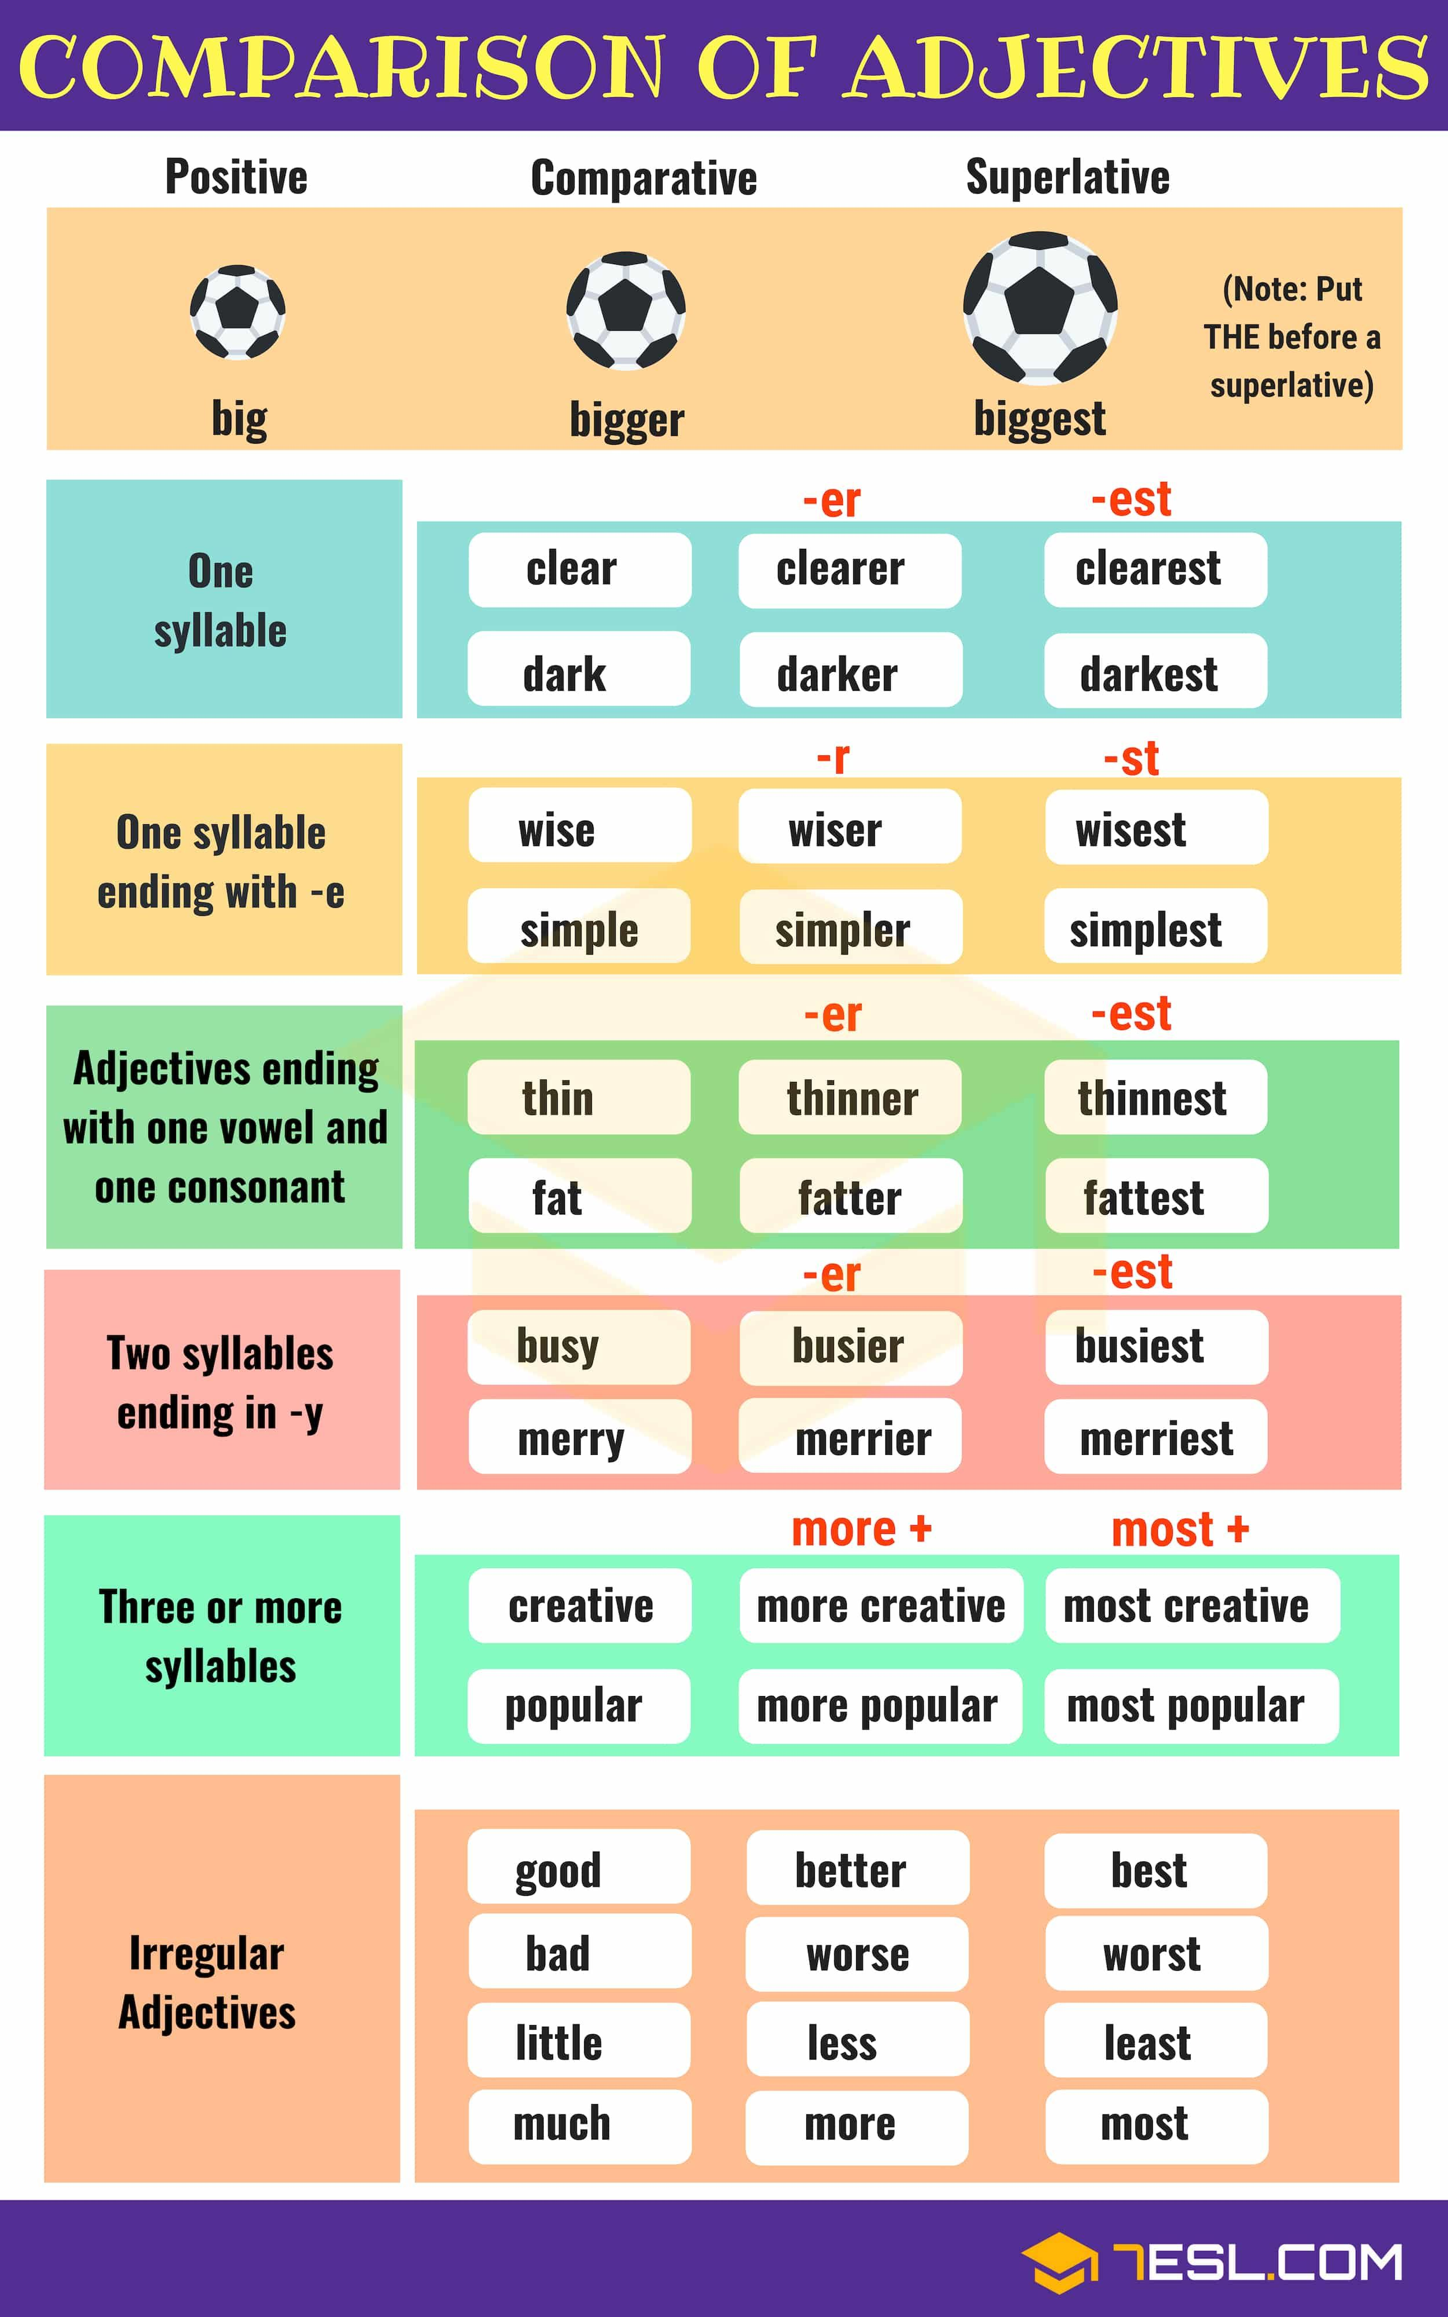

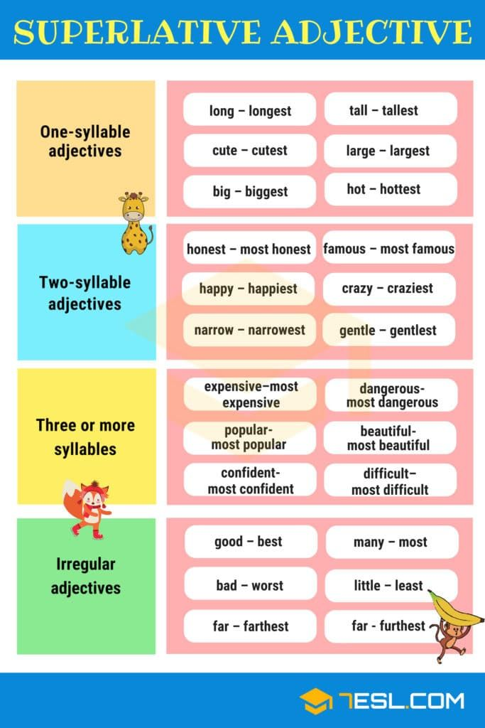

A. Fill in the correct form of the adjectives in parentheses.
- I am surely more fluent (fluent) now than I was last year.
- Maha is very nice; I think she is the most polite (polite) person of them all.
- She seemed happier (happy) than before.
- This girl was dancing really well, she is the most graceful (graceful) girl I saw.
- Could you write in a clearer (clear) handwriting?
- Planes can fly higher (high) than birds.
- He had an accident last year. Now, he is more careful (careful) than before.
- Jim can run faster (fast) than John.
- Our team played the worst (bad) of them all; that’s why we lost the match.
- He worked harder (hard) than ever before.
______________________________________________________________________________
B. Complete each the sentence by using the bold adjective in its correct form.
EXAMPLE: I have a fast car, but my friend has a faster car.

- This is a nice cat. It's much nicer than my friend's cat.
- Here is Emily. She's six years old. Her brother is nine, so he is older.
- This is a difficult exercise. But the exercises we did yesterday were more difficult.
- He has an interesting hobby, but my sister has the most interesting one in the world.
- In the last holidays I read a good book, but my father gave me an even better one last weekend.
- Skateboarding is a dangerous hobby. Bungee jumping is more dangerous than skateboarding.
- This magazine is cheap, but that one is cheaper.
- Yesterday John told me a funny joke. This joke was the funniest joke I've ever heard.


6. Writing: A comparative essay

In order to compare two items, follow the following steps:
1- Think of two things that have similarities and differences.
2- Use a diagram to help.
3- Use the simple present tense.
4- Use linking words to show comparison like:

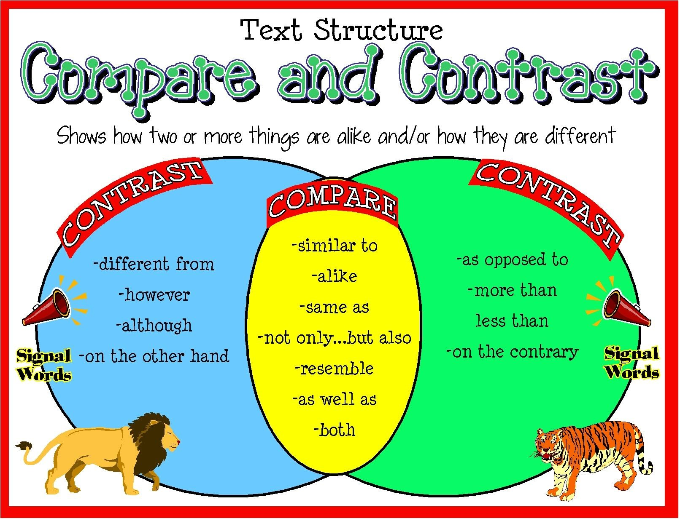

A. Read the following passage and complete the gaps using the correct word:
New York City and Los Angeles are two big cities found within the United States of America. Very large and populous. They both attract thousands of visitors in spite of being hugely crowded and costly to live in 1. While the cities have some similarities, New York City and Los Angeles are vastly different, especially in their climate, housing, and transportation
New York City’s (NY) Climate is much2.colder than that of Los Angeles (LA). In New York, the winter is glistening and frosty 3., In contrast Los Angeles has winters and summers that are warm.
The housing characteristics are also different The age of a home in New York is 4…older) than the age of a home in Los Angeles. While the cost of a home in New York is $581,400, in Los Angeles it is $583,600. This implies that it is a bit cheaper to acquire a home in NY as compared to LA.
Another major difference between New York City and the city of Los Angeles is public transportation. In LA, there is a huge car culture where almost everybody drives. Most people have their own cars. 5. Although there is public transportation in the city, few people use it. In New York on the other hand, almost everybody takes some form of public transportation.

In conclusion, New York City and Los Angeles have many differences 6.(in spite of having some similarities as large cities within the US. The cities are attractive to people from all over the world owing to their different features and characteristics. However, the climate, housing and public transportation show how vastly different the cities are.

Let’s write: Instructions
Choose a topic then write a (250) words essay comparing between them.
- Video Games vs. Sports: Which Builds Better Friendships?
- Online Friends vs. Real-Life Friends: Are They Equally Important?
- Living in a Big City vs. a Small Town
- Cats vs. dogs
- Online learning vs. traditional learning

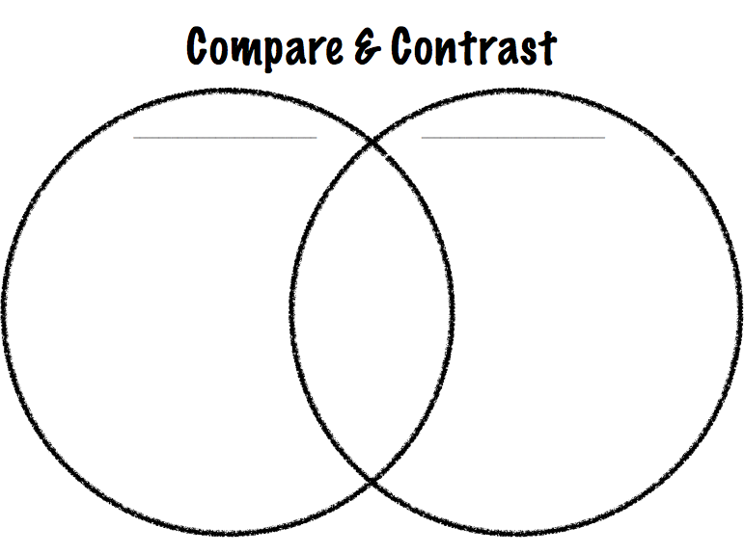
** Use the diagram to write the similarities and differences:

 Write down a descriptive essay to compare b
____________________

________________________________________________________

___________________________
__________________________________________________________________________________________________________________________________________________________________________________________________________________________________________________________________________________________________________________________________________________________________________________________________________________________________________________________________________________________________________________________________________________________________________________________________________________________________________________________________________________________________________________________________________________________________________________________________________________________________________________________________________________________________________________________________________________________________________________________________________________________________________________________________________________________________________________________________________________________________________________________________________________________________________________________________________________________________________________________________________________________________________________________________________________________________________________________________________________________________________________________________________________________________________________________________________________________________________________________________________________________________________________________________________________________________________________________________________________________________________________________________________________________________________________________________________________________________________________________________________________
Evaluate your writing:
Content and ides  (Using descriptive details)  /2 | punctuation  2 | Spelling  2 | Outline & paragraphing  2 | Handwriting  2 | Grammar (Using present tense)  2 | Total  12

After you finish your first draft, check for mistakes using the following checklist

- Adding a topic sentence to the introduction
- Writing the title
- Writing supporting sentences
- Using lots of descriptive details
- Using sequence words
- Clear handwriting
- Accurate spelling
- Using correct tense
- Using correct punctuation marks and avoiding capitalization mistakes.



