

Grade & Section: ____ ( ) Exaggerated Synonyms Unit: 3
Student's Name: __________________________ Date: ______ / ___ /2025
*************************************************************************************************Fill in the Blanks SBP 17 Word Store 2 A
Words/Phrases to Use:
plastered, looming, flitting, minefield, frazzled, manic, hammering, regurgitate, swimming in, all the advice under the sun
- Plastered → Covered everywhere, almost overwhelming
- Looming → Coming soon and causing worry/panic
- Flitting → Moving quickly and nervously
- Minefield → Full of hidden dangers or risks
- Frazzled → Extremely tired/stressed/confused
- Manic → Very hyper/anxious/out of control
- Hammering → Repeating something over and over
- Regurgitate → Repeat facts exactly
- Swimming in → Overwhelmed by a lot of something
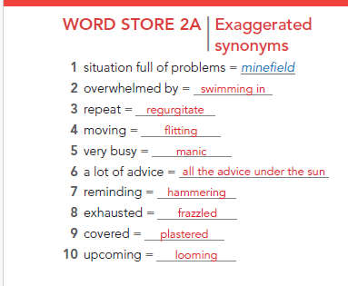
- All the advice under the sun → Every possible advice

- The library was _______________ before the exam, with students rushing and talking everywhere.
- After a whole night of studying, I felt totally _____________ and could barely think straight.
- I’ve read ________________ about how to revise, but I still don’t know which method works best.
- My bedroom is completely _________________ with notes and posters from my revision.
- I keep ________________ between subjects because I don’t know which one to focus on first.
- I’m ________________ homework, notes, and exercises; there’s just too much to handle at once.
- In the exam, we were asked to ______________ all the dates and facts exactly as we learned them.
- The teacher keeps _______________ the main points over and over so we remember them.
- Talking to the strict teacher about my grades felt like a ______________ — one wrong word could get me in trouble.
- The deadline for our final project is _____________, and I can feel everyone getting nervous.

