

Selection No. 3

Student’s Name: ____________________________
Grade: 6 / Section: __________________________

*Reading:
Fact or Fiction? >> p.8 - 12

*Vocabulary:
Key Words >> p.5
Academic Words >> p.6
Footnotes >> pp.8 - 12

*Grammar:
Parts of Speech and Parts of the Sentence >> p. 16

*Writing:
Write a paragraph to describe a place >> pp. 18 - 19

*Vocabulary:

No. | Word/ Phrase | Meaning
 | Archaeologist (n.) | a scientist who studies old objects and ruins to learn about people who lived long ago
 | Clues (n.) | pieces of information or hints that help you solve a problem or find something
 | Creature (n.) | any living thing, like an animal or insect
 | Disappeared (v.) | when something or someone is no longer visible or cannot be found
 | Fantasy (n.) | a type of story or imagination about things that are not real, like magical worlds or talking animals
 | Sacred (adj.) | something that is very special and important, often because it is connected to religion or deep beliefs
 | Accurate (adj.) | when something is correct or exact and free from mistakes
 | Create (v.) | to make something new or bring something into existence
 | Evidence (n.) | facts, signs, information or objects that help prove something exists or is true
 | Survive (v.) | to continue living or stay alive, especially after facing danger or difficulty (to continue to exist)
 | Pharaoh (n.) | ancient Egyptian ruler
 | Engineer (n.) | a person who plans how to build machines, roads, and so on
 | Abandoned (v.) | left completely behind and not used any more
 | Colonists (n.) | people who settle in a new country or area
 | Tentacles (n.) | long, thin arm-like parts
 | Calamari rings (n. ph.) | sliced squid, often served fried or in a salad

Instructions:
- Fill in each blank with the appropriate word from the list provided.

Words to Choose From:

- sacred
- tentacles
- calamari rings
- fantasy
- colonists
- clues
- abandoned

Sentences:
- The old, abandoned house at the end of the street was rumored to be haunted.
- In the seafood restaurant, the calamari rings are served as a popular appetizer.
- In the novel, the hero's journey takes place in a fantasy world full of magical creatures and adventures.
- The archaeologists found clues that helped them understand the ancient civilization.
- Our history lessons are about the European colonists.
- The octopus has eight tentacles that it uses to catch its prey.
- The mosque is considered a sacred and holy place.

- Use the following words to complete the paragraph after you decide the part of speech of each one.
evidence / accurate/ create/ survive
When scientists want to find out if something is true, they need to be very accurate. They gather evidence, like facts and observations, to help them understand and explain things better. For example, if scientists want to know how animals survive in the wild, they might study their habits and environments. By collecting and analyzing such pieces of evidence, they can create new solutions to help protect these animals.

Writing Task:
Use any five words from the list to write a short paragraph. Be creative!
________________________________________________________________________________________________________________________________________________________________________________________________________________________________________________________________________________________________________________________________________________________________________________________________________________________________________________________________________________________________________________________________________________________________________________________________________________________________________________________________________________________________________________________________________________

"Fact and fiction are two sides of the same coin; one reflects reality while the other reflects our imagination, yet both shape our understanding of the world."

*Comprehension:

“Path to the Stars”
1. Who built the three pyramids?
Cheops and his son and grandson built the three Pyramids of Giza in Egypt.
2. Why do you think these three pyramids were grouped together?
I think they were grouped together to resemble a group of stars in the sky called Orion’s Belt.
3. What is the relationship between Orion’s Belt and the three pyramids?
The whole group of stars-Orion-was sacred to the Egyptians.
“Mysterious Cities”
1. Where is the city Machu Picchu located?
It is located about 2,440 meters (8,000ft.) high in the Andes Mountains of Peru.
2. Scientists believed that people left the city of Machu Picchu for two reasons. Mention one.
Perhaps they left it because of smallpox, a deadly disease that was brought to the Americas by European explorers and colonists.
3. Who rediscovered the city of Machu Picchu in 1911?
The American explorer Hiram Bingham rediscovered it.

“Island of Giants”
1. Mention one reason behind building 900 statues on the island.
Scientists believe that the statues are the gods of the ancient people of Easter Island- the Rapa Nui people.
“Terrifying Tentacles”
1. Draw tentacles in the box then define the word.
Tentacles are long, thin arm-like parts.

*Write a summary of the text in at least 7 lines, including the main idea and key details.
________________________________________________________________________________________________________________________________________________________________________________________________________________________________________________________________________________________________________________________________________________________________________________________________________________________________________________________________________________________________________________________________________________________________________________________________________________________________________________________________________________________________________________________________________________________________

More Questions (In Class)
Path to the Stars

1. Who built the three pyramids of Giza in Egypt?
The pharaoh Cheops and his son and grandson built the three Pyramids of Giza in Egypt.

2. What was the purpose of these pyramids?
These pyramids were tombs, or places to bury the dead.

3. Who understood and noticed the shape of the pyramids?
Belgian engineer Robert Bauval understood and noticed the shape of the pyramids.
4. Does the shape of the pyramids look the same as something else? What is it?
Yes, it looks the same as part of a group of stars in the sky.
5. What is the group of stars called?
It is called Orion’s Belt.
6. Who was buried in the Great Pyramid of Giza?
When Cheops died, he was buried in the Great Pyramid of Giza.
7. Why did the Egyptians make a shaft from the pyramid to the sky?
Scientists believe that the Egyptians built this shaft so that Cheops could fly from the pyramid to Orion.

Mysterious Cities

1. Where is the city Machu Picchu located?
It is located about 2,440 meters (8,000 ft.) high in the Andes Mountains of Peru.
2. Does anybody know why Machu Picchu was abandoned?
No one knows why.
3. Who built Machu Picchu? When?
The Inca built Machu Picchu from about 1460 to 1470 c.e.
4. Where did the Inca live?
They lived in parts of South America, including what is now Peru.
5. What did the Inca use to make most of the buildings?
They used stone blocks to make most of the buildings. The blocks fit together perfectly.

6. When was Machu Picchu abandoned?
In the early 1500s, everyone left the city.
7. What were the possible reasons that made people leave Machu Picchu?
Perhaps people died or left because of smallpox, a deadly disease that was brought to the Americas by European explorers and colonists.
8. Who rediscovered Machu Picchu?
In 1911, the American explorer Hiram Bingham rediscovered it.
9. Quote a sentence that indicates the following idea: "Nowadays, this one-of-a-kind city attracts visitors from across the globe."
“Today, tourists from all over the world visit this unique city.”

Island of Giants
1. Describe Easter Island.
It is a tiny island in the Pacific Ocean and it is covered with nearly 900 large statues, called “moai.”
2. Who named it?
It was named by Dutch explorers wo arrived there on Easter Sunday.
3. How many statues cover the island?
The island is covered with nearly 900 statues.
4. What are the statues called?
They are called “moai.”
5. What is the belief of some scientists about the island?
Scientists believe the statues are the gods of the ancient people of Easter Island!
6. What were the people of the island called?
They were called the Rapa Nui people.
7. What was mysterious about the Rapa Nui people?
How the Rapa Nui people moved the heavy stones as far as 23 kilometers (14 mi.).
8. What have some archaeologists found?
They have found wooden tablets with the ancient language of the Rapa Nui people on them.
9. Can anybody read the language on the wooden tablets?
No one knows how to read this language today.

10. What does the pronoun “It” in the second line refer to?
It refers to Easter Island.

Terrifying Tentacles

1. Do scientists know a lot about the mysteries at the bottom of the ocean?
No, scientists say that we know more about Mars than we do about the mysteries at the bottom of the ocean.
2. Give an example to prove that?
For instance, little is known about giant octopuses and squid.
3. What is the average length of some sea creatures (Like the octopuses and squid)?
It is usually only about 60-90 centimeters (2-3 ft.) long.
4. Describe the strength of some giant octopuses and squid.
There have been reports … a large ship.
5. Who witnessed them? What did he say?
A man in Norway described seeing a huge sea monster “full of arms.” The man said that the monster looked big enough to crush a large ship.
6. If you were an explorer of the deep ocean and found a new sea creature, what would you want to learn about it, and why?
I’d want to learn how it survives in the extreme deep-sea environment to understand the unique adaptations life can develop.

*Unseen Text:

*Read the following paragraph and then choose the correct answer.
The Taj Mahal is a famous landmark located in Agra, India. It was built by Emperor Shah Jahan in memory of his beloved wife, Mumtaz Mahal, who passed away in 1631. The construction of this beautiful white marble mausoleum began in 1632 and was completed in 1653. The Taj Mahal is known for its stunning architecture, with its large dome, four minarets, and beautiful carvings. It is considered one of the most amazing buildings in the world and is also a UNESCO World Heritage Site.

Choose the correct answer.
- Who built the Taj Mahal?
  - A) Emperor Othman
  - B) Emperor Shah Jahan
  - C) Shah Jahan’s wife
  - D) Unknown

- Why was the Taj Mahal built?
  - A) To celebrate a festival
  - B) As a palace for the emperor
  - C) In memory of Shah Jahan’s wife
  - D) As a victory monument

- In which city is the Taj Mahal located?
  - A) Delhi
  - B) Baghdad
  - C) Agra
  - D) Amman

- What material is the Taj Mahal primarily made of?
  - A) Red sandstone
  - B) Granite
  - C) White marble
  - D) Brick

- When was the construction of the Taj Mahal completed?
  - A) 1625
  - B) 1635
  - C) 1653
  - D) 1675


*Grammar:
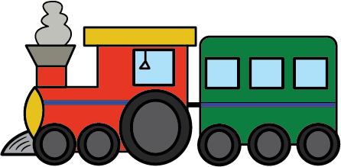
Parts of Speech and Parts of the Sentence

subject
predicate prepredicate predicate

A complete sentence has a subject and a predicate.
-Subject: What or who the sentence is about. It can be a noun (Ahmad can play football.), pronoun (He is the best player.) or noun phrase (Ahmad’s birthday is today.) ...
-Predicate: It tells something about the verb. It contains an action verb (He stole my keys.) or a linking verb (My cat is nice.) ...
(Don’t forget that a complete sentence has a subject and a predicate.)
- Sentence: The children play in the park.
- Subject: The children
- Predicate: play in the park
In this sentence, "The children" is the subject because it tells us who does/ is doing the action. "play in the park" is the predicate because it describes what the children do/ are doing.
- Sentence: The cat sleeps on the mat.
- Subject: The cat
- Predicate: sleeps on the mat
In this sentence, "The cat" is the subject because it's what the sentence is about. "sleeps on the mat" is the predicate because it tells what the subject does/ is doing.

Test Yourself!

* For each sentence below, underline the subject once and the predicate twice.
- The dog barks loudly.
- Rama reads a book.
- The sun sets in the evening.

Also, the following picture shows the main parts of speech:
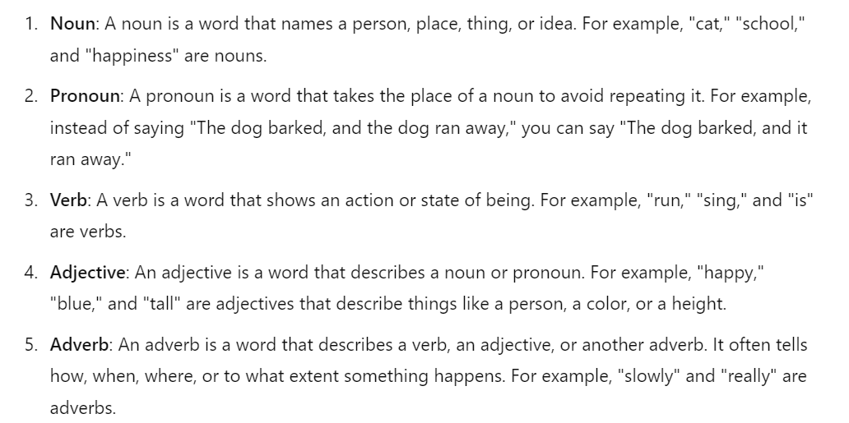

Q1. Identify the part of speech in each underlined sentence (noun, pronoun, verb, adjective, adverb, and preposition):
1. I speak two languages. _verb_______________
2. Mohammad felt tired at night. _adjective_______________
3. Razan found money in the street. _noun_______________
4. My mum drives quickly. __adverb
********************************************************

Q2. Circle the correct answer to complete the sentence:
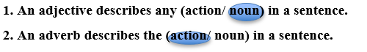
********************************************************

Q3. In the following sentence, label each word with its correct part of speech:
The small dog barked loudly.
• The - Article
• small – Adjective
• dog – Noun
• barked – Verb
• loudly – Adverb
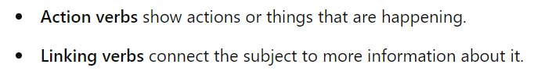
Remember!

Examples:

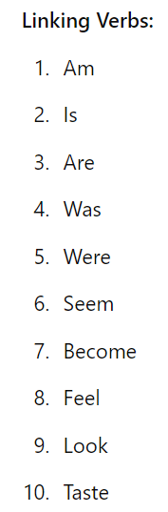
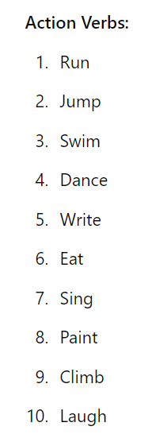

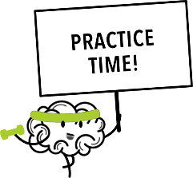

Q1. Decide whether the underlined words are action verbs or linking verbs:
1. Ahmed looks happy. Linking Verb
2. My friends studied well for the exam. Action Verb
3. This statue is big. Linking Verb
4. My parents watch TV every day. Action Verb

********************************************************
Writing Task:
Q5. Imagine you are a detective solving a mystery in a magical forest. Write a paragraph describing what you see and what you do. Be sure to include:
- Nouns (e.g., forest, detective, mystery)
- Verbs (e.g., explore, find, solve)
- Adjectives (e.g., mysterious, colorful, ancient)
- Adverbs (e.g., carefully, quickly, quietly)
Try to make your paragraph exciting and detailed, so it feels like an adventure for the reader!
______________________________________________________________________________________________________________________________________________________________________________________________________________________________________________________________________________________________________________________________________________________________________________________________________________________________________________________________________________________________________________________________________________________________________________________________________________________________________________________

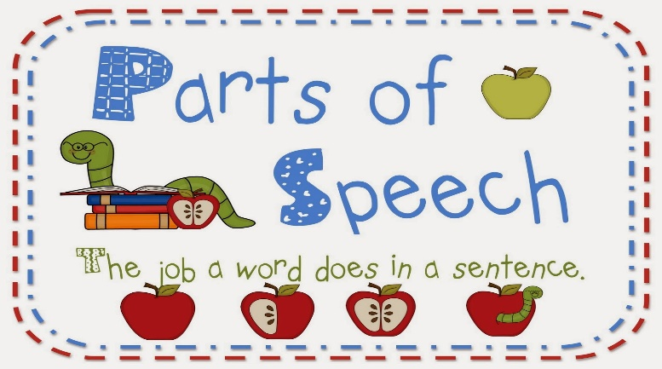

*Writing:
Describe a Place
- A description of a place can be of: a building, a room, a town, an area: indoors or outdoors.
- We can write about its appearance, things that happen there and why we like it. Take the following into consideration:

- A successful descriptive paragraph should have:
A. Introduction:
- Name of the place
- Location
B. Main Body:
- Things we can see
- Things to do
C. Conclusion:
- Your comments
- Your feelings
- Do you like the place? Why? Why not?

- Join the sentences with right words/phrases:
in the back, in the front, at that point, also, too, besides
- Use different single and multi-prepositions:
(in, on, in front of , next to , beside , above , outside , on top of , in the middle , near, beside .. etc.)
- Use visual adjectives to describe the place.

- Use present tense tenses in this type of writing.

- Don’t use short forms.

Adjectives to describe a place:
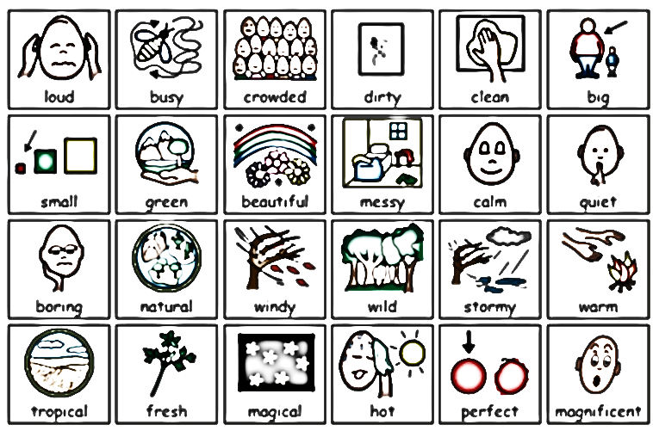

Read the following example and notice the words that show spatial order as you have to use such words in your composition:
My Home Library
My home library is the perfect place to relax. It was designed in 2015 by a well-known architect. When you first enter the room, the dark blue walls draw you in and make you feel at peace. A bookcase filled from top to bottom stands at the far end of the room inviting anyone to come grab a book. Next to this majestic red bookcase is the leather couch. It is well-worn so that it feels comfortable the minute you sit down. It is perfect for resting or reading or day dreaming.
The cozy armchair is across from the couch and by the window. This is another wonderful place to sit because when sunlight hits the chair, it warms your soul. Behind the armchair is a lush fern
in a brown, wooden planter. In between the couch and the armchair is a round wooden coffee table with a beautiful straw basket in the middle. And on the floor is a faded Persian rug. This gives the room the warmth that makes you want to stay for a while. When it is time for some peace at home, the library is the only room I want to be in.

*Here is another example after providing you with the necessary information.
• Location: Oman is on the southeastern side of the Arabian Peninsula, next to the Arabian Sea.
• Capital City: The capital city is Muscat.
• Landmarks:
- Hajar Mountains: Great for hiking.
- Wadi Shab: Known for its clear pools and waterfalls.
- Sultan Qaboos Grand Mosque: Located in Muscat.
- Old Forts: Found along the waterfront in Muscat.
• Coastline:
- Beaches: Lovely sandy beaches along the coast.
- Wildlife: Arabian Oryx can be seen in the wild, and turtles nest on the beaches.
• Historic Sites: Towns like Nizwa in the interior.
• Weather: Usually very hot during the summer, and more humid near the coast.
• Culture: Rich with traditional music, dance, and tasty food made with local ingredients.
• People: Friendly locals.
• Views: Stunning landscapes and scenery.

Oman is a fascinating country with many wonderful places to explore. It is located on the southeastern side of the Arabian Peninsula, next to the Arabian Sea. Its capital city is Muscat. Oman has amazing places to visit, like the Hajar Mountains, which are great for hiking up, and the beautiful Wadi Shab with its clear pools and waterfalls. In Muscat, you can see the impressive Sultan Qaboos Grand Mosque and explore old forts along the waterfront. The country also has lovely sandy beaches along the coast and historic towns like Nizwa in the interior. The weather is usually very hot during the summer, and it gets more humid near the coast. Omani culture is rich with traditional music, dance, and tasty food made with local ingredients. You might also see Arabian Oryx in the wild or turtles nesting on the beaches. Oman’s friendly people and stunning views make it a special place to visit.

Write about one of the following topics:
- Write about a place that you usually visit with your friends.
- Write about your favorite city / country.
- Write about your favorite mall.

Useful Expressions:
It’s located in ….. It’s close to ….. It’s well known for …..
The views are ….. What I like the most about it is ….. You can see …..
I do there every …..
___________________________________
______________________________________________________________________________________________________________________________________________________________________________________________________________________________________________________________________________________________________________________________________________________________________________________________________________________________________________________________________________
________________________________________________________________________________________________________________________________________________________________________________________________________________________________________________________________________________________________________________________________________________________________________________________________________________________________________________________________________________________________________________________________________________________________________________________________________________________________________

GOOD LUCK!

