Islamic Educational College  Jabal Amman | Mock exam  School year (2025/2026)  Subject: Science  Grade Six | 
Name :

- What do the letters inside each box of the periodic table represent?
a) The mass of the element b) The symbol of the element
c) The group number d) The colour of the element
- How are elements with similar properties arranged on the periodic table?
a) In rows b) In diagonal lines c) In vertical columns d) Randomly
- What is the Latin name for sodium (Na)?
a) Kalium b) Natrium c) Ferrum d) Aurum
- What is the Latin name for potassium (K)?
a) Kalium b) Plumbum c) Natrium d) Cuprum
- Sodium (Na) and potassium (K) in the same group,
a) they have the same colour b) they have the same atomic number
c) they have the same atomic mass d) they are all gases
- What is chromium (Cr) commonly used for?
a) Making jewellery b) Coating metal surfaces
c) Producing containers d) Making batteries
- Gold (Au) is described as a:
a) Heavy, black metal b) Shiny, yellow metal
c) Soft, grey metal d) Hard, white metal
- Which of the following is a form of carbon (C)?
a) Sulphur crystal b) Neon gas c) Graphite d) Tin foil
- What colour does sulphur (S) usually appear as?
a) Blue b) Yellow c) White d) Black

- Tin (Sn) is mainly used to produce:
a) Jewellery b) Containers c) Coins d) Wires
- Neon (Ne) belongs to which group of gases?
a) Reactive gases b) Noble gases c) Halogens d) Transition metals
- Why does neon glow?
a) When electricity passes through it b) When heated
c) When frozen d) When mixed with water
- Which of the following is non-metal
a. sulfur b. Sodium c. Gold d. Tin
- Which of the following is metal
a. sulfur b. Carbon c. Neon d. Tin
- What is an atom?
a) A large object made of many materials b) A type of energy
c) A type of molecule d) The smallest particle of an element
- Where are protons and neutrons found in an atom?
a) In the electron cloud b) In the nucleus c) In the outer shell
- What charge does a proton have?
a) Negative b) Neutral c) Positive d) No charge at all
- What charge does an electron have?
a) Positive b) Negative c) Neutral d) Both positive and negative
- What is the charge of a neutron?
a) Positive b) Negative c) Neutral d) Changing
- What does the atomic number tell you?
a) Number of electrons only b) Number of protons in the nucleus
c) Number of neutrons d) Number of protons + neutrons
- The atomic number of Helium is 2, How many protons does a helium atom have?
a) 1 b) 2 c) 3 d) 4
- Where are electrons found in an atom?
a) Inside the nucleus b) Inside protons
c) Orbiting outside the nucleus d) Between the neutrons
- The atomic number of Aluminum is 13, How many electrons does an aluminum atom have?
a) 13 b) 26 c) 30 d) 2
- Which particle determines the type of element?
a) Electrons b) Neutrons c) Protons d) The nucleus size
- What is a physical property?
a) A change that forms a new substance b) A characteristic you can observe with your senses
c) A chemical reaction d) A measurement of temperature only
- Which of the following is not a physical property?
a) Color b) Texture c) Odour d) Burning
- Which sense would you mainly use to observe an object’s texture?
a) Hearing b) Touch c) Taste d) Smell
- What does mass describe?
a) How rough something feels b) How heavy something is
c) How it smells d) How shiny it is
- If an object can be attracted by a magnet, it has the property of:
a) Elasticity b) Hardness c) Magnetism d) Odour
- Which physical property describes how an object smells?
a) Mass b) Hardness c) Odour d) Texture
- Which of the following describes elasticity?
a) How heavy something is b) How much it stretches or bends before breaking
c) How it smells d) How smooth or rough it feels
- What physical property tells us how easily something can be scratched or broken?
a) Hardness b) Texture c) Odour d) Size
- A shiny, smooth object is being observed. Which physical property is mainly being described?
a) Hardness b) Texture c) Odour d) Magnetism
- At what point does a substance change from solid to liquid?
a) Melting point b) Odour point c) Elasticity d) Texture point
- Water melts or freezes at:
a) 100°C b) –10°C c) 0°C d) 10°C
- Which of these items is likely to have high elasticity?
a) A glass cup b) A rubber band c) An iron nail d) A stone
- A magnet attracts:
a) Iron clip b) glass cup c) rubber band d) plastic bag
- Scientists observe physical properties because:
a) They want to make new substances b) They want to classify and understand materials
c) They want to remove colour from objects d) They want to change substances permanently
- …………………………. is the process that breaks down and changes rocks.
a) Erosion b) weathering c) Exfoliating
- which of the following factors (agents) can help in weathering
a) chemicals only b) living things c) ice and water d) all of the answers
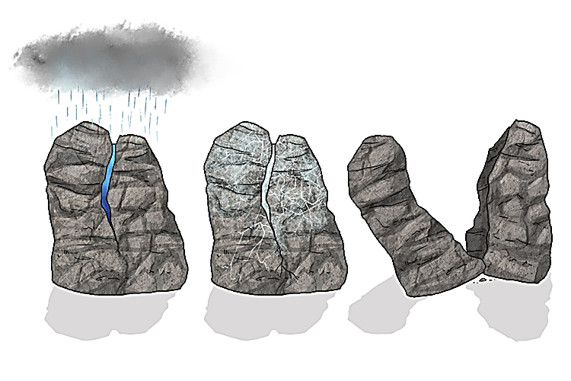
41. This picture shows a
a) chemical weathering
b) Physical weathering

