Islamic Educational College  Jabal Amman | Mock exam for pages 60/61/66/67  School year (2025/2026)  Subject: Science  Grade Seven | 
Name :

1. What does the term “environment” refer to?
A. Only the temperature of a habitat
B. The conditions in a habitat caused by physical factors
C. The number of organisms in an area
D. How many plants live in a habitat

2. Which of the following is a physical environmental factor?
A. The number of predators
B. The types of plants present
C. How windy it is
D. The amount of food available

3. Organisms are said to be “adapted” to their habitats because:
A. They can choose the best environment
B. They have features that help them survive
C. They breathe more than other species
D. They never change

4. Why do polar bears have small ears?
A. To hear better under water
B. To help them cool down
C. To reduce heat loss
D. To make them look bigger

5. Which adaptation helps polar bears walk on ice without slipping?
A. Thick fur B. White camouflage C. Rough soles D. Large ears

6. What is the purpose of the cactus’s spines?
A. To store extra sunlight
B. To protect it and reduce water loss
C. To attract insects
D. To help the cactus move

7. Why do cacti have no leaves?
A. Leaves would attract predators
B. Leaves require no light
C. Leaves increase water loss
D. Leaves prevent root growth

8. How does the cactus store water?
A. In its roots
B. In its spines
C. In its stem
D. In its flowers

9. What helps jack rabbits cool down in hot environments?
A. Their thick fur
B. Their large ears
C. Their small feet
D. Their short legs

10. Which adaptation helps jack rabbits escape predators quickly?
A. Large hind legs B. Long tail C. Extra fur D. Small ears

11. What is meant by a community in an ecosystem?
A. Only the animals in a habitat
B. Only the plants in a habitat
C. All animals and plants living together in a habitat
D. Only organisms that live in water
12. What adaptation helps hogsucker fish survive in fast-flowing rivers?
A. Bright-colored scales
B. Large fins for balancing
C. Suckers that allow them to attach to rocks
D. Thick fur to stay warm
13. What is the function of the hogsucker fish’s streamlined body?
A. To help it swim faster in strong currents
B. To store extra water
C. To scare predators
D. To allow it to float on the surface

14. What forms an ecosystem?
A. Only the physical environmental factors
B. Only the community of organisms
C. The community of organisms and all physical environmental factors together
D. Plants and animals that look alike

15. What are resources in a habitat?
A. Only the animals that live there
B. Anything organisms need to survive and grow
C. Only water and food
D. Only plants and air

16. Which of the following is a resource that animals need?
A. Mineral salts only B. Light and warmth
C. Oxygen, food, water, and mates D. Soil nutrients

17. What do plants need in order to grow?
A. Water, light, air, warmth, mineral salts, and space
B. Only water and warmth
C. Only sunlight and soil

18. What happens to the population of an organism if an important resource is missing?
A. The population increases B. The population stays the same C. The population goes down

19. Which statement best explains why organisms affect their habitat?
A. They change the weather
B. They use up the resources they need to survive
c. They do not need resources
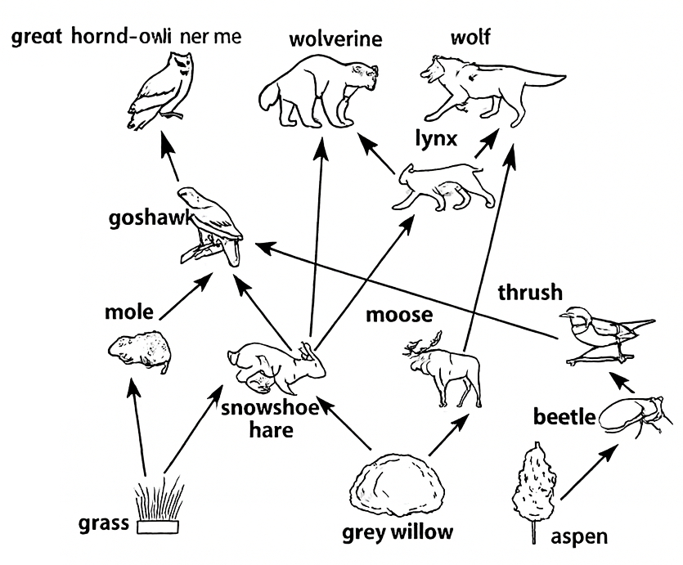
20. What is a food web?
A. A single food chain B. Many food chains linked together
C. A list of animals in an ecosystem D. A group of producers only

21. Which animals compete for hares in this food web?
A. Moose and beetles B. Goshawks and lynxes C. Thrush and beetle

22. What might happen if all goshawks die from a disease?
A. There will be fewer hares
B. Lynx population may increase
C. Grass will disappear
D. Wolves will have more food

23. Which organism in the food web is a producer?
A. Moose
B. Vole
C. Grass
D. Goshawk

24. Which organism is a herbivore?
A. Wolf
B. Lynx
C. Snowshoe hare
D. Wolverine

25. Which organism is a top predator (not eaten by others)?
A. Moose
B. Great horned owl
C. Thrush
D. Beetle

26. What does a herbivore eat?
A. Only meat
B. Plants
C. Dead organisms
D. Both plants and animals

27. Which of the following is a carnivore in the food web?
A. Beaver B. Snowshoe hare C. Goshawk D. Grass

28. If the number of hares increases, what will most likely happen?
A. Producer numbers increase
B. Lynx population might increase
C. Beetles will decrease
D. Wolves will leave the area

29. What connects producers to top predators in a food web?
A. Light B. Food chains C. Soil nutrients D. Weather

