
Worksheet Number ( )/ 5th grade/ Unit: Chapter 2: Reproduction and change.
Lesson 2: How are traits passed along? (Pg. 50+51)

Student's Name: _________________________ Date: / /2025
Educational Outcome:1. Identify: inherited, traits, offspring, gene
2.List some example of inherited traits. 3.Identify the features of firefly, their importance.

Task1: identify the following scientific terms: inherited traits, off springs, a gene.
Inherited traits: The traits that pass from parents to their offspring.
Offspring: their kids.
A gene: is a part (a section) of a chromosome that carries information that controls a trait.

Task2: A: Give some examples of the inherited traits

The ability to curl my tongue | The shape of father’s nose | My hair is straight or curly | My earlobe is attached or not attached | My color eyes is blue or another color
B: What are the effects of some traits on our body?
1.Some inherited traits effect on our organ of our body and its work.
2.Some inherited traits cause many diseases. (like diabetes)

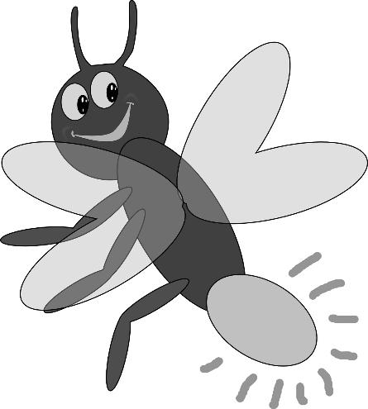
Task3: Identify the features of firefly?
antennae
Glow part
wings
6- legs

Task4: How does the firefly give off the light in the glow part?

The fire fly gives off the light because its body produces a chemical that can change the energy in its cell into the light.

GOOD LUCK
We can understand the roles of friendships and peer
We can understand the roles of friendships and peer
We can understand the roles of friendships and peer
We can understand the roles of friendships and peer
We are able to interpret other people’s words and predict what they will do next
We can understand the roles of friendships and peer
We are able to interpret other people’s words and predict what they will do next
We are able to interpret other people’s words and predict what they will do next
We are able to interpret other people’s words and predict what they will do next
We are able to interpret other people’s words and predict what they will do next
We can analyse other people’s actions and guess them
We can analyse other people’s actions and guess them
We can analyse other people’s actions and guess them
We can analyse other people’s actions and guess them
We can analyse other people’s actions and guess them
Sharing with peers or donating money
Sharing with peers or donating money
Sharing with peers or donating money
Sharing with peers or donating money
Sharing with peers or donating money
We can understand the roles of friendships and peer
We can understand the roles of friendships and peer
We can understand the roles of friendships and peer
Have a close relationship with cognitive perspective-taking
Have a close relationship with cognitive perspective-taking
Have a close relationship with cognitive perspective-taking

