
Worksheet Number ( )/ 7th grade ( ) 7Dd: Effects on the environment
(Pg. 66-67)

Student's Name: _________________________ Date: / 10 /2025
Educational Outcome:1. identify the scientific terms 2. Explain how some organisms live in their habitats?
Task1: Identify the following scientific terms?
Organisms: Are living things (plants, animals, humans).
Environment: The conditions in a habitat caused by physical environmental factors.
Habitat: A place where organisms live in.
The physical environmental factors: The physical: means non-living, like:( air, water, light, temperature, wind)
Environmental: conditions hot, cool, cold, ice, wet, dry, light dark, sunny, windy, …Factors: things.
Ecosystem: is formed from the community of organisms and all the physical environment factors in a habitat.
Community: all the animals and plants live in a habitat.
Adaptation the features that something has to enable it to a certain job or survive in a particular place.
Task2: Label the parts of the polar bear, and complete the following table:

The feature of the polar bear. | Its function
Small ears | To stop it losing too much heat
Fur:  White color | Camouflage (creeping up on seals without being seen). Camouflage means hide from enemy or their pray.
Large feet | 1.To spread out its weight.  2.To stop it from sinking  3.To swim
Rough soles | To grip the ice
Thick fur | - help keep it warm.
Thick and white fur
small ears
Large feet
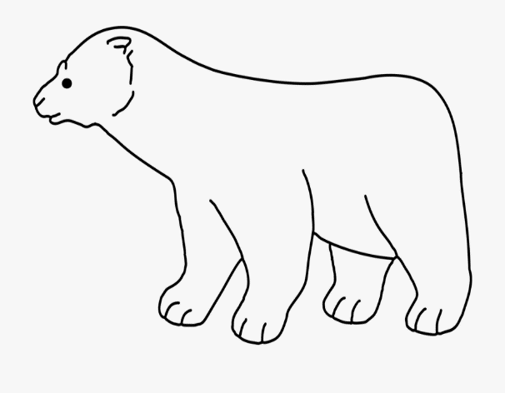
Rough soles

Task3: label the parts of the cactus and complete the following table:
No leaves
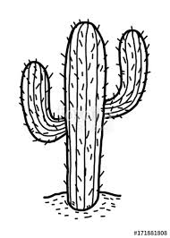
The feature of an cactus | Its function
No leaves | To lose less water
spines | To protect it from animals
Thick stem | To store water. The saguaro cactus can absorb a tonne of water a day after a storm.
Thin and long roots | To absorb as much water as possible when it rains.
spines

Thick stem
Thin and Long roots

Task4: label the parts of the jack rabbit and complete the following table:
The feature of a jack rabbit | Its function
Large ears | 1.To allow heat to escape  2:to improve hearing
mouth | Does not drink direct it gets water from eating food
Large hind legs | To run away quickly from animals (its speed = up to70% km/h)

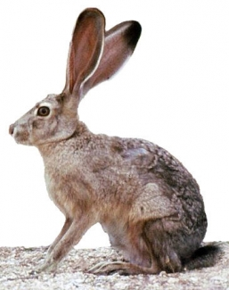
Large ears

Large hind leg

The features of fish | The importance
fins | to swim
gills | To breathe
Task3: Complete the following table:
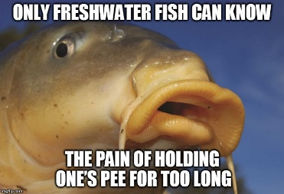
How can hog sucker fish live in fast flowing water.
Have suckers to allow them attach to rocks and stop them being swept away

THE END

