
Worksheet Number ( )/ 9th grade ( ) 8Fc+8Fd:( page93+97)

Student's Name: _________________________ Date: / 11 /2025
Educational Outcome:1. identify the Mendeleev’s table theory 2. The periodic table
Task1: Circle the correct answer ?
1. Argon belongs to____ group.
a. alkali b. halogen c. noble gases
2. The periodic table is based on _____ properties.
a. similar b. different c. neutral
3. _____is a vertical column of elements in the periodic table.
a. group b. period c. table
4. The simplest particles of matter are called ______.
a. atoms b. compounds c. mixtures
5. Scientists arranged elements in a table, which is called _____ .
a. periodic b. atomic c. acidic
6. Mendeleev arranged the elements by :
a. atomic number. b similar properties. c. leaving gaps for undiscovered elements
d. all of them are correct.

7. What was the Mendeleev’s mistake?
a. he denied the existence of Argon when it was discovered because it did not fit into any his groups.
b. he put the elements based on the atomic number.

Task2: Compare between the physical properties of metals and non- metals.

 | metals | Non- metals
The melting point | high | low
The conduction of electricity and heat | Good | Bad or insulators
Flexible or brittle | flexible | brittle
Shiny or dull | shiny | dull

Task4: Study the following periodic table to answer the questions below:
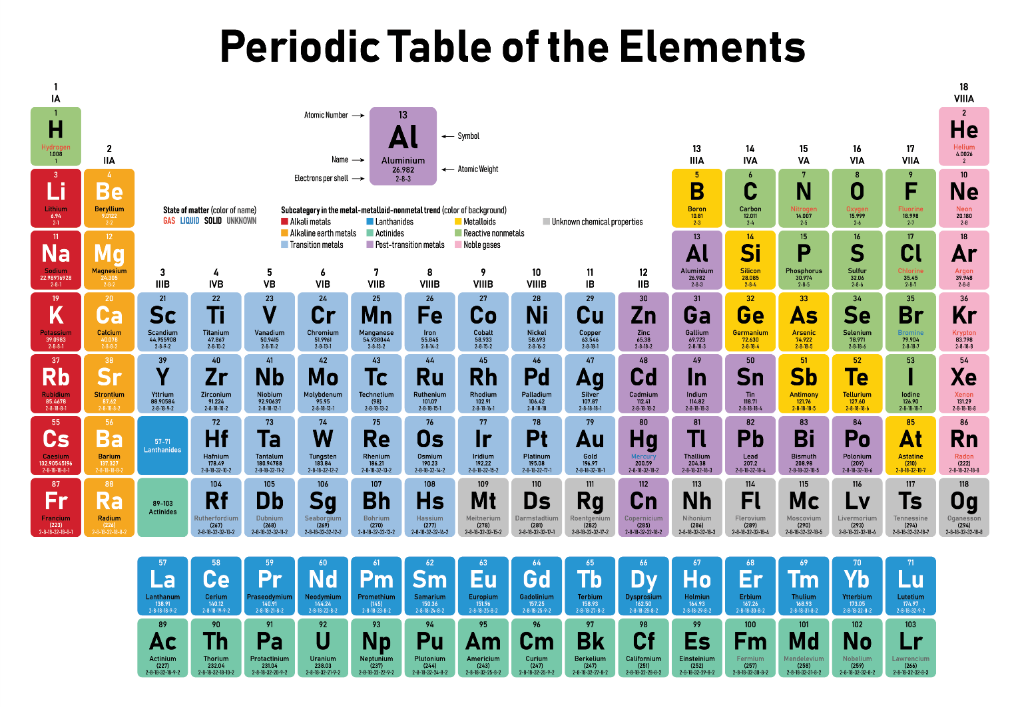
1: Name the element from the first group and the 4th period? K
2: Name the family of the first group? Alkali family

3: Name the element from the 15 group and it considered as semi-metal? As

4: Name an example of elements from the transition element (6th period, 5th group)? Ta

5: Name an example of element from the noble gases?
( helium, neon, krypton, xenon, and argon ) .
2: Name the family of the 17 group? Halogen

TASK5: Study the following square from the periodic table to answer the following questions:
1.atomic number of this element= 1
2. The chemical symbol (formula) is H
3. What is its atomic mass?1.000794
4.What is the number of valence electrons? 1
5.What is its state of matter at room temperature? gas

Task6: Study the following figure to answer the following questions:

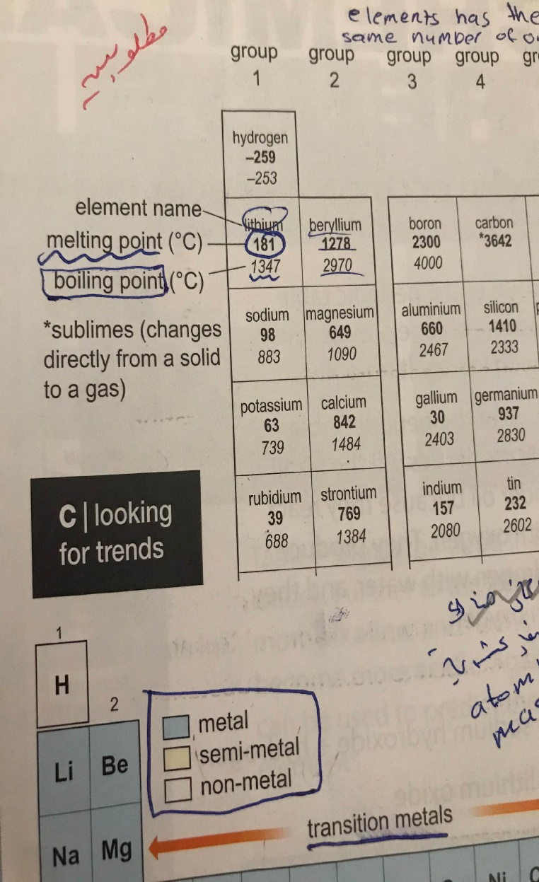
1.What is the melting point of lithium? 181⁰ C
2. What is the boiling point of lithium? 1347⁰ C

THE END

