
Worksheet Number (2+3)/ 10th grade ( ) Unit: 8Ce+8Cb
Student's Name: _________________________ Date: / /2025
Educational Outcome:1: recall what happens in anaerobic respiration and its effects.
2: compare between breathing and ventilation, mucus and cilia, inhaling and exhaling. 3: Label the parts of respiratory system, 4: identify gas exchange system, alveoli and its importance
Task1: circle the correct answer:
1. Oxygen is stored by _______ in red blood cells.
a. haemoglobin b. white blood cell c. plasma
2. What happens after holding your breath for a long time?
a. you breathe faster to get rid of extra CO₂ in your blood
b. you breathe faster to replace the O₂ that is used up from the blood and muscle
c. both of them are correct
3. Anaerobic respiration occurs in the ______ of your muscle cell.
a. nucleus b. cytoplasm c. plasma
4. Which one of the following cases would favor anaerobic respiration?
a. high amount of O₂ b. low amount of O₂ c. low amount of CO₂
5. Which kinds of respiration process would happen in your muscles during intense exercises?
a. aerobic b. anaerobic c. oxidation
6.If no oxygen is available, cells can obtain energy through the process of ______ respiration.
a. aerobic b. anaerobic c. fermentation

 | The definition
breathing | is when muscles between the ribs and in the diaphragm change the size of the lungs.
ventilation | the movement of air into or out of the lungs.
Task2: Compare between the following:
Exhaling | Inhaling | The movement  The changes
Carbon dioxide | oxygen | The kind of gas
Is increased | Is reduced | The air pressure in the lungs
Relaxes, pulls down and in | Pulling up and out | ribcage
Relaxes, up | Contracts and moving downwards | diaphragm
decreased | Increased | Volume of chest

 | mucus | cilia
definition | A sticky liquid which is produced by some cells in the tubes in the lungs. | Tiny hairs on the ciliated epithelial cells in the lungs.
function | Traps dirt, dust and microorganisms. | Sweep the mucus out of the lungs / into the gullet.

Task 3: Label the parts of the respiratory system:

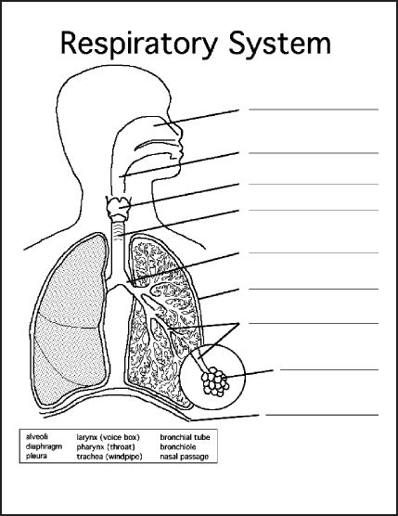
alveoli
diaphragm
Nasal cavity
bronchiole
trachea
bronchi
lung

Task4: Complete the following table :

Alveoli and the blood capillaries | Happens in
By RBCs with hemoglobin | How can gases transport?
By diffusion (transport way that let the gas to pass from high concentration to low concentration). | How can gases exchange?
Oxygen transport from alveoli to the blood  Carbon dioxide transports from the blood to the alveoli | The direction of gases during the gas exchange

Task5: explain:
1.The effect of the chemicals and heat in cigarette smoke.
(stop cilia working, then the mucus collects or accumulates in the lungs).

2. The lungs are adapted for gas exchange by having about 700 million of alveoli.
This gives the lungs the larger surface area and the faster diffusion occurs and increases the efficiency of the gas exchange
3. The alveoli walls are made up of only one thickening cell and the walls of the capillaries are thin.
(diffusion happens more quickly and this feature increases the efficiency of the gas exchange).

GOOD LUCK

