
Worksheet Number ( )/ 8th grade ( ) Unit: (122+123)
Student's Name: _________________________ Date: / 9/2025
Educational Outcome:1: Identify the cell . 2. Identify the parts of the cells, their functions. 3: compare between animal and plant cells. 4: label the parts of the cell.
Task1: A: identify the cell and what are the main parts in two kinds of cell (plant and animal cells?
The cell is the tiny basic unit that all organisms are made up of it, the main parts are: cell surface membrane, nucleus, cytoplasm, mitochondria, vacuole.

Task 2: Complete the following tables:

The part | The definition | The function
Cell surface membrane | is a very thin bag and all the cells are made up of it. | 1. keeps the cell together  2. controls what enters and leaves the cell.
Cytoplasm | is a watery jelly and all the cells are made from it. | most of the cell’s activities happen here like breathing/ respiration.
Nucleus |  | controls the cell
Mitochondria | a tiny jelly bean-shaped structure | make energy by making respiration.
Vacuole | is a storage space filled with cell sap (water and minerals). | to protect cell from dryness and firm.
Cell wall | is a box with holes in it which is made up of cellulose. | support the cell  cellulose: make the plant cell very strong.
Chloroplasts | chloro: green color , plasts discs : are green discs in the cytoplasm of the cells that have chlorophyll. | make food for the plants by using photosynthesis

Task3: Compare between animal and plant cell?

The part/ structure | Animal cell | Plant cell
1.Chloroplasts | Doesn’t have | has
2. Cell wall | Doesn’t have | has
3. vacuole | Many, small | one., large
TASK 4: Label the parts of the following cells?
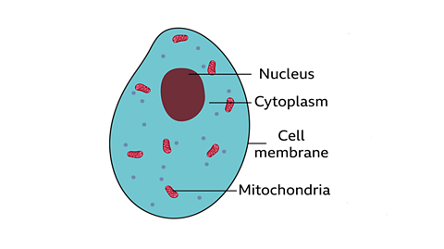
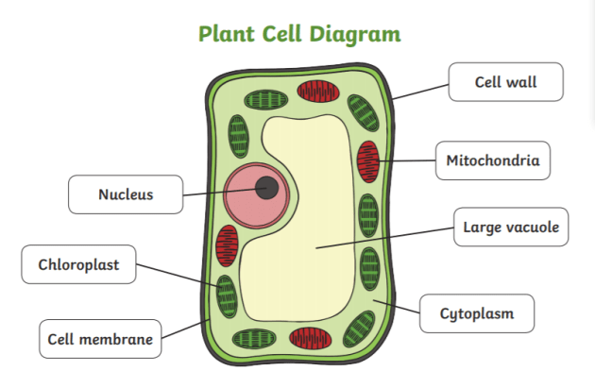
Animal cell diagram

Vacuole

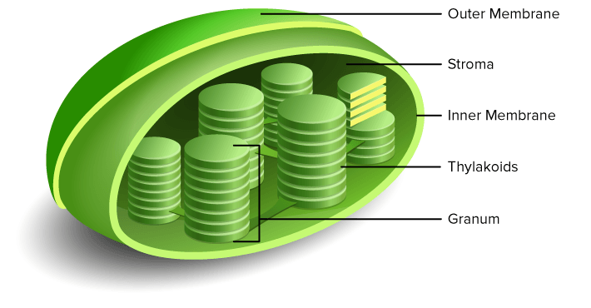
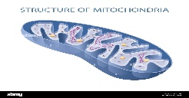

THE END

