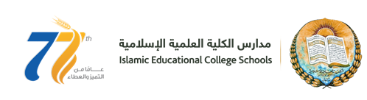
Worksheet Number ( )/ 8th grade ( ) Unit: (122+123)
Student's Name: _________________________ Date: / 11/2025
Educational Outcome:1: Identify : pure substance and impure substance, atom, element, compound and molecule . 2. Classify the substances .
Task1: A: The air is pure/ or not pure, why?
The air is made up of a mixture of gases. Like: oxygen, hydrogen, nitrogen, argon, and carbon dioxide.

B: Give some examples of not pure substances?
Drinking water or Mineral water. Tap water: water and chlorine. Sea water: water and minerals, salts, Any solution.

Task2: Identify atom, element and the compound?
An atom: is the simplest particles of matter
An element: if matter is made up of two or more identical atoms ( or is made up of only one type of atoms). Like: (Argon, sulfur, gold, oxygen, nitrogen)
A compound: is made up of two or more different atoms or elements. (rocks, lead sulfide (galena), water, carbon dioxide (CO₂ ) , tap water, nitrogen dioxide NO₂)

Task 3: Classify the following substances :( CO₂, H₂O, O₂, H₂ , NaCl , NO₂
An element | A compound
O₂, H₂ | CO_{2 ,} NO₂
 | H₂O , NaCl

Task4: Identify the molecule?
molecule: two or more atoms joined together in a group of a set size.
All the molecules contain: 1. the same type of atoms, and number of atoms

TASK5: Study the following figure to answer the following questions
1: Classify the following substance (is it an element or a compound)?
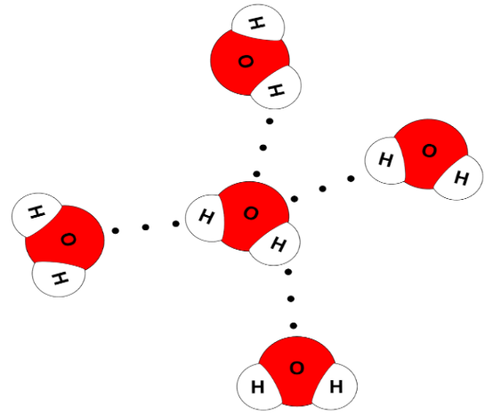
It is an element
2: Name this substance? water
3: Write the chemical symbol of this substance? H₂O
4: Name the elements that make up this substance? Hydrogen and oxygen
5: How many molecules of this substance in this figure? 5 molecules of water

THE END

