
Worksheet Number ( )/ 8th grade ( ) Unit: 7Ga(106+107)
Student's Name: _________________________ Date: / 11/2025
Educational Outcome:1: compare between the wastes materials, their effects.
Task1: Compare between the kinds of the waste materials:
feature  Type of matter | The solid waste materials | The liquid  waste materials | The gas waste materials
Able to transport | Easy to transport them by vehicles (open lorries) to landfill sites | Can be pumped a long pipeline | Difficult because they can be moved in all directions
examples | Papers, plastic, metals. | Waste cooking oil | The gas cylinder
Solve their problem | Recycle | Waste cooking oil can be converted into biodiesel | Put them inside cylinder in any store

Task2: Compare between the states of matter:
feature  Type  of  matter | shape | volume | example | Can be compressed  ( can be squeezed into a smaller volume)
Solid | fixed | Fixed, not change | ice | cannot
Liquid | Not fixed and takes the shape of its container | Fixed, not change | water | cannot
Gas | Not fixed and takes the shape of its container | Not fixed and takes the volume of its container | Oxygen, water vapour | Can
Task 5: identify the acid rain, its formation, its harmful?
Acid rain is the waste liquid materials that are produced from the dissolving gases with rain.
The waste gases materials come from: the burning of fossil fuels (factories and power stations)
They can cause harm to the environment
Task 3: Name the following hazard sign, its definition.
Task4: identify the volume, write its formula, answer Q5/ page 107Complete the following chemical reaction:
Volume: is the matter of space that takes up.
Volume of regular object= length X width X height
The measuring unit= cm³ Q5: 4 x 5 x 10=200 cm³

Good luck
the hazard sign | Its name
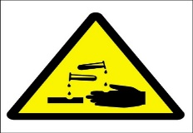 | corrosive: Can be eaten
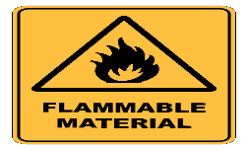 | Flammable: catch the fire
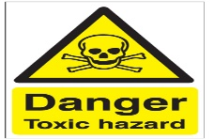 | Toxic: danger and causes death

