
Worksheet Number ( )/ 6th grade/ Chapter1: Classifying matter Lesson1: What are elements? (page 20+21)
Student's Name: _________________________ Date: / 4/2025
Educational Outcome:1: identify the element, periodic table.2: identify the physical properties of some elements. 3: identify the group, period of the periodic table.
Task1: identify the element, periodic table , group of element.

The element: is a simplest substance that cannot be broken.
Periodic table: is a chart that classifies elements by their properties.
A group of elements: is a vertical column in the periodic table (the elements in each group have similar properties).

Task2: Complete the following table:

Used to | the number of its group | The properties  (state of matter, color, texture) | Symbol of element | Name the element
- | 1 | Solid, metal, shiny, silvery | Na( comes from its Latin name natrium) | sodium
- | 1 | Solid, metal, shiny, silvery | K( comes from its Latin name kalium) | potassium
To coat metal surface such as the trim on cars | 6 | Mirror- like metal, solid | Cr | chromium
To make jewelry | 11 | Yellow metal, shiny ,solid | Au | gold
Graphite, coal, diamond | 14 | Black, solid , non-metal | C | carbon
Producing containers | 14 | Metal, solid, shiny | Sn | tin
- | 16 | Yellow crystal , solid | S | Sulphur
- | 18 | Gas, glow when the electricity passes through it . | Ne | neon

Task3: use the following periodic table to answer the following questions:

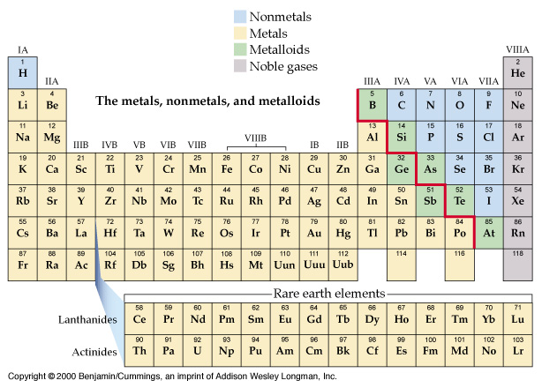
Question6
- Name the element from the first group? (H, Na, K, Rb , Cs and Fr)
- How many groups in the periodic table? 18
- How many periods in the periodic table? 7
- Name an element from the 17th group and 4th period? Br
- Name the element from the noble family? (He, Ne, Kr, Xe, Rn)
- Name the element from the artificially group?
Task4: study the following square from the periodic table to answer the following questions:
1: What is the atomic number of this element? 1
2: Name of this element. (hydrogen)
3.What is the symbol of this element? H
4: How many electrons in this element? 1
5: How many protons in the nucleus of this element? 1

GOOD LUCK
We can understand the roles of friendships and peer
We can understand the roles of friendships and peer
We can understand the roles of friendships and peer
We can understand the roles of friendships and peer
We are able to interpret other people’s words and predict what they will do next
We can understand the roles of friendships and peer
We are able to interpret other people’s words and predict what they will do next
We are able to interpret other people’s words and predict what they will do next
We are able to interpret other people’s words and predict what they will do next
We are able to interpret other people’s words and predict what they will do next
We can analyse other people’s actions and guess them
We can analyse other people’s actions and guess them
We can analyse other people’s actions and guess them
We can analyse other people’s actions and guess them
We can analyse other people’s actions and guess them
Sharing with peers or donating money
Sharing with peers or donating money
Sharing with peers or donating money
Sharing with peers or donating money
Sharing with peers or donating money
We can understand the roles of friendships and peer
We can understand the roles of friendships and peer
We can understand the roles of friendships and peer
Have a close relationship with cognitive perspective-taking
Have a close relationship with cognitive perspective-taking
Have a close relationship with cognitive perspective-taking

