
Class Worksheet Number ( )/ 6th grade ( ) Unit: What changes the Earth’s surface?
Student's Name: _________________________ Date: / 11/2025
Educational Outcome:1: identify the weathering, its agents and how can freezing water break down the rocks.
Task1: Identify weathering? Their types

Is the process that breaks down and changes rocks

Task2: list some agents that can break down and change rocks?

Air (wind), water, chemicals and living things like (animals, plants, humans).

Task 3: Explain the effect of the physical weathering?

They can change the size and the shape of the rocks without changing what they are made of.

Task 4: explain the steps of weathering the rocks by freezing water?
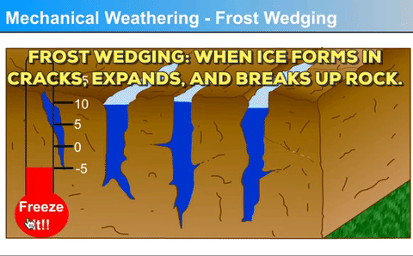

- Water enters tiny cracks
- It freezes at 0⁰C and then expands
- It enlarges the tiny cracks
- Over many years, ice can split them and change rocks.

The end

