

Class worksheet Number ( 3)/ 5th grade/ page 32+33
Student's Name: _________________________ Date: / /2025
Educational Outcome:1: Label the parts of the seed, classify the plant and its parts into monocot or dicots.
Task1: Label the parts of the flowering plant
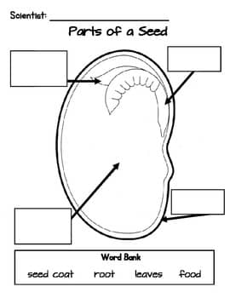

Developing plant
Seed leaves

Seed coat
Store food

Task2: Complete the following charts

Task3: Classify the following seeds into monocot and dicots seeds?
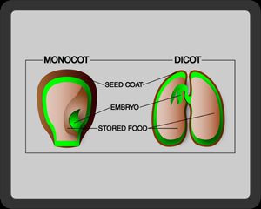
Dicots seed
Monocot seed

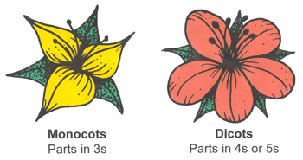
Task4: Classify the following flowers into monocot and dicots plants?
Task5: Classify the following roots into monocot and dicots plants

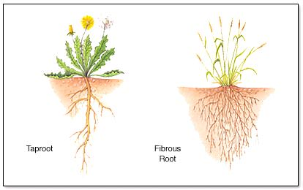
Dicots root
Monocot root

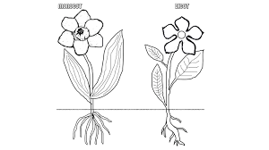
Task 6: Use the following figure to compare between monocot plant and dicots plant, use the following table:
monocot
dicots
 | Monocot | Dicots
Seed leaves | one | two
Flower parts | 3 or multiples 3 | 4 or 5 or their multiples
Leaves | Parallel vein | Branched or net vein
roots | Fibrous and thin | Tap root

Task7: Complete the following table:

 | Some flowering plants:  Live long time | Some flowering plants:  Live for short time
Time to grow | Grow for many years | Grow only season
The size of a plant | Can be huge tree | Can be small plants
The stem | Have large rigid, woody stems | Have green, flexible stem
examples | Like: elms, oak | Grass, duckweeds

GOOD LUCK

