

Worksheet Number ( 3 )

Grade & Section: 6th grade ( ) Unit: 1
Student's Name: _________________________ Date: ______ / ___ /2024
Lesson: Atoms (pages 22 + 23)
Educational Outcome: Identify the atom’s parts
*********************************************************************************************************************
Atom is the smallest particle of an element that has the properties of the element.
Activity 1: watch the video then answer the following questions
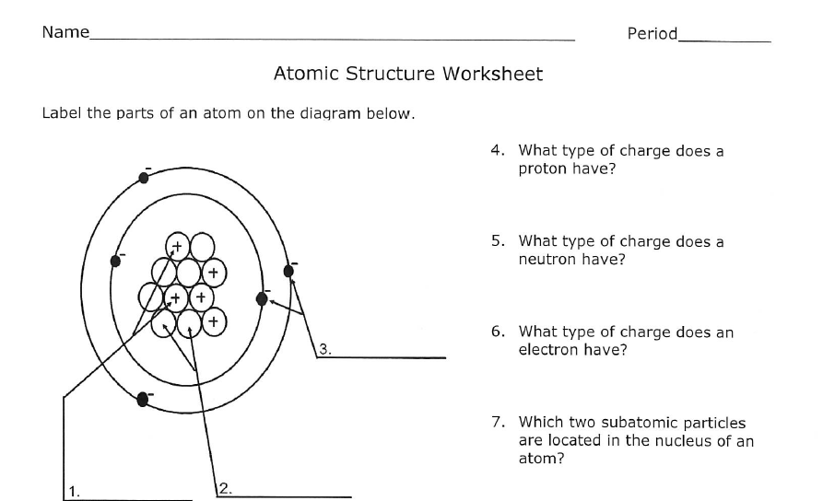
https://www.youtube.com/watch?v=ajg07Dnc1BQ

Activity 2:
Complete the following table to compare between proton, electron and neutron
 | Proton | electron | neutron
Location
Charge

The atomic number: is the number of protons in an atom
Activity 1 :
Fill in the blank
The atomic number tells you the number of ______________________ in one atom of an element. It also tells you the number of ______________________ in a neutral atom of that element.
No two different elements will have the ______________________ atomic number.

Activity 2 : look at the following figure and answer the following

- Give the symbol and number of protons in one atom of:
Helium : Nitrogen:
Neon : Oxygen:

- How many electrons are found in a Chlorine atom?
c. True or false
1. Electrons dart around the nucleus in high-speed motion (very fast).
2. atoms of an elements can have different numbers of neutron.
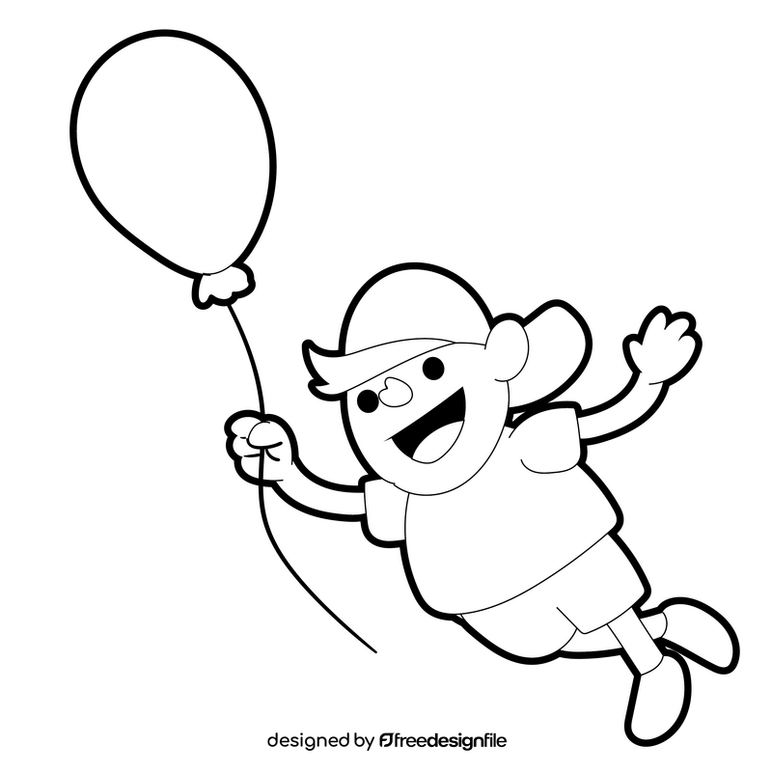
d. Explain helium-filled ballon rises through the air.

