

Worksheet (2 ) : Effect on the environment page ( 66 – 67 )
Grade & Section: 7th grade ( ) Unit: 1
Student's Name: Date:

Outcome: define main terms (resources – competition)
Identify the parts of food web

First: resources
Resources are the needs of an organisms to survive and grow in a habitat.
Activity 1: based on the first paragraph in page 66, complete these diagrams.

Second: food chain

Activity 2 : Fill in the blank
1. ………………………………………… to fight for resources.
2. ……………………………………..a way that shows how energy passes from organism to another.
3. ……………………………………several food chains that interact together.
4. When population size goes up the competition for resources between them ……………
5. When one of the resources is limited or missing, the number of an organism (its population) will ……………………………….

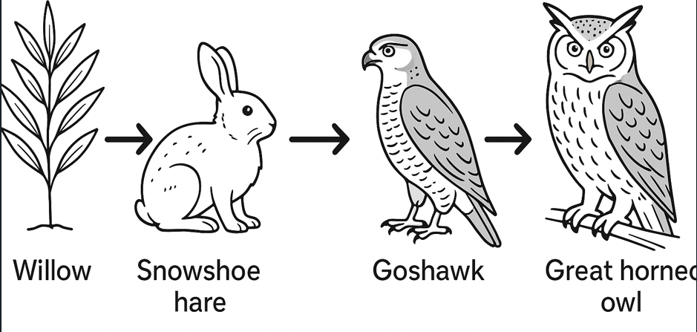
Activity 3: look at the following food chain and answer the following
Grey willow
Great horned-owl
Goshawk
Snowshoe hare

- Organism that makes their own food is ……………………….., and in this food web it is the …………………………………….
- If the number of goshawk decreases, the competition between the population of great horned owl will ………………………………

c. What is the herbivore in this food chain?

d. Name a prey and a predator in this food chain.

Third: food web
Main terms and ideas.
- Producer: organism that make their own food “such as plants”
- Consumers: living thing that eat other living things “such as animals”.
- Herbivore: consumers that eat plants.
- Carnivore: consumers that eat other animals.
- Omnivore: consumes that eat both plants and animals.
- Prey: an animal that is caught and killed by another for food.
- Predator: an animal that lives by killing and eating other animals.
- Top predator: a predator at the top of a food chain, without natural predators of its own
- Remember the organisms in an ecosystem all depend on one another for many things, not just food.
- We say they area interdependent for example, birds use trees for shelter and plants use animals waste to help them grow. (The waste contains minerals salts).
- Populations change depending on how much food is available.
- Organisms with the best adaptations to get the resources are more likely to survive and produce. The others may move away or die

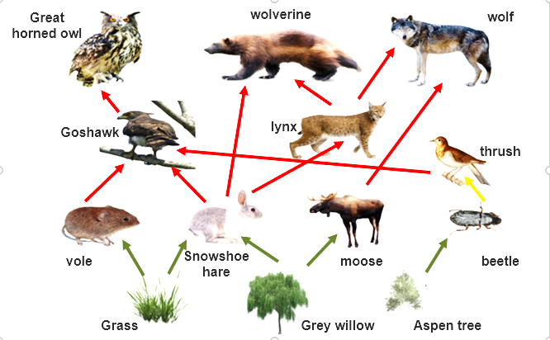
Activity 4: Study this food web and answer the following

- Name two animals that compete for grass

- Name two animals that compete for (snowshoe hare)

- Name a prey and a predator.

- Write a food chain from this food web.

- Why are goshawk and wolverine in competition with each other?

- Use this food web to predict what would happen to the vole populations if:
- The snowshoe hares all died.
- There was no rain for a long time.
- Use the food web to find a/an
- Herbivore 2. carnivore
3. Omnivore 4. Top predator

