

Worksheet Number (2)
Grade & Section: 5th ( ) Unit: 2 Student's Name: Date: / /2025 Skill/Lesson: How are traits passed along?
Educational Outcomes:
- Define the inherited traits.
- List different inherited traits in humans.
- Recognize inherited traits in fireflies.
*********************************************************************************************************************
Activity 1: Inherited traits
According to the next picture answer the questions.

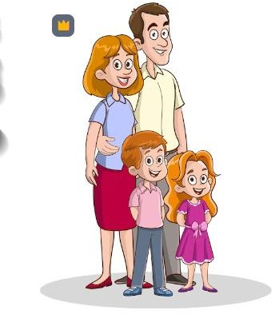
Q1) What are the common characteristics that passed from parents to their offspring?

Q2) Do hair color and skin color passed from parents to their offsprings?

Q3) Define the inherited traits?

Q4) What is the meaning of inherited diseases?

Activity 2:
Inherited traits: traits that passed from parents to their offsprings

Q1) Circle the inherited traits

Khaled can sing | Own has brown eyes
Hamzeh and his father have the same nose shape | Rashed can swim
Adnan is tall | Basheer has Curly Hair
Hashem rides bikes | Sultan has Dimples
Omar can Curl His tongue | Basel likes chocolate

Activity 3: Firefly inherited traits

Look at the next picture and answer the following

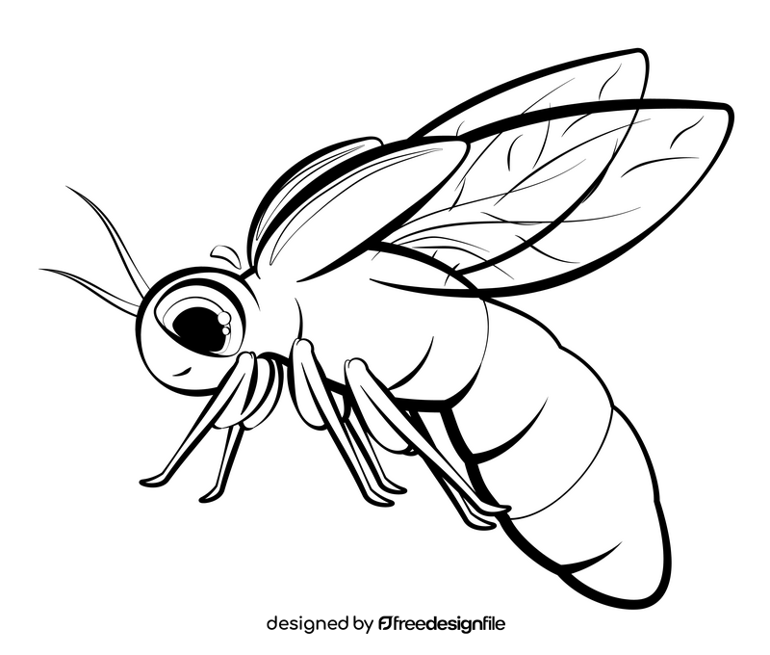
Q1. What is the name of this insect?

Q2. How many legs does it have?

Q3. Label the parts of the insect in the picture.

Q4. What special trait does this insect have?

Q5. Explain how firefly is able to give off light.

