

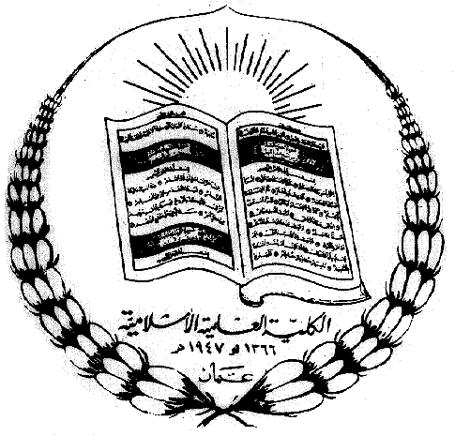

Name:
Study Sheet no. 2
Science department
2025-2026
1st semester
5th grade (A, B, C )
Date :

Page 50 – 51: First: terms with definition:

- Inherited traits: traits that pass from parents to offspring.
- Gene: The part of chromosomes that carries information that controls traits.
- Fire fly: insect that can glow in the dark.
- Inherited disease: diseases that are caused by traits that can pass from parents to offspring.

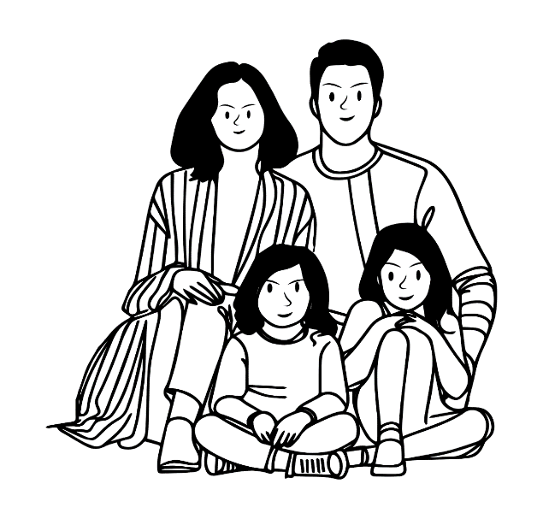
Second: examples of inherited traits: -
- Hair touch
- Hair color
- Eyes color
- Skin color
- Nose shape
- Curling tongue
- Inherited diseases
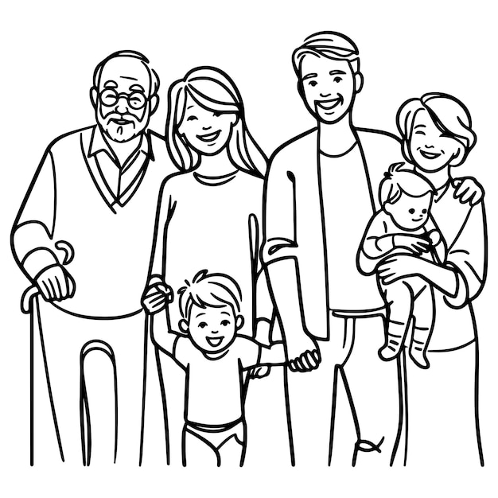
People who are closely related usually have some traits in common.
Having two parents, however, means that members of a family are not exactly the same

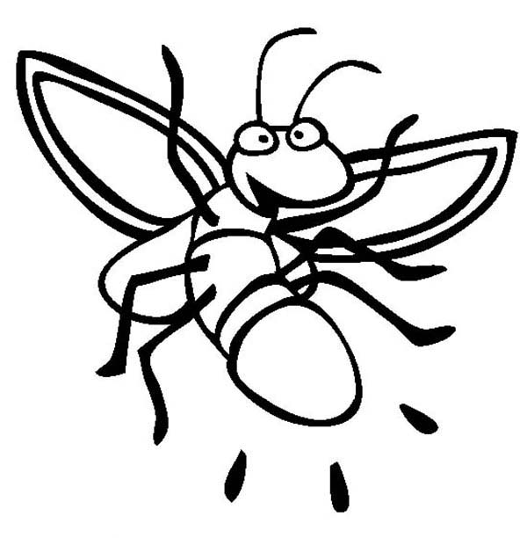
Third: Firefly
- Every kind of organism has its own traits.

Firefly traits:
1. Six legs
2. Hard outer wings
3. Two antennae
4. being able to give off light.

How firefly can give off light?
Firefly body produces a chemical that can change energy in its cells into light.

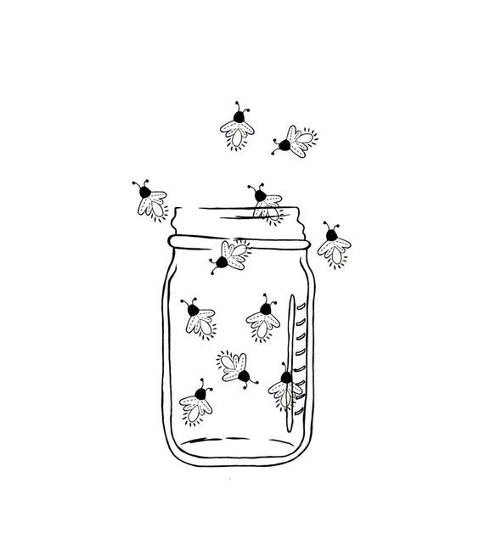
- Fireflies produce different patterns and colors of flashing light; it depends on the firefly inherited traits.

- Genes of firefly control how and when light is produced.

- Some fireflies lay eggs that glow.

