Math  Department  A,B,C, | Name:
Math  Department  A,B,C, | Grade: ( 5)
Math  Department  A,B,C, | Math study sheet | Date: / Nov/ 2025

Dear parents and students:
The final exam for Math will be on 8 /Dec/2025
The required pages are(p1,p2,p3,p10,p11,p13,p55,p57,p59)
Q1) choose the correct answer:
- Which of the following represents increasing pattern?
a) 40, 35, 30, 25 b) 5, 15, 25, 35 c) 90, 70, 50, 30 d) 100, 90, 80, 70
- Which of the following represents decreasing pattern?
a) 12, 24, 36, 48 b) 60, 70, 80, 90 c) 100, 130, 160, 190 d) 8, 6, 4, 2
- What is the next number in the pattern: 120, 140, 160, 180, …?
a) 190 b) 200 c) 175 d) 300
- Find the next number in a pattern 400, 420, 440, 460, …
a) 480 b) 500 c) 450 d) 420
- In the pattern 9, 12, 15, 18… what is the pattern rule?
a) Add 2 b) Add 3 c) Multiply by 2 d) Subtract 3

- In the pattern 2, 7, 12, 17… what is the pattern rule?
a) Add 5 b) Multiply by5 c) subtract5 d) +10
7. What is the standard form of “four hundred sixty-two thousand eight hundred fifteen”?
a) 462,815 b) 462,581 c) 426,851 d) 462,158
8. What is the standard form of “six hundred five thousand eight hundred twelve”?
a) 605,812 b) 650,812 c) 605,821 d) 608,512
9. What is the missing number in the pattern ( 80, 160, 240, ______, 400 )?
a) 260 b) 300 c) 320 d) 280
10. What is the missing number in the pattern (60, 120, 180, ___, 300) ?
a) 240 b) 210 c) 200 d) 180
11. Rounding ( 389,742 ) to the nearest ten thousand gives:
a) 399,000 b) 390,000 c) 389,700 d) 380,000
12. Rounding ( 246,895) to the nearest ten thousand gives:
a) 247,000 b) 246,000 c) 240,000 d) 250,000
13. One of these fractions is equivalent to $\frac{3}{4}$ :
a) $\frac{6}{8}$ b) $\frac{4}{6}$ c) $\frac{3}{6}$ d) $\frac{1}{12}$
14. One of these fractions is equivalent to: : $\frac{2}{5}$
a) : $\frac{4}{10}$ b) : $\frac{3}{5}$ c) : $\frac{2}{6}$ d) : $\frac{5}{8}$
$\frac{5}{9}$
15. Compare: $\frac{7}{9}$ ____
a) > b) < c) = d) ≥
$\frac{5}{9}$

16. Compare: $\frac{5}{6}$ ____ $\frac{8}{12}$
a) > b) < c) = d) ≤

17. Write the missing number to get equivalent fractions:
$\frac{5}{}$ = $\frac{15}{9}$
a) 2 b) 3 c) 5 d) 6

18. Write the missing number to get equivalent fractions:
$\frac{2}{16}$ = $\frac{1}{}$
a) 2 b) 3 c) 5 d) 8

Q2: Round each number to the nearest hundred thousand
- 648,920: __________________
- 205,389: __________________
- 981,200: __________________
Q3: Write each number in standard form
- 300,000 + 40,000 + 2,000 + 500 + 30 = ____________________
- 500,000 + 6,000 + 700 + 20 = ____________________
- 700,000 + 80,000 + 900 + 4 = ____________________
Q4) Write an equivalent fraction to describe the shaded parts
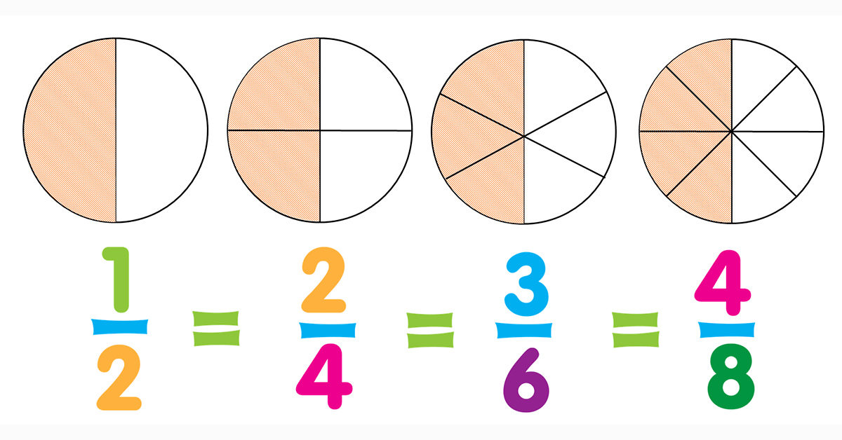
- 2.
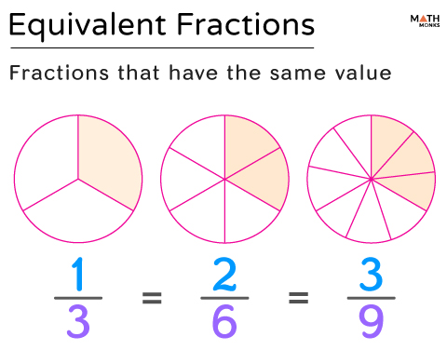
Q5) Compare each pair of fractions using < or >
- $\frac{3}{7}$ ____ $\frac{1}{7}$ 2. $\frac{9}{10}$ ____ $\frac{4}{5}$ 3. $\frac{3}{3}$ ____ $\frac{1}{2}$
____________________________________________
Comparing Fractions – Summary
- Same Denominator
If two fractions have the same denominator, the fraction with the larger numerator is greater.
- Example: $\frac{5}{8}$ > $\frac{1}{8}$ is greater.
- Same Numerator:
If two fractions have the same numerator, the fraction with the smaller denominator is greater.
- Example: $\frac{3}{4}$ > $\frac{3}{8}$ → 3/4 is greater.
- Different Numerator and Denominator
Find a common denominator
Example: : $\frac{2}{3}$ > $\frac{3}{5}$ → : $\frac{2 x5}{3x5}$ = $\frac{10}{15}$ , $\frac{3 x3}{5x3}$ = $\frac{9}{15}$ 2/3 is greater.

