

Class worksheet Number ( 3)/ 5th grade/ page 32+33
Student's Name: _________________________ Date: / /2025
Educational Outcome:1: identify the respiration, its kinds and compare between them .
Task1: Label the parts of the flowering plant
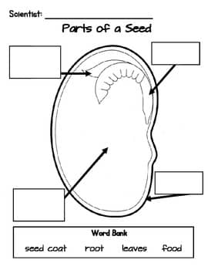

Developing plant
Seed leaves

Seed coat

Store food

Food Store
Developing plant

Task2: complete the following charts

Task3: Classify the following seeds into monocot and dicots seeds?
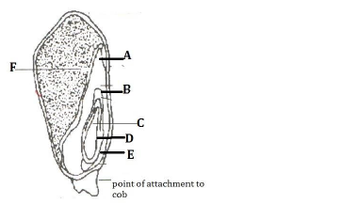
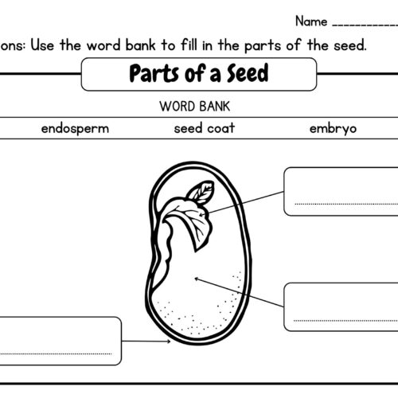

Dicots seed
Monocot seed

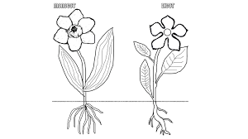
Use the following figure to compare between monocot plant and dicots plant, use the following table :
monocot
dicots
 | Monocot | Dicots
Seed leaves | one | two
Flower parts | 3 or multiples 3 | 4 or 5 or their multiples
Leaves | Parallel vein | Branched or net vein
roots | Fibrous and thin | Tap root

GOOD LUCK

