

Class worksheet Number ( 2 )/ 5th grade/ Unit 1: Life Science
Chapter1: Comparing living things Lesson 3: How are plants classified? (page32-33)
Student's Name: _________________________ Date: / /2025
Educational Outcome:1: classify plants, and compare between two kinds, compare between two kinds of the flowering plants.
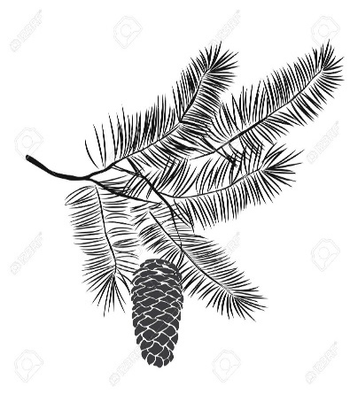
Task1: Complete the following chart:
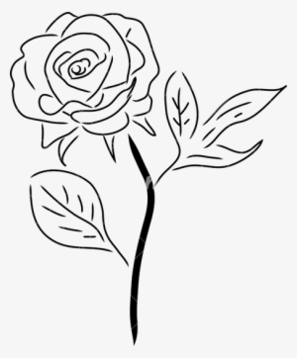

 | Some flowering plants:  Live long time | Some flowering plants:  Live for short time
Time to grow | Grow for many years | Grow only season
The size of a plant | Can be huge tree | Can be small plants
The stem | Have large rigid, woody stems | Have green, flexible stem
examples | Like : elms, oak | Grass, duckweeds
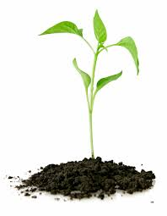
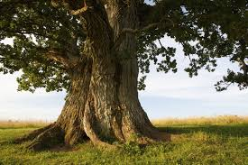

Task2: Complete the following table:

Worksheet Number ( )/ 5th grade/
Unit 1: Life Science Chapter1: Comparing living things Lesson 3: How are plants classified? (page32-33)
Student's Name: _________________________ Date: / /2025
Educational Outcome: classify plants and compare between two kinds, compare between two kinds of the flowering plants.
Task4: Classify the following seeds into monocot and dicots seeds?
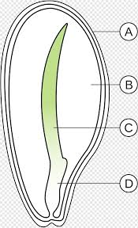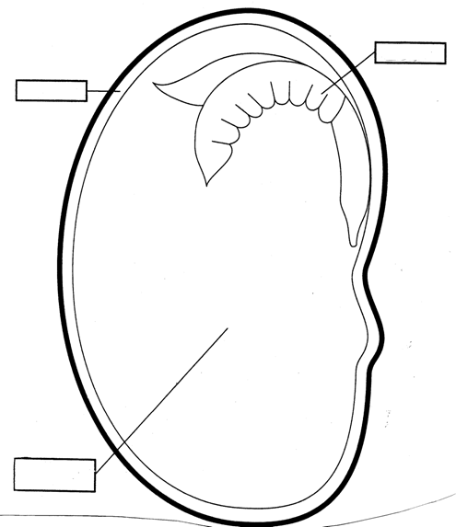
dicots
monocot
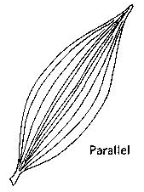
Task5: Classify the following figures into monocot and dicots
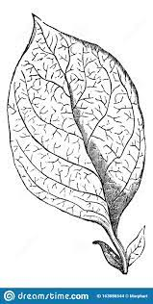

monocot
dicots
dicots
monocot

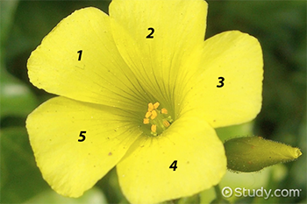
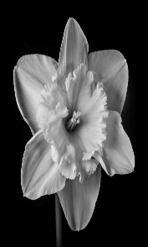
dicots
monocot

GOOD LUCK

