Grade 4 – Final Speaking Assessment
Dear Parents,
We hope this message finds you well. We would like to inform you that your child’s final speaking assessment will take place during the first session next week (30 November – 4 December).
For this assessment, each student will prepare a one-minute presentation on the topic: Disadvantages of Junk Food.
Please note that we have already discussed this topic in the classroom, so students have prior knowledge to help them prepare.
* Reminder: Use these helpful vocabulary words that we discussed in class in your assessment/presentation:
Word | Part of Speech | Definition | Example Sentence | Picture
mood swings | noun | Quick changes in how a person feels, like going from happy to sad. | She had mood swings and felt happy one minute and sad the next. | 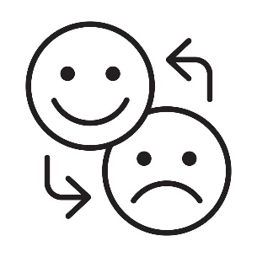
Depression | noun | A strong feeling of sadness that lasts a long time. | He didn’t want to play or eat because of his depression. | 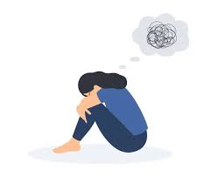
forgetfulness | noun | When a person often forgets things. | Her forgetfulness made her leave her homework at home. | 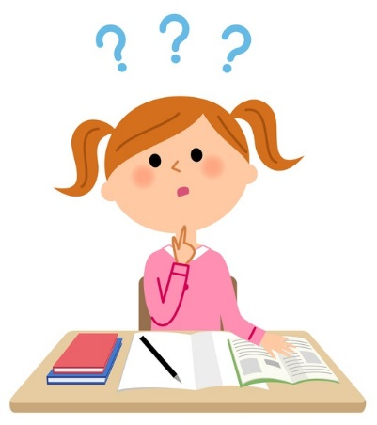
Addictive | adjective | Causing someone to want something again and again. | Video games can be addictive if you play them too much. | 
Diabetes | noun | A disease where the body has trouble controlling sugar in the blood. | Eating a lot of sugary junk food can increase the risk of diabetes. | 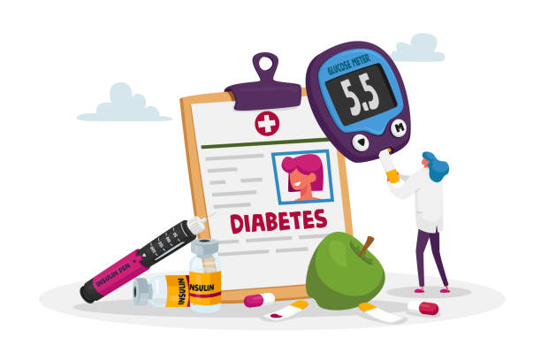
Fatigue | noun | Extreme tiredness or lack of energy. | After the long walk, he felt full of fatigue. | 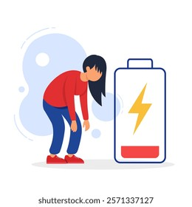
Obesity | noun | A condition where a person has too much body fat. | Eating too much junk food can lead to obesity. | 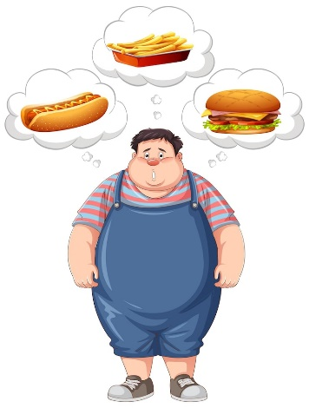

*Note: Students will be asked critical thinking questions after their presentation. To use their own words and share their personal thoughts and opinions naturally, not memorized answers.

❓ Sample Questions for Students
- Why do you think eating too much junk food can affect our brain and body?
- If your friends eat junk food every day, what could happen to their health and learning?
- What are some healthy snacks you can choose instead of candy or chips, and why are they better for your brain?
- How can you help your classmates and friends understand the harms of eating junk food?
- What can parents do to help children eat less junk food, and why is this important for health and the brain?

Thank you for your support in encouraging your child to think independently and speak with confidence.
Teacher : Eman AL- Younis

