

Grade & Section: ____ ( ) Worksheet Reading 2 Unit: 1

🧠 Word Bank
- Accurate (adj.) – correct and free from mistakes; exact.
- Blood (n.) – the red liquid that circulates in the body, carrying oxygen and nutrients.
- Captivating (adj.) – attracting and holding someone’s attention; charming or fascinating.
- Compelling (adj.) – very interesting or persuasive; difficult to resist.
- Condone (v.) – to accept or allow behavior that is morally wrong or offensive.
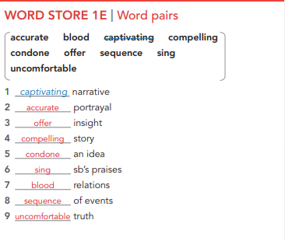
- Offer (v.) – to present or give something to someone.
- Sequence (n.) – an ordered series of events or actions.
- Sing (v.) – to produce musical sounds with the voice.
- Uncomfortable (adj.) – not feeling relaxed or at ease; uneasy or physically uneasy

✏️ Fill in the Blanks Task :
Fill in each blank with the correct word from the word bank.
- The documentary was so _________________ that I couldn’t stop watching it.
- Please make sure your answers are ___________________ before submitting the exam.
- The teacher did not ____________________ cheating during the test.
- The nurse drew a sample of ___________________ for testing.
- The girl’s _________________ voice made everyone stop and listen.
- He decided to ____________________ his help to anyone who needed it.
- I felt __________ during the speech because I wasn’t prepared to talk.
- The magician’s performance was ___________________; the audience was amazed.
- The movie followed a clear ___________________ of events from beginning to end.
- Can you ___________________ the national anthem for the school ceremony?

Answers
- captivating
- accurate
- condone
- blood
- compelling
- offer
- uncomfortable
- captivating (or “compelling” if you want variety)
- sequence
- sing

