
- Read the paragraph below. Pay attention to the underlined Academic Words.:
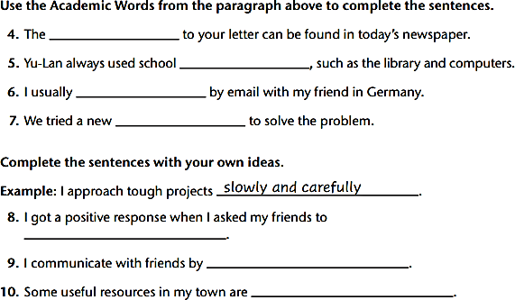
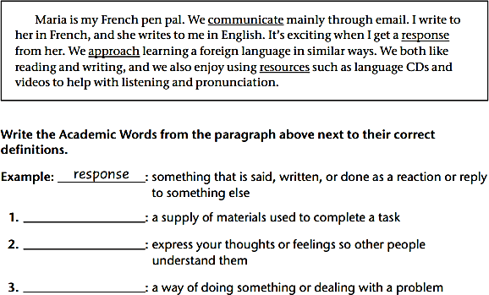










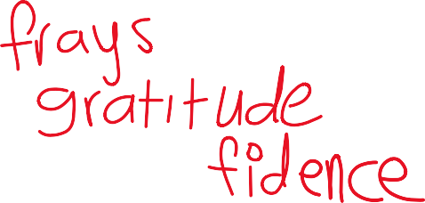
B. Fill in the gaps with the most suitable answer:
approached / response / exhausted / confidence / gratitude / frays
- Cheap fabric soon
- Sarah expressed her
- Ali had gained his teacher’s
with time.
to the committee for their support. because of his attitude.


  - She returned home from work.
  - We received 400 applications in to the job ad.
  - The train the main line.

- Choose the best answer:
- The talented artist created an (admirable/admiration) painting that left everyone in awe.

- Authors often find (inspiration /inspirational /inspired) from their surroundings and experiences.

- The students displayed great (confidence/ confident /confidently) when presenting their projects.

- The chef's (creative/ creation / creatively) in the kitchen led to a unique and delicious dish.

- After a long day of work, her (fatigue/ fatigued/ fatiguing) was evident in her tired eyes.
- The historical artifacts are the last (remnants/ remnant) of an ancient civilization.
- The (neglect/ neglecting/ neglected) garden was overgrown with weeds and untamed plants.



  - Change these two paragraphs into a different point of view:



    - In the evening, David sat by the campfire, gazing at the stars. It was a peaceful moment, and he couldn't
help but feel a sense of wonder at the hugeness of the universe. ( change to first person)

2. My friends and I went to the amusement park. I was thrilled to ride the roller coaster, and as we climbed higher and higher, my heart raced with excitement. ( change to the third person)

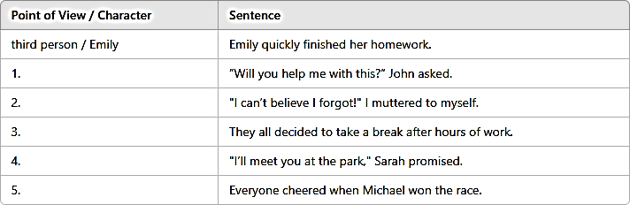

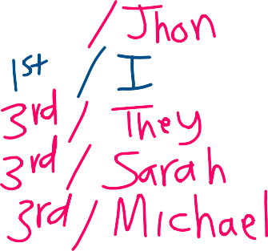
  - Label each sentence with the point of view that is used. Write the name of the character.:
7


 After reading the text in p.84-87 , answer these reading comprehension questions:

Answer Key
1. first person
2. "Like a hen guarding her chicks, she never neglected us because of her fatigue."
3. Yu-Lan (the narrator/daughter) and her mother Tai-Chih.

4. She feared not understanding what people were saying and being laughed at. Her class was overcrowded.
5. Physical: Moon-shaped eyes, big black eyes, long black hair, shortest mother, welcoming smile. Personality: Caring, determined, confident, encouraging, sacrificing, hardworking, devoted.
6. Very close and supportive. The mother cared about her daughter's feelings and they worked as a team.
7. Yes. She worked exhausting night shifts but woke early to cook breakfast. She sacrificed resting time to help Yu-Lan learn English despite not knowing it herself.

8. Yes. Yu-Lan learned English and could communicate. Tai-Chih learned English, passed the postal exam, and enrolled in college.

Critical Thinking: The family responds with resilience, unity, and determination. They work together as a team, view challenges as growth opportunities, and support each other through hard work and strong family values.


A.
- is not written
- are being designed
- are being cleaned
- is not created
- Has she been informed
- is taught
- Is the building being renovated
- is being debated
- Are the documents signed
- has been being tested
- is not grown
- has been being protected

- Change these sentences from active to passive voice:
  - Somebody is cleaning the house now.








  - This factory employs 2000 people in Egypt.





  - She has created a new device.





















  - They don’t teach Chinese in our school.
5. They are offering us new jobs.
6. Jordan imports oil from Iraq.
7. The team has designed advanced AI applications.

