



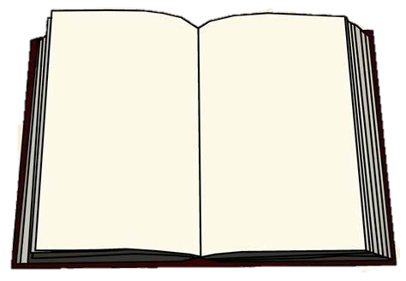
English Language
1st Semester 2025/2026

8th Grade
Unit (2) Five New Words Handout

Name:

Section:

1. Unit’s Content:
Topic : | Students’ Book Pages:
1. The Big Question | 80
2. Vocabulary (Literary words, academic words, word study) | 81-83
3. Reading Five New Words | 84-87
4. Grammar:
C. Passive Voice | 108-109
5. Writing: Write a short story with a starter | 78-79

1. The Big Question:
What are the benefits of facing challenges?
Writing Task (1)
Moving to a new city, state, or country can be overwhelming. You have to say good-bye to your friends, you might have to go to a new school, and you might live among people who speak a different language or have different beliefs or customs from your own. Have you ever moved to a new place? Where did you move? What challenges did your family face there? How was the move beneficial for your family? If not, what is the biggest challenge you faced in your life? Explain how facing this challenge helped you. _________________________________________________________________________________________________________________________________________________________________________________________________________________________________________________________________________________________________________________________________________________________________________________________________________________________________________________________________________________________________________________________________________________________________________________________________________________________________________________________________________________________________________________________________________________________
________________________________________________________________________
2. Vocabulary:
NO. | Word | Meaning | Example
 | dreaded ( adj) | worried about or afraid of | …
 | gratitude ( n.) | Thankfulness and appreciation | He expressed his gratitude for the thoughtful gift he received.
 | exhausted (adj ) | tired | After a long day at work, she felt completely exhausted.
 | confidence ( n. ) | believing in oneself | His confidence in his abilities allowed him to tackle challenges with ease.
 | admirable (adj ) | worthy of respect; notable; likable | Her admirable dedication to her studies earned her the respect of her peers.
 | Fraying | becoming loose; falling into pieces | The old book showed signs of wear and tear, with its pages starting to fray.
 | neglected (v.) | failed to take care of something or someone. | The abandoned building in the neighborhood was neglected for years.
 | aura (n.) | quality or feeling | There was an aura of excitement in the air as the concert began.
 | remnants (n.) | parts of something that remain after the rest of it is gone | Only remnants of the once-grand castle remained on the hill.
10 | fatigue (n.) | tiredness | After a long hike, the fatigue in his legs was evident.
11 | Response (n.) | Something that is said, done, or written as a reaction to something or reply. | The student’s response to the exam was unexpected!
12 | Approach (n./ v.) | A way of doing something or dealing with a problem. | My dad has a unique approach to deal with careless drivers.
13 | Resources (n. ) | A supply of materials used to complete a task. | The teacher uses many resources to explain grammar.


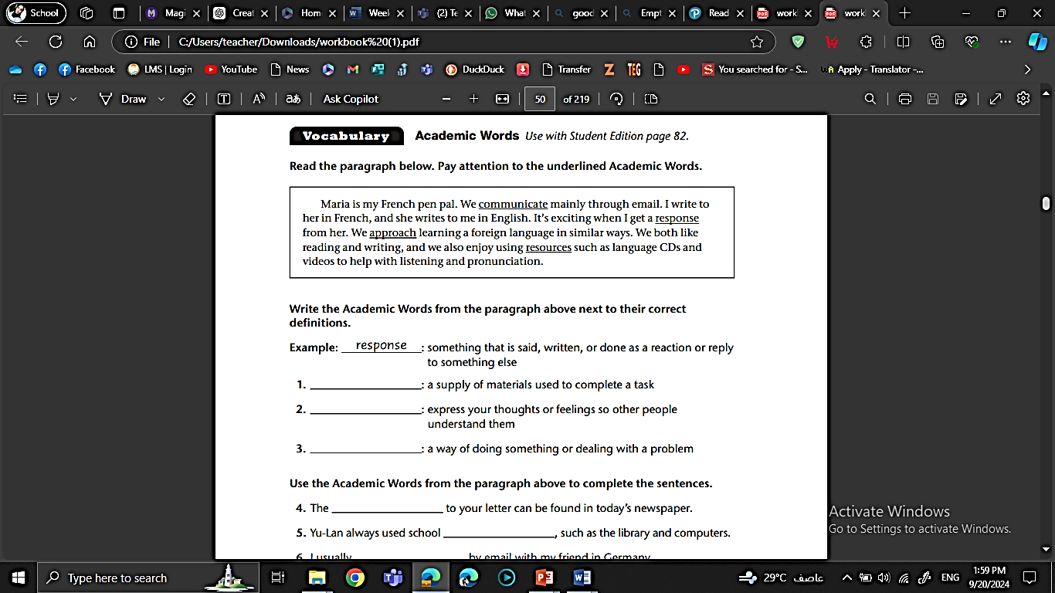
A. Read the paragraph below. Pay attention to the underlined Academic Words.:

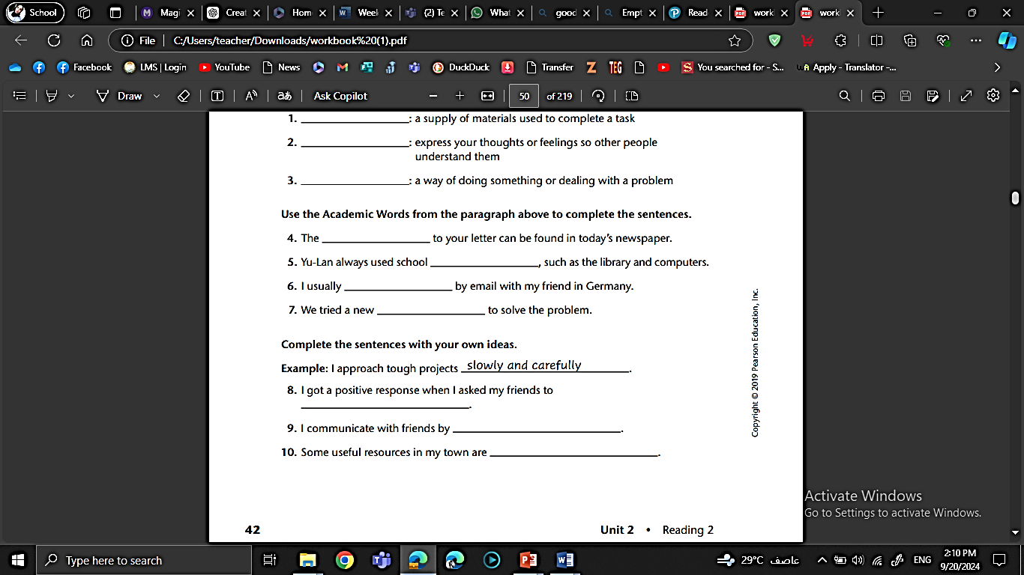

approached / response / exhausted / respect / gratitude / frays

B. Fill in the gaps with the most suitable answer:
approached / response / exhausted / confidence / gratitude / frays
- Cheap fabric soon _________________with time.
- Sarah expressed her _______________________to the committee for their support.
- Ali had gained his teacher’s ______________________ because of his attitude.
- She returned home, _______________________from work.
- We received 400 applications in ______________________ to the job ad.
- The train _____________________the main line.
C. Choose the best answer:
- The talented artist created an (admirable/ adorable /admiration) painting that left everyone in awe.
- Authors often find (inspiration /inspirational /inspired) from their surroundings and experiences.
- The students displayed great (confidence/ confident /confidently) when presenting their projects.
- The chef's (creative/ creativity/ creatively) in the kitchen led to a unique and delicious dish.
- After a long day of work, her (fatigue/ fatigued/ fatiguing) was evident in her tired eyes.
- The historical artifacts are the last (remnants/ remnant/ remnant) of an ancient civilization.
- The (neglect/ neglecting/ neglected) garden was overgrown with weeds and untamed plants.
Writing Task (2)
Write a descriptive paragraph talking about someone you admire. list the reasons why you feel inspired by his/her actions. Use words from the text.
_____________________________________________________________________________________________________________________________________________________________________________________________________________________________________________________________________________________________________________________________________________________________________________________________________________________________________________________________________________________________________________________________________________________________________________________________________________________________________________________________________________________________________________________________________________________________________________________________________________________________________________________________________________________________________________________________________________________________________________________

3. Literary Words:

A. Point of view
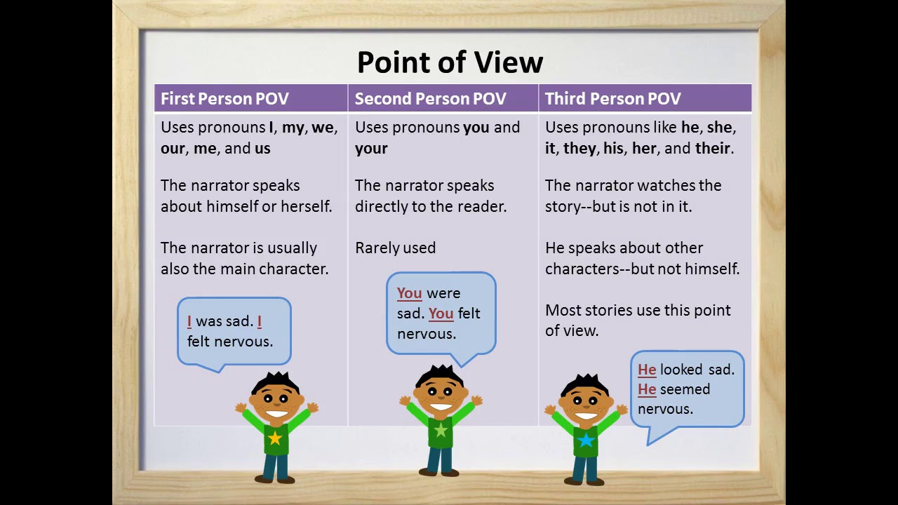
A. Change these two paragraphs into a different point of view:

1. In the evening, David sat by the campfire, gazing at the stars. It was a peaceful moment, and he couldn't help but feel a sense of wonder at the vastness of the universe.
____________________________________________________________________________________
____________________________________________________________________________________
____________________________________________________________________________________
2. My friends and I went to the amusement park. I was thrilled to ride the roller coaster, and as we climbed higher and higher, my heart raced with excitement.
____________________________________________________________________________________
____________________________________________________________________________________
____________________________________________________________________________________

B. Label each sentence with the point of view that is used. Write the name of the
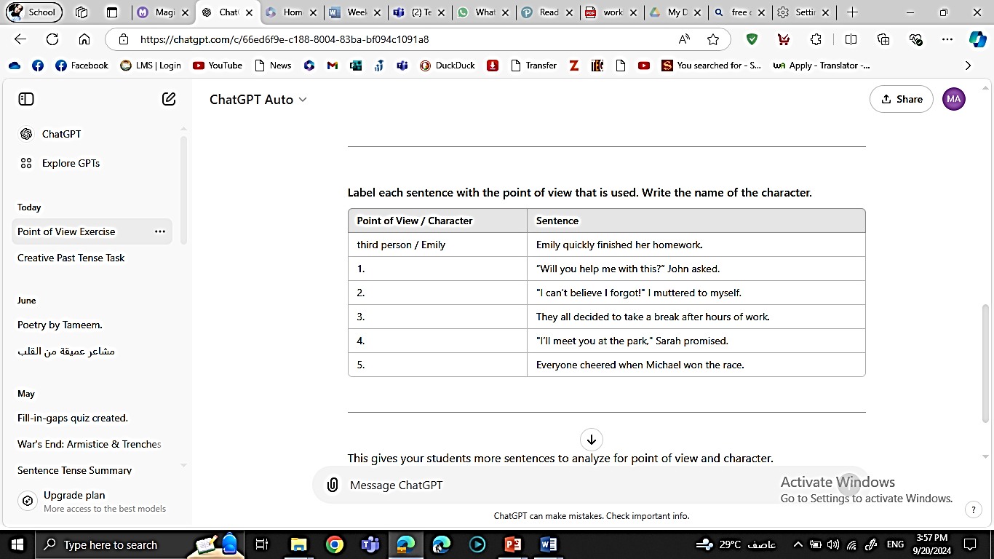
character.:


Writing Task (3)
Scan the code and watch the modified version of Red Riding Hood story. Choose the point of view you want to write with, then Write a scene from the story.

Point of View: ____________________
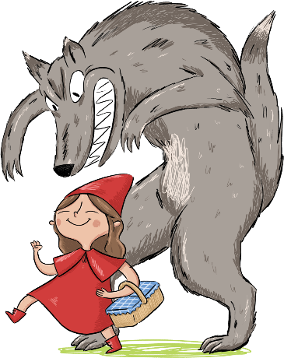
____________________________________________________________________________________________________________________________________________________________________________________________________________________________________________________________________________________________________________________________________________________________________________________________________________________________________________________________________________________________________________________________________________________________________________________________________________________________________________________________________________________________________________________________________________________________________________________________________________ ___________________________________________________________ ___________________________________________________________
__________________________________________________________

4. Reading Comprehension:

After reading the text in p.84-87, answer these reading comprehension questions:

1. The story is told in: ………………………… point of view.
2. Find an example of a simile mentioned in the text
………………………………………………………………………………………………………………………………………………

2. Who are the characters?
………………………………………………………………………………………………………………………………………………………………
3. Why was she scared of going to school?
………………………………………………………………………………………………………………………………………………………………
4. Describe her mother’s physical features and personality?
……………………………………………………………………………………………………………………………………..……………………… .………………………………………………………………………………………………………………………………………………..…………
6. How was their relationship?
……………………………………………………..……………………………………………………………..……………………………………………
7. Was she a devoted mom? Explain.
……………………………………………….…………………………………………………………………………………………………………………… ……………………….…………………………………………………………………………………………………………………………………………
8. Did they achieve their goals? Explain.

……………………………………………….…………………………………………………………………………………………………………………… ……………………….…………………………………………………………………………………………………………………………………………
Critical thinking
How do you think the family responds to the challenges they have faced while moving to the place? ………………………………………………………………………………………………………………………………………………
………………………………………………………………………………………………………………………………………………………………..……
………………………………………………………………………………………………………………………………………..…………………………

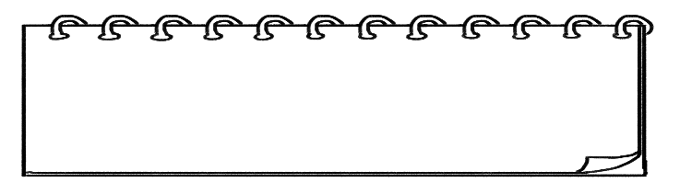
4. Grammar:
A. Passive Voice

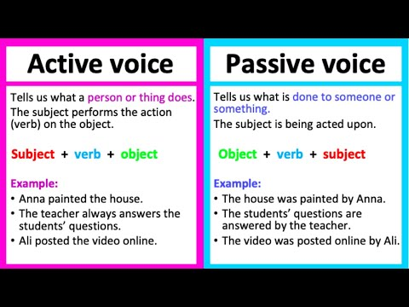

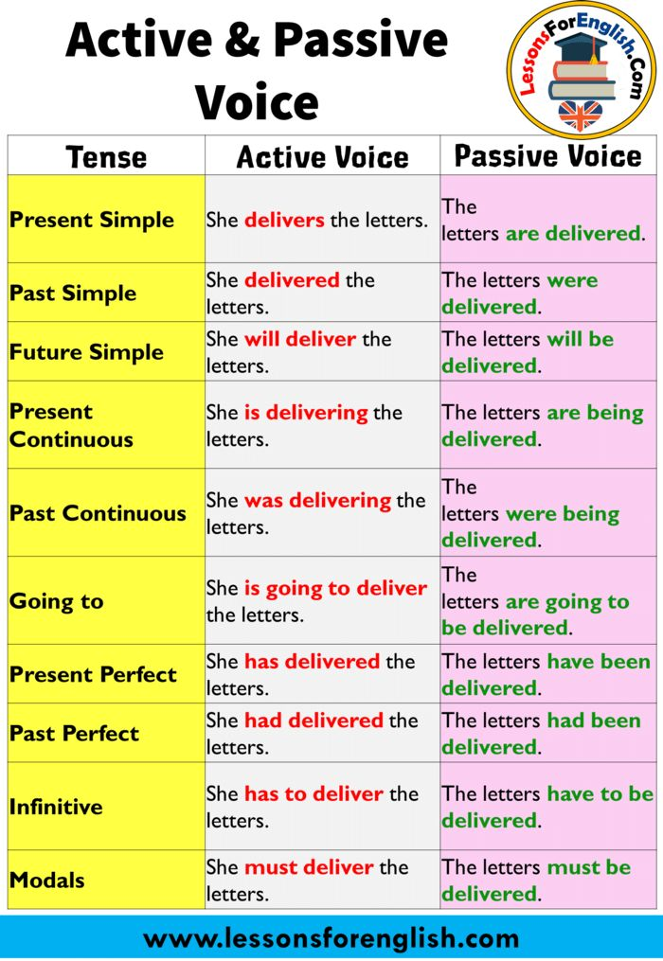

II) Form:
1. Present simple:
‎S . + be (is/am/are) + past participle ‎
She teaches Sami well.

Sami is taught well.
‎ 2. Present Continuous:
‎S. + be (am/is/are) + being+ past participle ‎

She is teaching Sami now.

Sami is being taught now.

‎ 1. Present Perfect
‎S . + has/have +been + past participle ‎
She has taught Sami already.

Sami has been taught well.
A. Complete the sentences with the correct form of the verbs in brackets. Use the passive voice.
- The latest bestselling novel ___________________ (not/write) by the famous author.
- Creative software solutions ___________________ (design) by our team as we speak.
- The ancient artifacts __________________ (clean) by the museum's restoration experts now.
- Surprisingly, the new eco-friendly skyscraper __________________ (not/create) by the award-winning architect.
- _____________(have) she _________(inform) about the news yet?
- English literature __________ (teach) by Professor Johnson every semester.
- ____________(be) the building ______________________(renovate) at the moment?
- The controversial law _________________ (debate) in parliament at this very moment.
- ______________(be) the documents______________ (sign) by the manager every day?
- The new vaccine _____________________ (test) in clinical trials since last year.
- Surprisingly, coffee _________________________ (not/grow) in every tropical country.
- The company's sensitive data ________________ (protect) by state-of-the-art encryption software since July.
B. Change these sentences from active to passive voice:
1. Somebody is cleaning the house now.
‎____________________________________________________________________________________‎
2. This factory employs 2000 people in Egypt.
‎____________________________________________________________________________________‎
3. She has created a new device.
‎____________________________________________________________________________________‎
4.‎ They don’t teach Chinese in our school.‎
‎____________________________________________________________________________________‎
‎ 5.‎ They are offering us new jobs.
‎____________________________________________________________________________________‎
‎6.‎ Jordan imports oil from Iraq. ‎
‎____________________________________________________________________________________‎
7. The team has designed advanced AI applications.
‎____________________________________________________________________________________‎
Writing Task (4)
Write a short paragraph about a lost treasure that was found by a group of friends. Use passive voice to describe what happened, such as “The treasure was discovered” and “Maps were given to the friends. _____________________________________________________________
_________________________________________________________________________________________________________________________________________________________________________________________________________________________________________________________________________________________________________________________________________________________________________________________________________________________________________________________________________________________________________________________________________________________________________________________________________________________________________________________________________________
______________________________________________________________________

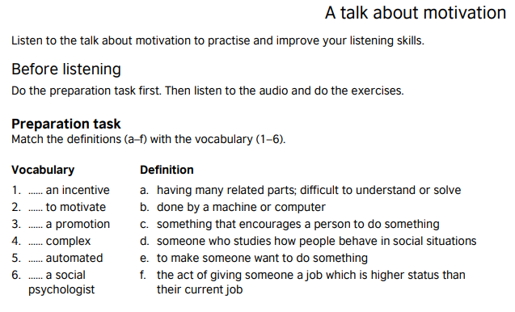

6. Listening:






Scan the QR code to listen to the audio.
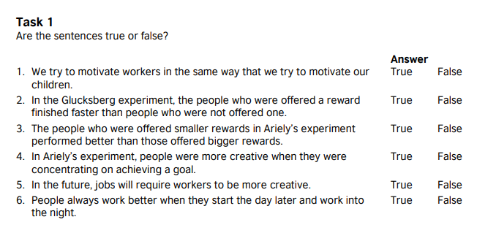

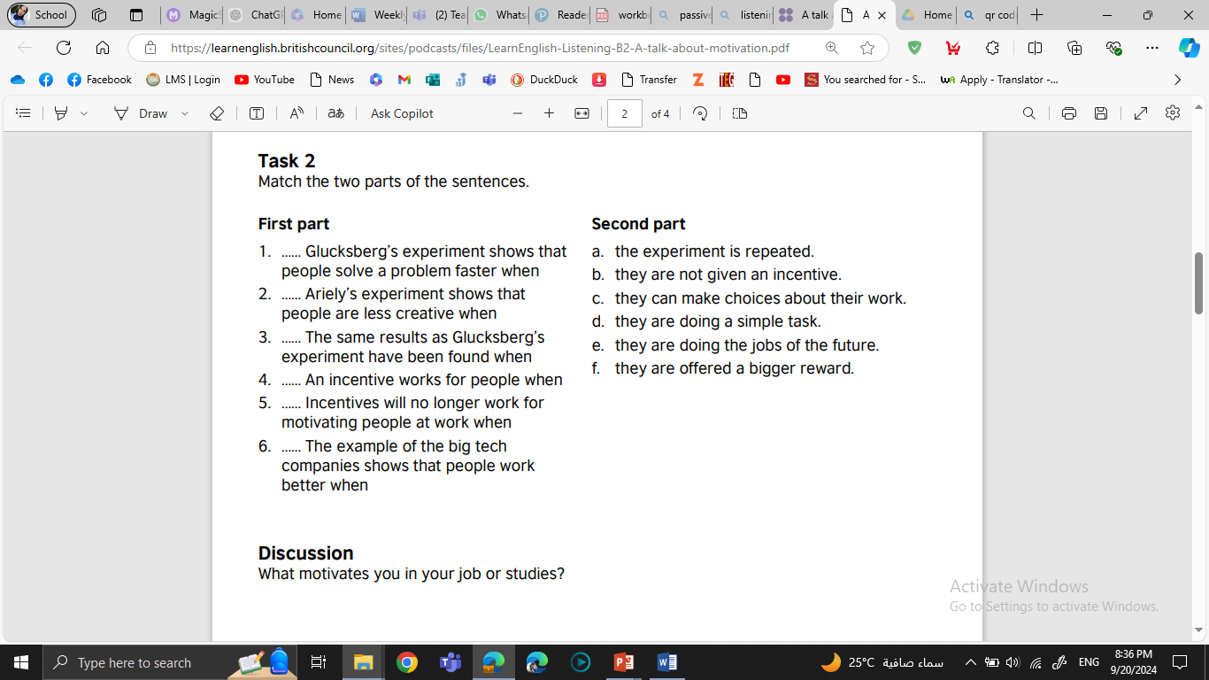


Discussion:
What motivates you in your studies? What is your biggest incentive? Discuss your answer with a partner.



7. Writing:
Write a short story with a starter:
Story Development Guide:

1. Characters:

Who is in your story? Describe your main character and secondary characters.
Ex: Emily is a hard-working young student who always gets her homework done quickly. She likes to stay organized.

2. Setting:

Where and when does your story take place? Describe the environment.
Ex: It was a warm Sunday morning. The classroom is bright and tidy, with rows of desks and big windows that let in lots of sunlight. It’s a quiet place where students focus on their work.

3. Plot:
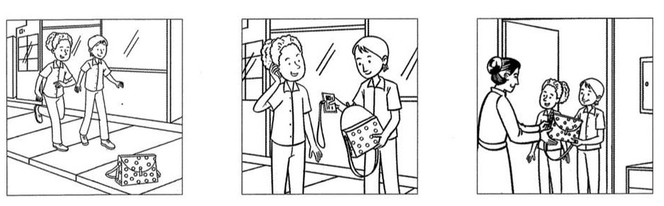
What happens in your story? Remember to include:

A beginning  (introduce the situation) | A middle  (develop the conflict or problem) | An ending  (resolve the conflict)

4. Dialogue:

Include some conversation between characters to bring your story to life.
Ex: Character 1: "We’re lost. What do we do now?"
Character 2: "Don’t worry, I know the way—follow me!"

5. Descriptive language:
Use vivid adjectives and strong verbs to make your story more engaging.
Ex: The teacher smiled warmly and spoke softly, explaining the problem with clear, patient words. John’s face lit up with excitement, and he grinned widely when he finally understood the tricky solution.


Instructions: Choose one of the story starters below and use it to write a short story. Your story should be about 300 words. Remember to include characters, setting, plot, and dialogue in your story.
Story Starters (Choose one):
- The old, dusty book glowed when I opened it………
- As soon as I stepped through the mirror, I realized everything had changed………..…
- The text message said, "Don't come home. It's not safe."…………….
- When I woke up, I could suddenly understand what animals were saying……………..
- The door to the abandoned house creaked open by itself……………….
- The eyes in the painting follow him down the corridor. ……………….
- It was the day the moon fell……….
- “ I finally did it! I can’t believe my eyes!” Dan said as he went to receive the medal…..

Story Outline:
setting:

ending:

Title:

-------------------

characters:

plot:



First Draft
____________________________ ________________________________________________________________________________________________________________________________________________________________________________________________________________________________________________________________________________________________________________________________________________________________________________________________________________________________________________________________________________________________________________________________________________________________________________________________________________________________________________________________________________________________________________________________________________________________________________________________________________________________________________________________________________________________________________________________________________________________________________________________________________________________________________________________________________________________________________________________________________________________________________________________________________________________________________________________________________________________________________________________________________________________________________________________________________________________________________________________________________________________________________________________________________________________________________________________________________________________________________________________________________________________________________________________________________________________________________________________________________________________________________________________________________________________________________________________________________________________________________________________________________________________________________________________________________________________________________________________________________________________________________________________________________________________________________________________
Ideas and sequence /2 | Punctuation marks /1 | Spelling /2 | Outline & paragraphing /2 | Word choice /1 | Grammar /2 | Total  10
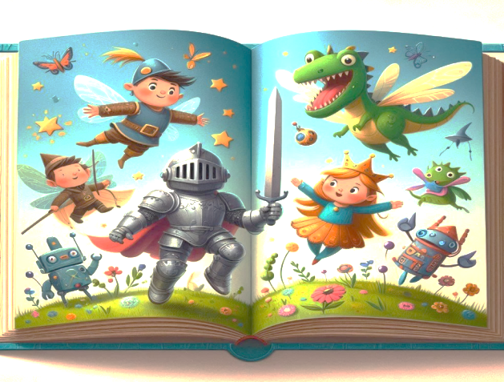


After you finish your first draft, check for mistakes using the following checklist

- Adding a topic sentence to the introduction
- Writing the title
- Including details about the event in all paragraphs.
- Answering all 5 WH questions.
- Using lots of adjectives or phrases that draw pictures in readers’ minds
- Using sequence words
- Clear handwriting
- Accurate spelling
- Using correct tense
- Using correct punctuation marks and avoiding capitalization mistakes.



