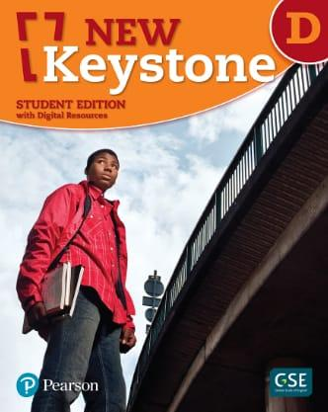

Vocabulary and Derivation – Student’s Book pages (51+52)
Word | Part of Speech | Definition | Example
Device | Noun | a piece of technology , or an item, with a specific function | We need a measuring device for our project.
Equipment | Noun | the things that you need for a particular activity | Scientists use special equipment in their labs to test new ideas.
Industry | Noun | a collection of stores or places of business focusing on the same product or services | The AI industry is always changing with new inventions.
Investors | Noun | people who spend money to support a business or a business idea in order to later make money when the business succeed | Investors gave money to help build the investor’s new robot.
Patent | Noun | a document which claims that within a certain time frame, a particular company is only one allowed to sell a newly invented product | She got a patent to protect her invention so no one else could copy it.
Tenacity | Noun | Resilient, determined | His tenacity heled him keep working, even when his invention failed at first.
Contribution | Noun | something a person gives to the world that helps and is positive | Her contribution to science made life better for millions of people.
Reject | Verb | Not to choose | Many companies rejected his brand-new idea, but he didn’t give up.
Injury | Noun | some damage caused to a body | After an injury, she invented a tool to help people walk more easily.
Significant | Adjective | Important; meaningful | The telephone was a significant invention that change how we communicate.
1-Read each sentence and choose the correct word from the table to complete it.
- She showed great ________tenacity_______________by never giving up on her invention.
- The new ___________device____________helps people hear better.
- His idea was _________rejected______________by three companies.
- After an ________injury_______________he built a safer bike helmet.
- The phone was a ___significant____________________invention in history.
- She got a _____________patent__________to protect her new idea.
- His _________contribution______________helped solve the clean water problem.
- Modern _______equipment________________makes building things easier.
- He met with _____investors__________________to get money for his project.
- The car____________industry___________ builds millions of vehicles every year.
2-Choose the correct form of the word to complete each sentence.
1. The engineer designed a new _______________________ to help measure wave strength.
A) device B) devices C) devise D) devising
2. Safety _______________________ must be worn at all times while on deck.
A) equipment B) equip C) equipping D) equipped
3. The shipping _______________________ is experiencing rapid growth due to global trade.
A) industry B) industrial C) industrialize D) industrious
4. The _______________________ were pleased with the latest shipping innovation.
A) invest B) investor C) investors D) investing
5. She filed a _______________________ for her new anchor mechanism.
A) patent B) patented C) patenting D) patents
6. His _______________________ in solving ship maintenance problems inspired the entire crew.
A) tenacity B) tenacious C) tenacitied D) tenaciously
7. His most important _______________________ was creating an emergency alert system.
A) contribute B) contribution C) contributing D) contributed
8. The funding committee chose to _______________________ the outdated proposal.
A) rejection B) reject C) rejected D) rejecting

9. The sailor recovered quickly from his back _______________________
A) injure B) injured C) injury D) injuring
10. The invention marked a _______________________ advancement in ship safety.
A) significance B) significantly C) significant D) signify
3- Many great inventions have changed how people wok and live, especially at sea. Write a paragraph imagining that you are an inventor who has created a new device that could improve safety or efficiency for seafarers. USE THE NEW WORD
______________________________________________________________________________________________________________________________________________________________________________________________________________________________________________________________________________________________________________________________________________________________________________________________________________________________________________________________________________________________________________________________________________________________________________________________________________________________________________________________________________________________________________________________________________________________________________________________________________________________________________________________________________________________________________________________________________________________________________________________________________________________________________________________________________________________________________________________________________________________________________________________________________________________________________________________________________________________________________________________________________________________________________
Word Study-Student’s book page (53)
A suffix is a letter or group of letters that, when added to the end of a word, forms a new word.
Words ending in e + a suffix usually follow certain spelling rules.

Adding Suffixes to Words Ending in "e"
When adding a suffix to a word that ends in "e", follow these general rules:

1. If the suffix begins with a consonant:
➡️ Keep the "e"
Examples:
- taste + ful → tasteful
- improve + ment → improvement

2. If the suffix begins with a vowel:

➡️ Drop the "e"
Examples:
- like + able → likable
- danger + ous → dangerous

3. Exceptions:
Some words break the rule due to pronunciation or tradition.
Examples:
- mileage (not milage)
- agreeable (not agreable)

Practice:

1. What is the correct form of "hope" + "ing"?
A) hoping B) hopeing C) hope-ing D) hoppeing

2. What is the correct form of "care" + "ful"?
A) carful B) carefull C) careful D) caringful

3. What is the correct form of "love" + "able"?
A) loveable B) lovable C) lovible D) loveble

4. What is the correct form of "arrange" + "ment"?
A) arrangement B) arrangment C) arrangeement D) arrangemant

5. What is the correct form of "create" + "ive"?
A) creatve B) creative C) createive D) creativm

🧠 Comprehension – (Providing Light in the Darkness)

Pages (54-56)

1-What sources of light did people use before the invention of the electric light bulb?
They used candles, torches and gas lamps.

2-What was Edison’s job at the age of 12, and how did he expand it by age 15? As a teenager, what does this conclude about him?
At the age of twelve, he became a newspaper boy on a train. By the time he became 15 , he had gone beyond selling somebody else’s newspaper. He was publishing his own.
3-What happened when Edison experimented with chemicals in the baggage car? What would you do in this situation?
He started a small fire, which spiraled out of control.
4-What was Edison’s first patented invention, and what was its purpose?
It was an electric vote recorder. It was ment for use by members of congress.
5-In his beginnings, Edison faced setbacks, like being banned from the train and having his invention rejected. What does this tell you about his personality? How?
Answers may vary
Possible answer: He was optimistic and resilient to handle these challenges. Some people may give up and stop when they face such problems
7-Edison used his surroundings (like the train and telegraph job) to learn and experiment. How can everyday environments help us learn and grow creatively?
Answers may vary
Possible answer: I agree. You can exploit your surroundings for useful things, but you have to be careful when dealing with dangerous things.
8.-Write down the sentence which shows the qualities of Thomas Adison.
An inquisitive and restless student, he left school after only twelve weeks.

Page 56
1-What was Edison’s second invention?

The stock ticker

2-What does the pronoun “he” in the first paragraph refer to? Thomas Edison
3- Find a word in the text which means the same as” a piece of technology or an item with a specific function.” Device
4-What problem did the stock ticker solve for business people?
Edison's device provides the prices of the sticks instantly over wires, so it'll take a shorter time.

5-Qoute the sentence which indicates Thomas Edison’s contribution to the invention of the telephone.
Seven years later, Edison made some improvement to Alexander's Grahambel's in invention, the telephone
6-At what age did Edison begin work on an electric light for home use?
He was thirty one

7-What did Edison envision beyond just lighting a single home?
He could imagine a future where electricity goes through the entire city.
8- Edison found investors although he did not even have an electric light bulb yet. Why?
Answers may vary
Suggestion: They were confident that the invention would succeed.
9-How might the world be different today if Edison had not improved the telephone or created the phonograph?
Answers may vary
Suggestion: We wouldn't do the activities that we are used to doing at night.
Page 57
1. What did Edison announce to the New York newspapers before actually inventing it ? What does this show about his personality?
He told them about his accomplishments even before he was done.

2. According to the passage? What was the most difficult part of creating the light bulb, according to the passage?
The part inside the bulb which light up when electricity asses through it.

3. How many materials did Edison and his team experiment with before finding the right element for the bulb?
More than 6000 Materials.

4. What material did Edison’s team finally use for the element inside the bulb?
He settled on a specially treated bamboo.

5. Besides inventing the bulb, what else did Edison and his team create?
They invented the telephone and the phonograph

6. How did Edison describe the working conditions in his laboratory?
It was a scene of feverish activity.

7-Why do you think Edison was willing to announce his invention before it was fully developed? What risks and benefits might this approach have had?
Answers may vary
Suggestion: He was brave to announce his invention even before he had done it. He was not afraid of failure.

8- Edison’s work involved a lot of trial and error with thousands of materials. What does this tell you about the importance of persistence and experimentation in innovation? Can you think of a situation in your own life where persistence helped you succeed?

Answers may vary

9- A) The synonym of the word determination” is_Tenacity
B) The pronoun “they” in the last paragraph refers to__Edison and his team

Page 59

1-What invention did Edison create in 1895 that combined film and sound?
The kinetophone

2. Why did Edison abandon the kinetophone in 1915?
Because of the black of interest

3. How many patents did Edison secure by the end of his life?
He had secured 1093 patents

4. What type of lighting did Edison want to improve, and why?
He wanted to improve the gas lamps because it was too expensive and dangerous to illuminate at home.

5-Edison said, "I have not failed 10,000 times—I've successfully found 10,000 ways that will not work." What does this quote tell us about Edison's attitude toward failure? Do you think this mindset is useful today? Why or why not?

Answers may vary
Suggestion: he had a positive attitude toward failure that he took the advantages of his failure as a kind of success.

6. Some of Edison's inventions, like concrete furniture, were not successful. What might this suggest about the relationship between creativity and practicality?

Answers may vary
Suggestion : Besides being creative, the new things that you want to do needs a practical experience
7-Qoute the sentence which shows Edison’s attitude towards failure.

Yet Edison had a good attitude toward his failure: "I have not failed 10,000 times—I've successfully found 10,000 ways that will not work."

Write a paragraph summarizing the biography of Thomas Edison.
__________________________________________________________________________________________________________________________________________________________________________________________________________________
__________________________________________________________________________________________________________________________________________________________________________________________________________________
__________________________________________________________________________________________________________________________________________________________________________________________________________________
__________________________________________________________________________________________________________________________________________________________________________________________________________________
__________________________________________________________________________________________________________________________________________________________________________________________________________________
__________________________________________________________________________________________________________________________________________________________________________________________________________________
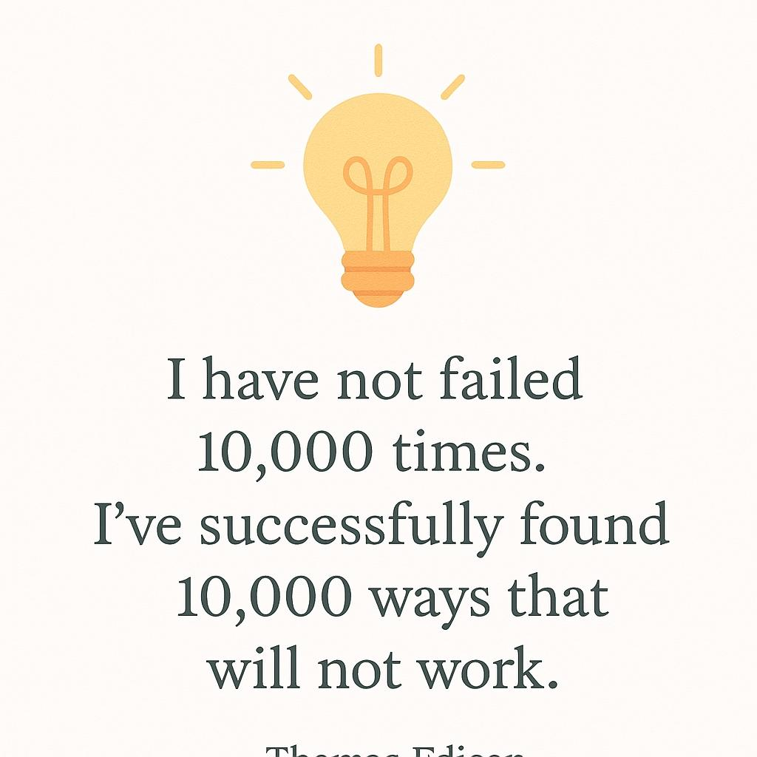
THOMAS EDISON

🌟Grammar: "Used to" 🌟

✅ 1. Function: To talk about past habits or states that are no longer true now.

🔹 I used to smoke , but I quit last year.
🔹 She used to live in London, but now she lives in Paris.

🧱 2. Form

Affirmative: Subject + used to + base verb.

- I_____________used to go___________ to the gym when I was younger. (Go)
- The teacher _____________used to believe___________ that reading novels is important. (Believe)

Negative: Subject + did not\didn’t + use to + verb (base)

- I didn't use to like vegetables. (Like\not)
- My brother and I didn't use to sleep late at night. (Sleep\not)

Questions:
- YES\NO: Did + Subject + use to + Verb (base)
- WH : Wh-word + did + Subject + use to + verb (base)

- Why did those kids use to watch silly videos. (Why\watch)
- How did we use to do these tasks? (do)

1-Read each of the following and choose the correct answer.
1- Which sentence shows a past state?
A) We used to walk to school.
B) I used to have long hair.
C) They used to play basketball.
D) She used to read comic books.

2- Which sentence shows a past action?
A) He used to own a car.
B) I used to love chocolate.
C) We used to go fishing every weekend.
D) She used to be shy.

3- I used to ________________up early before school.
A) getting B) got C) get D) gets

4- Which sentence is correct?
A) I used to going to the gym every day.
B) I used to go to the gym every day.
C) I use to go to the gym every day.
D) I used go to the gym every day.

5- They didn’t use to __________much TV.
A) watched B) watch C) watching D) watches

6. Did he use to ________________in this building?
A) live B) living C) lived D) lives

2-Correct the verbs between the brackets.
1-I used to play_the piano when I was younger. (Play)

2. She didn't use to like vegetables, but now she eats them every day. (not\like)

3. We used to go camping every summer. (Go)

4. Did people use to write letters instead of sending emails. (Write)

3- Rewrite each of the following sentences using used to.

1-I played football every weekend when I was a child.
I used to play football every weekend.

2. My grandparents lived in a small village.
My Grandparents used to live in a small village

3. People traveled by horse and carriage in the past.
People used to travel by horses and carriage.

4- Think about how your daily life has changed over the past five years. What are some of the things you used to do that you no longer do? Why did those habits or routines change?
__________________________________________________________________________________________________________________________________________________________________________________________________________________
__________________________________________________________________________________________________________________________________________________________________________________________________________________
__________________________________________________________________________________________________________________________________________________________________________________________________________________
__________________________________________________________________________________________________________________________________________________________________________________________________________________
__________________________________________________________________________________________________________________________________________________________________________________________________________________

Writing: How to write an opinion Essay

An opinion essay is a formal piece of writing where you express your opinion on a topic and support it with reasons and examples.

The structure of an opinion essay:

1-Introduction
- Grab the reader’s attention ( start with a question or quotation)
- Introduce the topic ( give a background about your topic)
- Clearly state your opinion (your main idea) Ex. In my opinion…..\I believe that……….I am convinced that…………It is my view that…………
2- Body paragraphs
- Each paragraph should focus on one reason for your opinion.
- Support each reason with examples, facts, or personal experience.
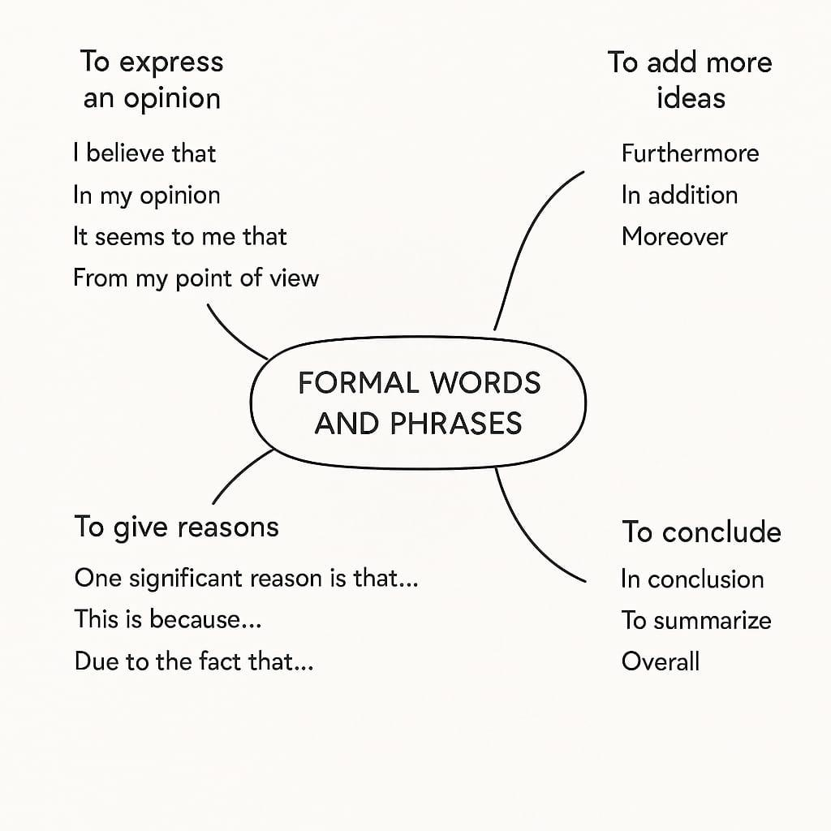
- Use linking words .

3- Conclusion
- Restate your opinion in a different way. (Paraphrase it)
- Summarize your main reasons.
- End with a strong or thoughtful statement.

Modal of an opinion essay: Should School offer Free lunch to all students?

Many people argue about whether schools should offer free lunch to all students, regardless of their financial background. I am of the opinion that schools should provide free meals to every student. This policy would promote equality, improve students’ health, and support academic success.

One significant reason is that free school meals help reduce the gap between students from different economic backgrounds. When every student receives the same lunch, no one feels embarrassed or left out due to their financial situation. This is due to the fact that food insecurity is a common issue in many communities, and offering free lunch ensures that all students have access to at least one nutritious meal during the day.

Furthermore, students who eat healthy meals are more likely to stay focused and perform better in class. A hungry child cannot concentrate or participate actively in learning activities. A clear example of this is seen in schools that have already implemented free lunch programs and noticed a rise in attendance and academic performance.

In addition, providing free lunch can encourage better eating habits among young people. When schools serve balanced meals, students are more likely to eat vegetables, fruits, and whole grains. Not only that, but it also relieves parents of the stress of preparing lunch every day, especially for those working long hours.

In conclusion, providing free lunch to all students is a valuable step toward equality and improved education. It supports students’ health, boosts learning, and creates a more inclusive school environment. For these reasons, I firmly believe that free school meals should be available to every student, every day.

Rubric
Opinion Essay Rubric for 9th Grade (No Contrast Idea) - 3 Point Scale
Criteria | 3 - Excellent | 2 - Satisfactory | 1 - Needs Improvement
Thesis Statement | Clear, strong opinion stated directly; sets clear direction for the essay. | Opinion stated but may lack clarity or strength; direction somewhat clear. | Opinion unclear or missing; essay lacks clear direction.
Supporting Reasons | Provides multiple relevant reasons that strongly support the opinion. | Provides some relevant reasons but may be limited or weakly connected. | Few or no relevant reasons supporting the opinion.
Organization | Logical, well-organized structure with clear introduction, body, and conclusion. | Organization is present but may be uneven or lack smooth transitions. | Disorganized or confusing structure; lacks clear introduction or conclusion.
Evidence and Examples | Uses specific and relevant examples to support reasons effectively. | Examples provided but may be general or only somewhat relevant. | Lacks examples or uses irrelevant or vague evidence.
Language and Style | Uses clear, precise language appropriate for grade level; sentences varied and engaging. | Language is generally clear but may be repetitive or simple; some sentence variety. | Language is unclear, inappropriate, or overly simple; little to no sentence variety.
Grammar and Mechanics | Few or no errors in grammar, punctuation, and spelling. | Some errors that do not distract significantly from meaning. | Frequent errors that interfere with understanding.

Do you think that using technology in the classroom helps students learn better?
Write an essay giving your opinion. Support your opinion with reasons and examples.

__________________________________________________________________________________________________________________________________________________________________________________________________________________
__________________________________________________________________________________________________________________________________________________________________________________________________________________
__________________________________________________________________________________________________________________________________________________________________________________________________________________
__________________________________________________________________________________________________________________________________________________________________________________________________________________
__________________________________________________________________________________________________________________________________________________________________________________________________________________
__________________________________________________________________________________________________________________________________________________________________________________________________________________
__________________________________________________________________________________________________________________________________________________________________________________________________________________
__________________________________________________________________________________________________________________________________________________________________________________________________________________
__________________________________________________________________________________________________________________________________________________________________________________________________________________
__________________________________________________________________________________________________________________________________________________________________________________________________________________
__________________________________________________________________________________________________________________________________________________________________________________________________________________
__________________________________________________________________________________________________________________________________________________________________________________________________________________
__________________________________________________________________________________________________________________________________________________________________________________________________________________
__________________________________________________________________________________________________________________________________________________________________________________________________________________
__________________________________________________________________________________________________________________________________________________________________________________________________________________
__________________________________________________________________________________________________________________________________________________________________________________________________________________
__________________________________________________________________________________________________________________________________________________________________________________________________________________
_______________________________________________________________________________________________________________________________________________________________________________________________________

Editing

When I was younger, I use to admire my older sister a lot. She always worked hard and never gave up, showing real tenasity in everything she did. I use to help her with school projects, and she always appreciated my contributon. She was a great role model I wanted to be just like her, determined, focused, and kind. Now that I’m older, I still look up to her

