



2025 / 2026
Science Department | Student’s Name:
Science Department | Grade: 7 ( )
Science Department | Subject: Study sheet 1 | Date : / / 2025

Ecosystem

Physical environmental factors
- Humidity
- Rainfall
- Amount of sunlight
- The temperature
Living things
People
Animals
Plants
Microorganism

- Terms and definition (Page 60-61)
- Adaptation: features or behaviors that let the organisms to survive in their habitats.
- Camouflage: the way that color or shape of an animal or plant appears to blend in its natural environment.
- Population: all members of the same species with similar features.
- Community: all the animals and plants that live in a habitat
- (Members of communities may have similar adaptations to cope with the problems in a particular habitat.)
- Ecosystem: the community of organisms and all physical environmental factors in a habitat.
1. Fish has fins that help it to swim.
2. Fish has gills that let it to take in dissolved oxygen from water.
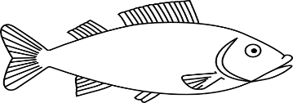
- White fur for camouflage ( useful for creeping up on seals without being seen.)
- Thick fur to help keep it warm.
- Small ears to stop it losing too much heat.
- Rough soles to grip the ice.
- Large feet to spread out its weight
and stop it from sinking in the snow.
- Large feet to help it to swim.
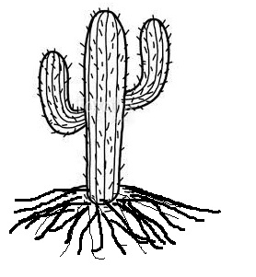

- no leaves to lose less water.
- Roots cover a large area to absorb as much water as possible when it rains.
- Stem stores water.
“Saguaro cactus can absorb a tone of water a day after storm.

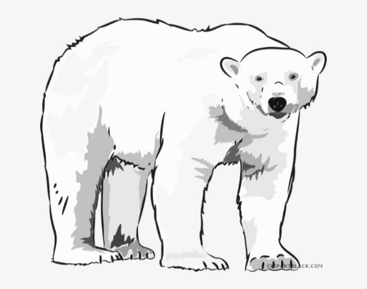

1. Large ears to allow heat to escape and improve hearing
2. This rabbit doesn’t
drink water and
gets all its water
from its food
3. Large hind legs to run away quickly from animals that might eat it.

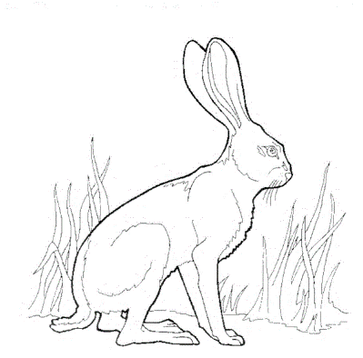

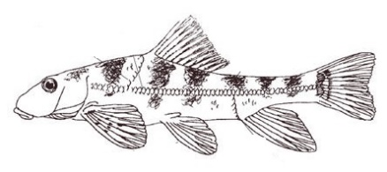

1. Hog sucker fish live in fast-flowing water.
2. Hog sucker fish has suckers to attach it to rocks and stop them being swept away.
Hog sucker has flexible streamlined body

