 | Worksheet 1  Science  7th grade |  | مدارس الكلية العلمية الاسلامية  جبل عمان / الجبيهة
UNIT: | 7th grade section | Adaptation
Name: |  | Date:

Outcomes:
To identify: Adaptation, Environment, Community, Ecosystem.
To list how some animals adapt in their habitat

Activity 1: Watch this video then answer the questions below:
https://www.youtube.com/watch?v=VzXcfY4T8jI&t=69s
Q1: The Environment is the condition in a habitat. These conditions are caused by the physical Environmental factors such as:
- Amount of light 2. Wind speed
3. Temperature 4. How wet it is (humidity)
Q2: What is the difference between Community and Ecosystem?
Community: all the animals and plants that live in a habitat
Ecosystem: the community of organisms and all physical environmental factors in a habitat

Activity 2: After watching the below video about Polar Bear answer the questions below: https://www.youtube.com/watch?v=1zRGzlWqce4&t=50s

Why the Polar Bear have small ears? To stop it losing too much heat.
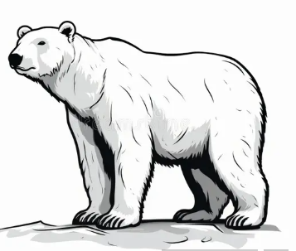
What is the main food for Polar Bear? Seals
What is the importance of its large feet?
To spread out its weight and stop it from sinking in the snow.
What is the feature that helps it to camouflage? His white fur

Activity 3 : After watching the below video about Fish answer the questions below
https://www.youtube.com/watch?v=dObGYTWNzAg&t=63s
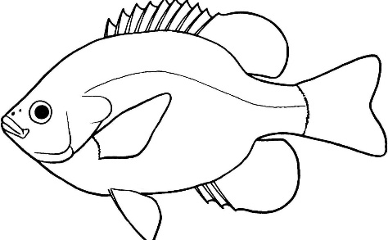
What is the main importance of gills and fins in fish?

Gills: To breathe in water
Fins: To swim

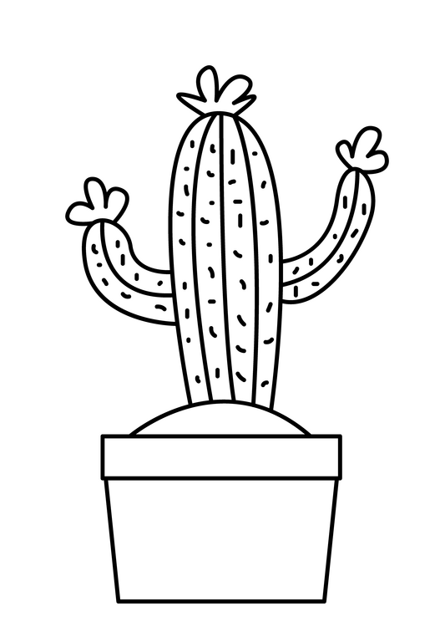
After watching the below video about Cactus answer the questions below:
https://www.youtube.com/watch?v=TBXjmjrH0hE
- What is the importance of its spines?
- no leaves to lose less water b. to protect it from predators
- Why the cactus has large roots? to absorb as much water as possible when it rains.
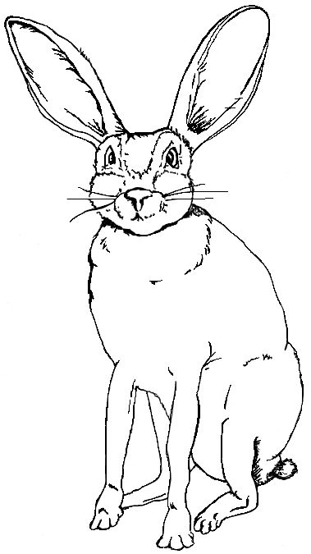
After watching the below video about Jackrabbit answer the questions below:
https://www.youtube.com/watch?v=PTljPpmJM6o
- - Why the jackrabbit has large ears?
To allow heat to escape and improve hearing
- - How the jackrabbit survives in dessert?
Doesn’t drink water and gets all its water from its food
- - What is the importance of it is large hind legs?

To run away quickly from animals that might eat it.

https://www.youtube.com/watch?v=O40tQ1qK1Z4
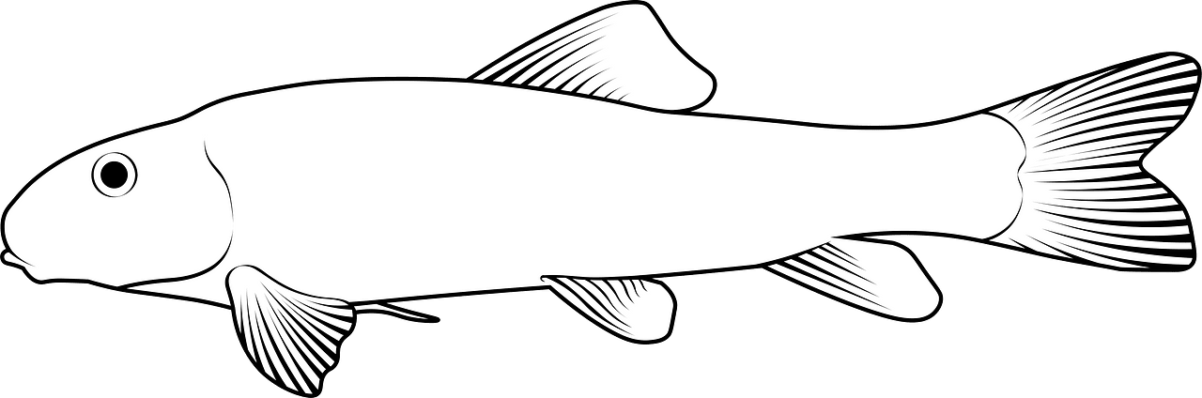
The hog sucker is an organism that lives in fast-flowing water,
- What is the importance of its sucker?
To attach it to rocks and stop them being swept away.
True or false:
1. Organisms from the same habitat have similar adaptations. True

