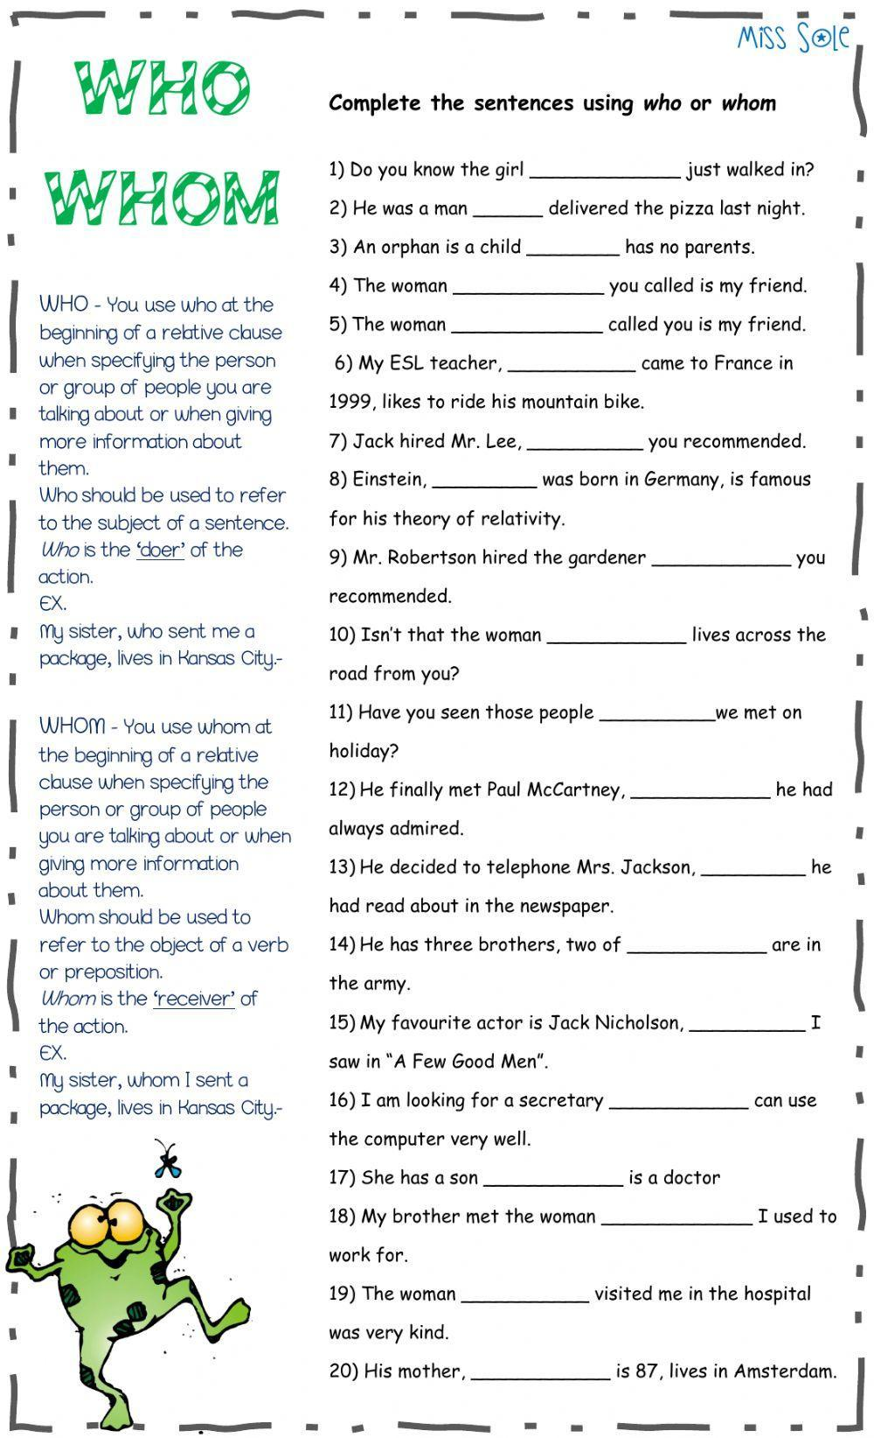

- Do you know the girl who just walked in?
- He was a man who delivered the pizza last night.
- An orphan is a child who has no parents.
- The woman whom you called is my friend.
- The woman who called you is my friend.
- My ESL teacher, who came to France in 1999, likes to ride his mountain bike.
- Jack hired Mr. Lee, whom you recommended.
- Einstein, who was born in Germany, is famous for his theory of relativity.
- Mr. Robertson hired the gardener whom you recommended.
- Isn’t that the woman who lives across the road from you?
- Have you seen those people whom we met on holiday?
- He finally met Paul McCartney, whom he had always admired.
- He decided to telephone Mrs. Jackson, whom he had read about in the newspaper.
- He has three brothers, two of whom are in the army.
- My favourite actor is Jack Nicholson, whom I saw in “A Few Good Men”.
- I am looking for a secretary who can use the computer very well.
- She has a son who is a doctor.
- My brother met the woman whom I used to work for.
- The woman who visited me in the hospital was very kind.
- His mother, who is 87, lives in Amsterdam.

