


  English Department | My name is:
 | Grade 4: ( )
 | Writing Samples.(Descriptive) | Date: /9/ 2025
Writing sample 1
My Best Friend

My best friend Ali is the most brilliant student in our school. He is a tall young boy. He looks slim. He has an oval face with long straight black hair and small blue eyes. He puts on glasses. He always looks elegant. He is a relaxed and sociable person .I am lucky to have such an amazing friend.

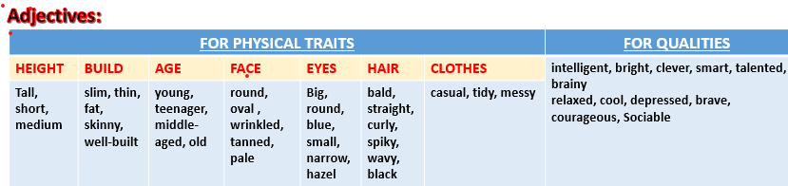

Writing Sample 2
My Favorite Season

Many people like winter but for me, summer is my favorite season. I
love summer because the weather is warm and sunny, which makes it perfect for swimming and eating ice cream. Also, in summer vacation we don’t go to school, we can relax and enjoy playing with our friends. Moreover, we can enjoy eating fresh fruits like watermelons and strawberries. Isn’t it obvious why I love summer.



English Department | My name is:
 | Grade 4: ( )
 | Writing Samples.(Descriptive) | Date: /9/ 2024
Writing sample 1
My Best Friend

My best friend Ali is the most brilliant student in our school. He is a tall young boy. He looks slim. He has an oval face with long straight black hair and small blue eyes. He puts on glasses. He always looks elegant. He is a relaxed and sociable person .I am lucky to have such an amazing friend.

Writing Sample 2

My Favorite Season

Many people like winter but for me, summer is my favorite season. I
love summer because the weather is warm and sunny, which makes it perfect for swimming and eating ice cream. Also, in summer vacation we don’t go to school, we can relax and enjoy playing with our friends. Moreover, we can enjoy eating fresh fruits like watermelons and strawberries. Isn’t it obvious why I love summer?

