
Grade & Section: ____ ( ) Worksheet Number ( ) Unit: ___
Student's Name: __________________________ Date: ___ / ___ /2025
Skill/Lesson: Simple Past: Regular and Irregular Verbs (Grammar)
Educational Outcome: To recognize the form of simple past and apply it correctly *********************************************************************************************************************

Explanation of the Simple Past Tense
Rule:
The simple past tense is used to describe actions that happened at a specific time in the past. It is used for actions that are completed and finished.
Keywords:
- Yesterday
- Last week/month/year
- In 2000
- Two days ago
- When I was a child
Form:
- Affirmative:
  - Regular Verbs: Add -ed to the base form (e.g., walk → walked)
  - Irregular Verbs: Change to the specific past form (e.g., go → went)
- Negative:
  - Use did not (didn't) + base form of the verb (e.g., did not walk or didn't walk)
- Interrogative:
  - Use Did + subject + base form of the verb? (e.g., Did you walk?)
Note # 1
The simple past tense of the verb "to be" is used to describe states or conditions that existed in the past. The verb "to be" has two forms in the simple past: "was" and "were."

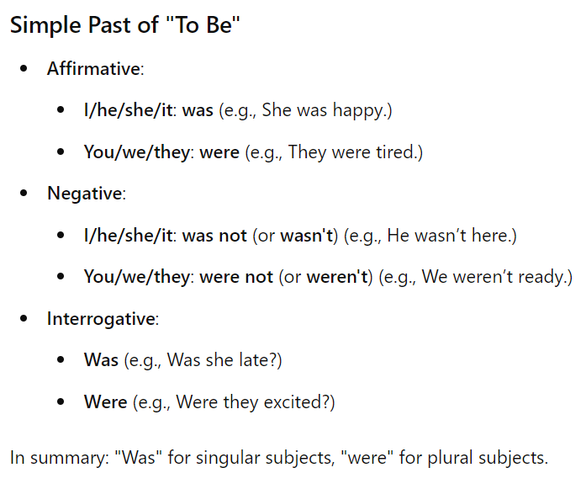
In summary, the simple past tense of "to be" helps describe conditions or states that were true in the past but may no longer be the case.
Note # 2
The simple past of "to have" is "had."
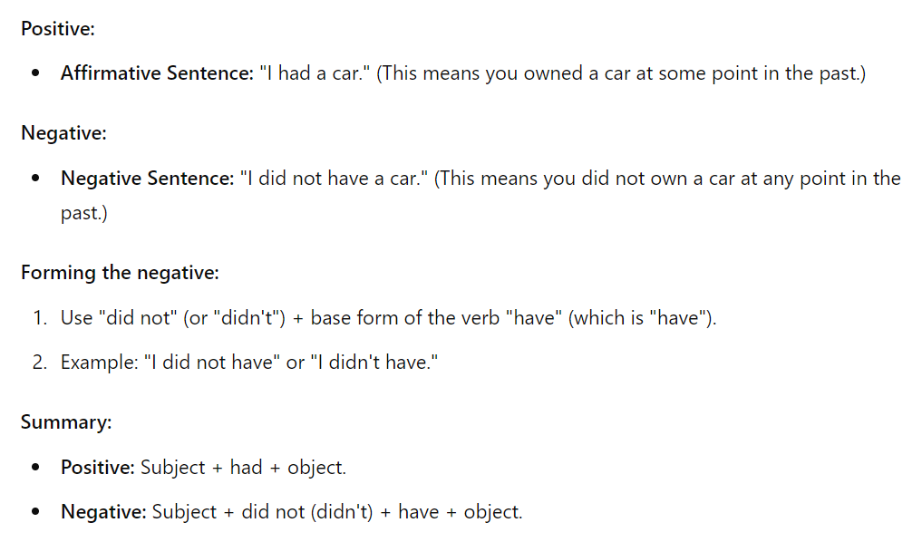

Exercises
A. Complete the sentences using the correct form of the verb in parentheses.
- She (visit) __________ her grandparents last summer.
- They (not/like) __________ the movie yesterday.
- When (you/arrive) __________ at the party?
- I (see) __________ a great show last night.
- He (not/finish) __________ his homework on time.
B. Write sentences in the simple past tense based on the prompts.
- I / play / soccer / last weekend
______________________________________________________________
- She / not/enjoy / the concert / last night
______________________________________________________________
- They / travel / to Italy / two years ago
______________________________________________________________
- He / study / for the test / yesterday
______________________________________________________________
- We / visit / the museum / on Monday
______________________________________________________________
C. Change the following sentences to the negative form.
- She wrote a letter. __________________________________________________________________________
- They went to the beach. ____________________________________________________________________
- He ate breakfast early. _____________________________________________________________________
- I finished my project. ______________________________________________________________________
- We watched the game. _____________________________________________________________________

D. Form questions from the sentences below.
- You / watch / the movie
______________________________________________________________________________
- They / go / to the park
______________________________________________________________________________
- She / make / dinner
_____________________________________________________________________________
- He / drive / to work
_____________________________________________________________________________
- You / read / the book
_____________________________________________________________________________
Multiple Choice Questions
E. Choose the correct answer.
- Which sentence is correct in the simple past tense?
  - a) She don't like the book.
  - b) She didn't liked the book.
  - c) She did not like the book.
  - d) She likes the book.

- Which sentence correctly uses the simple past tense?
  - a) We had dinner at 7 PM last night.
  - b) We does dinner at 7 PM last night.
  - c) We didn't had dinner at 7 PM last night.
  - d) We eats dinner at 7 PM last night.

- Select the correct simple past tense form:
  - a) He sleeps early last night.
  - b) He sleeped early last night.
  - c) He did not sleep early last night.
  - d) He sleep early last night.

- Choose the correct sentence in the past tense:
  - a) They was at the party yesterday.
  - b) They were at the party yesterday.
  - c) They is at the party yesterday.
  - d) They are at the party yesterday.

- Identify the correct sentence:
  - a) I wrote a report last week.
  - b) I write a report last week.
  - c) I did not wrote a report last week.
  - d) I writes a report last week.
F. Write a paragraph using the simple past tense.
Prompt: "Describe a memorable event from your last summer vacation. Include details about what you did, where you went, and who you were with. Be sure to use the simple past tense throughout your paragraph."
_____________________________________________________________________________________________________________________________________________________________________________________________________________________________________________________________________________________________________________________________________________________________________________________________________________________________________________________________________________________________________________________________________________________________________________________________________________________________________________________________________________________________________________________________________________________________________________________________________________________________________________________________________________________________________________________________________________________________________________________________________________________________________________________________________________________________________________________________________________________________________________________________________________________________________________________________________________________________________________________________________________________________________________________________________________________________________________________________________________________________________

Remember:
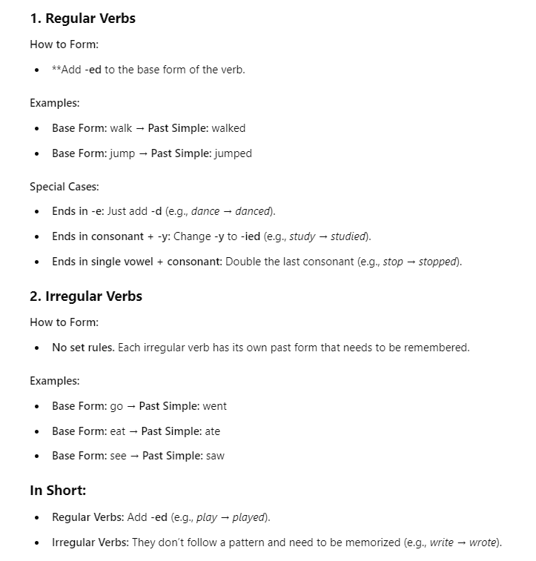

Thank you!

