

Grade & Section: ____ ( ) Grammar Worksheet Unit 1
Student's Name: __________________________ Date: ___ / ___ /2025
Skill/Lesson: Past Continuous: When & While (Grammar)
Educational Outcome: to differentiate between simple past and past continuous *********************************************************************************************************************

Past Continuous: Using "While" and "When"
Objective: Understand the use of "while" and "when" in sentences with the past continuous tense.

Part 1: Explanation
- While: Used to describe an action that was in progress at a certain point in the past. It introduces simultaneous actions (actions that were happening at the same time in the past).
  - Example: I was reading a book while my friend was cooking dinner.
In many cases, "while" and "as" can be used interchangeably without changing the meaning significantly, especially in informal contexts. However, there is a slight difference in the function of each one.
Example: She was reading a book while/as I was cooking dinner.
- When: Used to describe an action that was completed at a specific point in the past. It often introduces a sudden or interrupting action.
  - Example: I was reading a book when the phone rang.

Part 2: Fill in the Blanks
Complete the sentences using the past continuous tense with "while" or "when."
- I was watching TV when the power went out.
- She was jogging in the park when it started raining.
- They were having dinner when the phone rang.
- He was studying for his exam while his friends were having a party.
- We were waiting for the bus when it started to snow.

Part 3: Choose the Correct Option
Select "while" or "when" to complete each sentence.
- They were playing soccer __________ it started to get dark.
  - a) while
  - b) when
- I was taking a nap __________ my roommate was cleaning the house.
  - a) while
  - b) when
- He was reading a book __________ the teacher entered the room.
  - a) while
  - b) when
- She was shopping __________ her phone rang.
  - a) while
  - b) when
- We were enjoying the concert __________ the lights went out.
  - a) while
  - b) when

Part 4: Rewrite the Sentences
Rewrite the following sentences using either "while" or "when" to show the relationship between the actions.
- The kids were playing in the garden. It started to rain.
The kids were playing in the garden when it started to rain.
- She was cooking dinner. Her friend arrived.
When her friend arrived, she was cooking dinner.
- He was driving to work. He heard an interesting podcast.
While he was driving to work, he heard an interesting podcast.

- They were watching a movie. The electricity went off.
The electricity went off while they were watching a movie.
- I was working on my project. My colleagues were chatting.
I was working on my project while my colleagues were chatting.

Now, be creative!
Write a paragraph using both the simple past and past continuous tenses.
Prompt: "Think about a time when you were doing something, and then something else happened unexpectedly. Write a paragraph describing the situation. Use the past continuous tense to describe the action that was ongoing and the simple past tense to describe the action that interrupted it."
________________________________________________________________________________________________________________________________________________________________________________________________________________________________________________________________________________________________________________________________________________________________________________________________________________________________________________________________________________________________________________________________________________________________________________________________________________________________________________________________________________________________________________________________________________________________________________________________________________________________________________________________________________________________________________________________________________________________________________________________________________________________________________________________________________________________________________________________________________________________________________________________________________________________________________________________________________________________________________________________________________________________________________________________________________________________________________________________________________________________________________________________________________________________________________________________________________________________________________________________________________________________________________________________________________________________________________________________________________________________________________________________________________________________________________________________________________________________________________________________________________________________________________________________________________________________________________________

Remember:
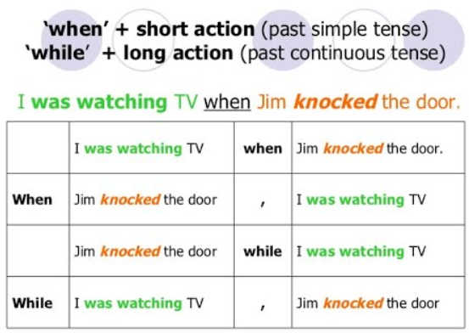

Thank you!

