

Class worksheet Number ( 1 )/ 5th grade/ Unit 1: Life Science
Chapter1: Comparing living things Lesson 3: How are plants classified? (page32-33)
Student's Name: _________________________ Date: / /2025
Educational Outcome:1: identify the parts of the plant, the function of the flower
Task1: Label the parts of the flowering plant
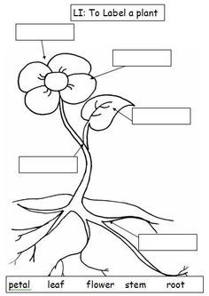

Task 2: What is the function/ or the job of the /flower?
Task3: What is the meaning of reproductive part?

Task4: Complete the following sentences:
- The flower will be developed into _____ , ___________ .

- A ______ is a part of a plant that surrounds the seed and we can eat it.

- A ------------ is a part inside a fruit that can grow to make a new plant.

GOOD LUCK

