

Class worksheet Number ( 3)/ 5th grade/ Unit 1: Life Science
Chapter1: 8C Lesson 8C: Page 39
Student's Name: _________________________ Date: / /2025
Educational Outcome:1: identify the respiration, its kinds and compare between them .
Task1: Label the parts of the flowering plant
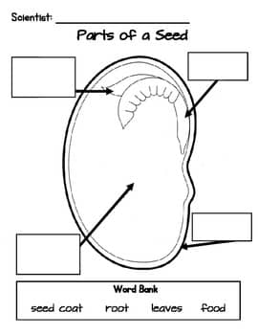

Food Store
Developing plant

Task2: complete the following charts

Task3: classify the following seeds into monocot and dicots seeds?
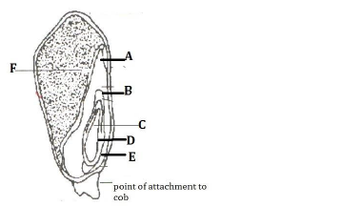
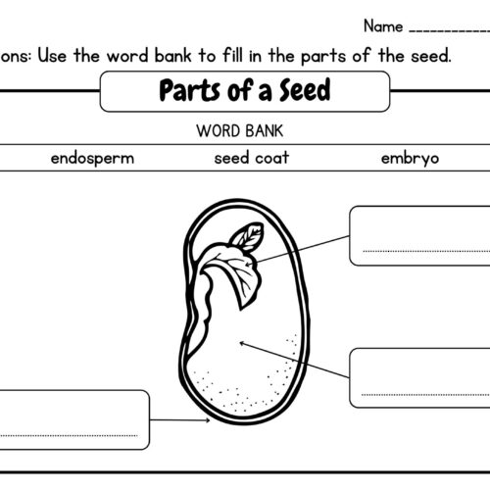

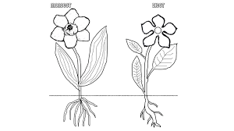
Use the following figure to compare between monocot plant and dicots plant, use the following table :
 | Monocot | Dicots
Seed leaves
Flower parts
Leaves
roots

Task4: Complete the following sentences:
- The flower will be developed into _____ , ___________ .

- A ______ is a part of a plant that surrounds the seed and we can eat it.

- A ------------ is a part inside a fruit that can grow to make a new plant.

GOOD LUCK

