

Class worksheet Number ( 2 )/ 5th grade/ Unit 1: Life Science
Chapter1: Comparing living things Lesson 3: How are plants classified? (page32-33)
Student's Name: _________________________ Date: / /2025
Educational Outcome:1: classify plants, and compare between two kinds, compare between two kinds of the flowering plants.
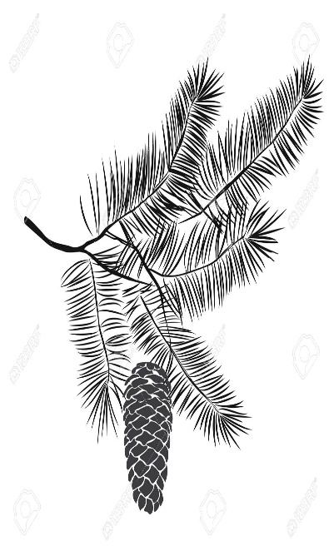
Task1: Complete the following chart:
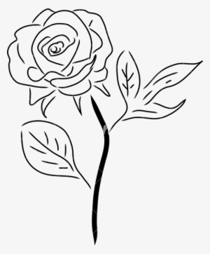

Task 2: Compare between two kinds of the flowering plants in the figure, use the following table
 | Some flowering plants:  Live long time | Some flowering plants:  Live for short time
Number of the seed leaves
The size of a plant
The stem
examples
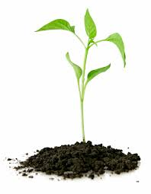
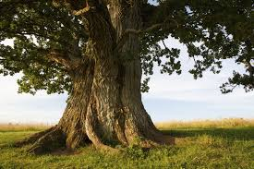

Worksheet Number ( )/ 5th grade/
Unit 1: Life Science Chapter1: Comparing living things Lesson 3: How are plants classified? (page32-33)
Student's Name: _________________________ Date: / /2025
Educational Outcome: classify plants and compare between two kinds, compare between two kinds of the flowering plants.
Task3: Complete the following charts

Task4: Classify the following seeds into monocot and dicots seeds?
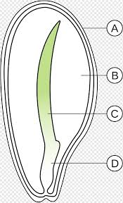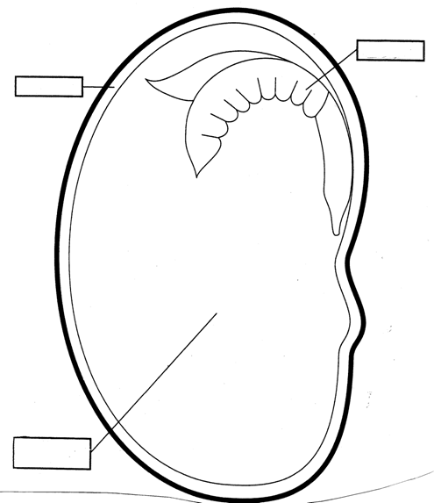
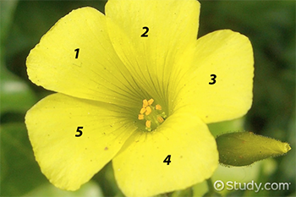
Task5: Classify the following figures into monocot and dicots
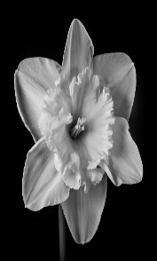
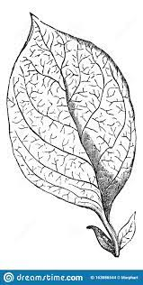
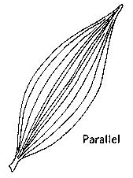

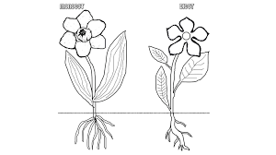
TASK6:Use the following figure to compare between monocot plant and dicots plant, use the following table:
 | Monocot |  | Dicots
Seed leaves
Flower parts
Leaves
roots

GOOD LUCK

