
Worksheet Number (1)
Grade & Section: 10th (A, B, C) Unit: Breathing and respiration
Student's Name: _________________________ Date: ______ / ___ /2025
Skill/Lesson: Aerobic respiration
Educational Outcome: 1- Define aerobic respiration.
- Explain the word equation of aerobic respiration.
*********************************************************************************************************************
Task1:
After watching the video whoso link is below, and using the figure below answer the following questions:
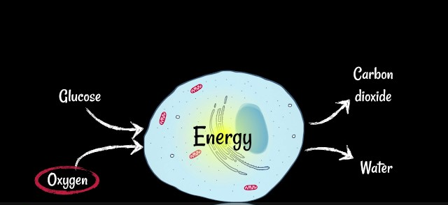
**** https://www.youtube.com/watch?v=n0uABIlfj44 *******

1-What is this kind of respiration?..........................................................................
2- Name the reactants of this respiration?................................................................
3-Name the products of this respiration?..................................................................
4-Write the word chemical equation to represent this kind of respiration.
…………………………………………………………………………………………..
5-What is the kind of chemical reaction of this respiration?..................................
6-What is the importance of energy from this respiration?......................................

GOOD LUCK

