

Worksheet Number ( )
Grade & Section: 8th (A, B, C) Unit: Cells, tissues, organs and systems
Student's Name: Date: / /_____

Skill/Lesson: Cells

Educational Outcome: 1- Determine the parts of plant and animal cells.
2- Compare animal and plant cells.
*********************************************************************************************************************

Task1:
After watching the video whoso link is below, and using the figure below answer the following questions:
**** https://www.youtube.com/watch?v=EeMJcOBz89I *******
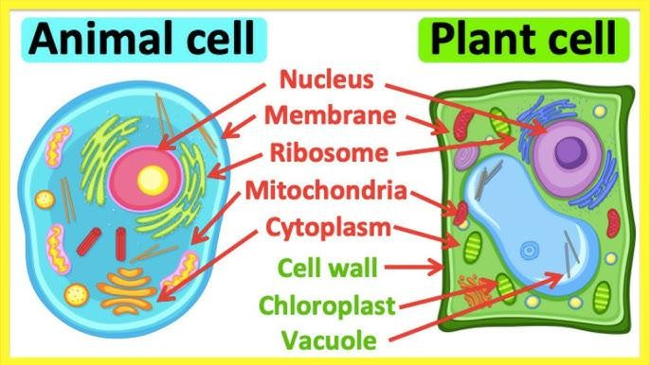
1
… cell
… cell
- Label each cell in the figure above properly.
- What are the common parts between these cells?
.............................................................................................................................................
- What is the function of:
Cell surface membrane .................................................................................................
Nucleus ……………………………………………………………………………….. Mitochondria ………………………………………………………………………… Cell wall……………………………………………………………………………….

- What is the name of the organelle that labeled with number 1? And what is its function?
………………………………………………………………………………………………

- compare between animal and plant cell according to the presence of:

 | Animal cell | Plant cell
nucleus
cytoplasm
Chloroplast
Cell wall
Cell surface membrane
mitochondria

==========================
GOOD LUCK

