


Booklet 1
Answer Key

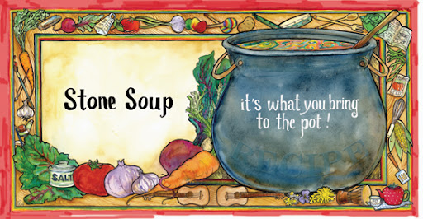

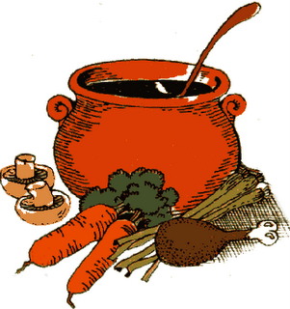
Name: ……………………….

Grade 5 : ……………………

Subject: Vocabulary List #1

Key Words

Picture | Sentence | Definition |  | Part of speech | Word
 | Do not carry heavy things. | to hold something or someone with your hands, arms, or on your back. |  | Verb | 1. carry
 | Water and food are scarce in some poor countries. | not easy to find or to get |  | adjective | 2. scarce
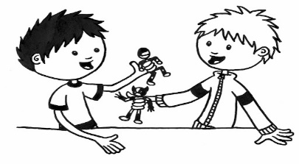 | If you want to have fun with your friends, you need to share your toys. | to have or use something at the same time as someone else |  | Verb | 3. share
 | She peeked out of the window to see the coming car. | to look, especially for a short time or while trying to avoid being seen |  | verb (past tense) | 4. peek / peeked
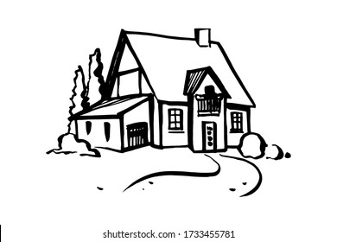 | She lives in a small cottage. | a small house, usually in the countryside |  | Noun | 5. cottage
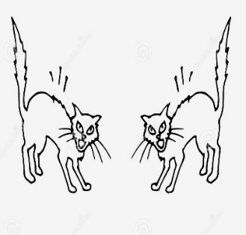 | The lion charged the sheep by the river. | to move forward quickly and violently, especially towards something that has caused difficulty or danger |  | Verb | 6. charge
Academic Words

 | You need to identify the questions before answering the exam. |  | to tell what someone or something is | verb | 7. identify
 | This party occurs every year. |  | to take place of happen | verb | 8. occur
 | This lesson is a major lesson in our course book. |  | big or important | adjective | 9. major

Part One: Read each sentence. Decide the part of speech of each of the underlined words. Circle the correct part of speech.
- I hope this incident will not occur again.
- verb b. noun c. adjective
- My grandmother lives in a small cottage.
- verb b. noun c. adjective

Part Two: Read each sentence. Fill in each blank with the most suitable word.
occur, identify, major, charge, share, peeked, scarce, carry, cottage

1. He peeked into the room before the door closed. He saw his grandparents in the corridor.
2. The voucher can be used at most major supermarkets.
3. I share a bedroom with my sister.
4. The food was scarce during the war. Soldiers used to eat canned meat.
5. Lions charge hyenas in the wilderness.
6. Please! carry the chairs into the house for me.
7. I can identify that watch is mine by the scratches on the back.
8. Many bodily changes occure during adolescence.
9. There is a small and homely cottage in the forest.

Part Three: Make sure you understand the meaning and part of speech of each of the following words, and use each word in a complete and meaningful sentence.

- carry (verb)
I always carry my backpack to school because it holds all my books.

- scarce (adjective)
Fresh water is scarce in the desert, so people must conserve it carefully.

- identify (verb)
The teacher asked the students to identify the main idea of the story.
- cottage (noun)
The family spent their summer holiday in a small cottage by the lake.
Critical thinking

- What might occur if people never followed traffic rules? How would life be different?
_____________________________________________________________
Students’ Answers
_____________________________________________________________

- If clean water became scarce, how would people’s lives change? What could we do to fix the problem?

_____________________________________________________________
_____________________________________________________________

Subject: Literature
Fiction vs Nonfiction

What is Literature?
Literature is any written work, sometimes imaginary (fiction) and sometimes real (nonfiction).
No. | Fiction | Non-fiction
1.  2.  3.  4.  5.  6. | is not real  tells a story  is written to entertain the reader (for fun)  has literary elements (characters, setting, plot)  must be read in order  (beginning, middle, end)  examples of genres:  realistic fiction, novels, short stories, folktales, science fiction, mystery, fairytales, … | is real and based on facts  gives the reader information  is written to inform the reader  (to teach the reader)  has facts, photos, charts, headings, diagrams, …  can be read in any order  examples of genres:  biography, informational texts, journal, newspaper, documentary, letter, …

Subject: Literary Elements (Story Parts)
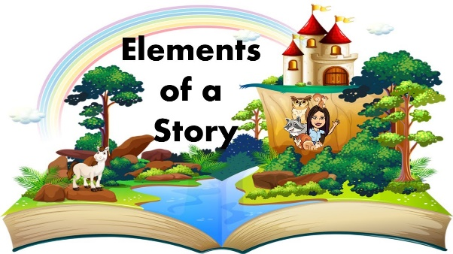

Climax: when the main character faces the conflict; the most exciting part in a story

setting: time and place: when and where a story happens

conflict: main problem in a story

resolution (solution): when the conflict is solved; how a story ends

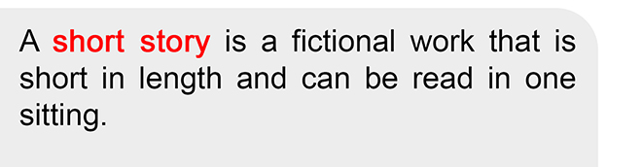

character: a person or an animal in a story

theme: the lesson learned; the big idea of a story

plot: the events in a story (conflict + climax + resolution)

Subject: Folktale
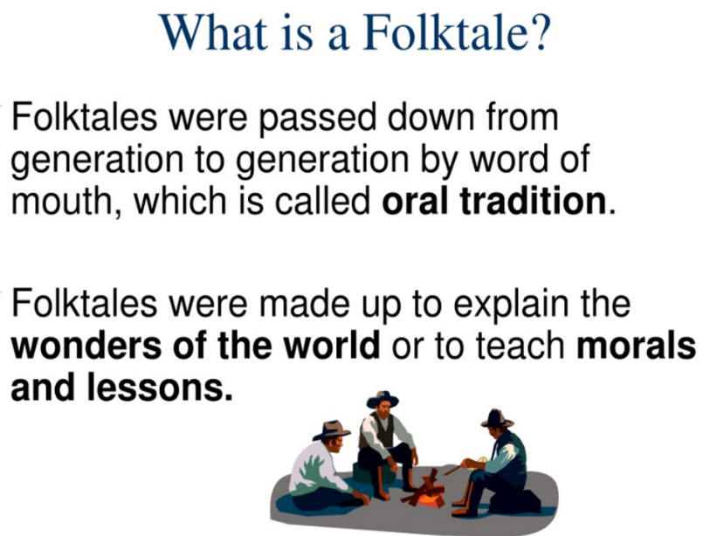

Steps of Writing a Folktale:

- Choose a Title
- Choose Characters (Character Traits)
- Choose Setting (Place and Time)
- Create a problem, find the solution.
- Remember to mention the lesson the reader will learn (value, and moral) from your story.

Types of Folktale:

- Fable
- Fairytales
- Tall Tales
- Myths

Folktale writing:

The Magical Fish
Long ago, in a small village, there lived a clever rabbit. This rabbit was very curious and loved to explore. One day, while walking near the river, the rabbit met a magical fish. The creature said, “If you help me, I will grant a wish for you.” The rabbit agreed, but instead of listening, he played tricks and caused trouble. At last, the rabbit realized his mistake and apologized. From that day on, he learned that kindness is always rewarded.

Subject: Unseen text

Long ago, in a quiet cottage by the river, there lived a poor woodcutter named Karim. Every day, he would carry his heavy axe to the forest to collect firewood and sell it in the market. In those days, money was scarce, and Karim often found it hard to buy enough food for his family.

One hot afternoon, while cutting wood near the riverbank, Karim’s axe slipped from his hands and fell into the deep water. He bent down to peek into the river, but the axe was nowhere to be seen. Karim sat sadly, knowing he could buy a new one.

Suddenly, the river fairy appeared, holding a shiny golden axe. She asked, “Is this yours?” Karim shook his head. The fairy then showed him a silver axe, but again, Karim said, “No, mine was just an old iron axe.” Finally, she pulled out his rusty iron axe. Karim’s eyes lit up, and he said joyfully, “Yes, that is mine!”

The river fairy smiled at his honesty. As a reward, she gave him all three axes—the golden, the silver, and his own iron one. Karim returned to his cottage a happy man and promised to share his story with the villagers. From then on, the tale of Karim reminded everyone of the value of honesty.

- Is the text above fictional or nonfictional? Explain your answer.
It is fictional, because it includes a magical river fairy and events that cannot happen in real life. has literary elements (characters, setting, plot. has literary elements. must be read in order
(beginning, middle, end)

- What makes this story a folktale? Write two features.
- It teaches a moral lesson about honesty.
- It includes magical elements such as a fairy.
- Who are the main characters in the story?
Karim (the woodcutter) and the river fairy.
- What is the setting of the story?
A quiet cottage by the river and the nearby forest/riverbank.
Time: In the past (Folktale)/ Daytime
- What conflict did Karim face?
His axe fell into the deep river, and he could not find it.
- How was the problem solved?
The river fairy returned his iron axe and rewarded him with golden and silver axes for his honesty.
- What is the theme of the story?
Honesty is always rewarded. This is Moral
Theme: Honesty
- Find an adjective in the first paragraph that means “not enough”. scarce
- Find a verb in the second paragraph that means “look quickly”. peek
- In the sentence: “She asked, ‘Is this yours?’ Karim shook his head.” – what does the pronoun She refer to? It refers to the river fairy.

- Critical Thinking Questions (oral discussion) (Students’ answers)
- Do you think Karim would have still been rewarded if he had lied about the golden axe? Why or why not?

- If you were in Karim’s place and your family was very hungry, would you lie to take the golden axe? Explain your answer.

- Is honesty always the best choice, even if it makes life harder sometimes? Give an example.

- Why do you think folktales like this one were told to children in villages long ago?

Grammar : Simple Past
Past Simple | Infinitive  (base form)
heard  kept  knew  left  lost  made  met  paid  put  read  rode  ran  said  saw  sold  sent  sang  sat  took  taught  told  thought  understod | hear  keep  know  leave  lose  make  meet  pay  put  read  ride  run  say  see  sell  send  sing  sit  take  teach  tell  think  understand

Past Simple | Infinitive  (base form)
was/were  began  broke  brought  bought  built  caught  chose  came  cut  did  drew  drank  drove  ate  fell  felt  fought  found  flew  forgot  got  gave  went  had  won  wrote | be  begin  break  bring  buy  build  catch  choose  come  cut  do  draw  drink  drive  eat  fall  feel  fight  find  fly  forget  get  give  go  have  win  write

Fill in the blanks Complete the sentences with the correct past tense of the verb in brackets.

- Yesterday, we played (play) football in the park.
- It was cold last night. (be)
- My father didn’t cook (cook, not) dinner last night.
- They went (go) to the zoo last Sunday.
- She didn’t read (read, not) a book about dinosaurs.
- We watched (watch) a movie yesterday.
- We weren’t read ready. (be, not)

Make your own

Write three sentences about what you did last weekend using the past tense.
- I visited my grandparents and had lunch with them.
- I watched a movie with my friends on Saturday evening.
- I cleaned my room and organized my books on Sunday.
Change the following sentences into questions.

I walked to school yesterday.

-When did you walk to school?
We planned a surprise party for our teacher last week.

-What did you plan for your teacher last week?
They enjoyed picnics at the park 2 days ago.

-What did they enjoy at the park 2 days ago?
The babies cried loudly because they were hungry.

- Why did the babies cry loudly?

