

Grade 9 Booklet -First Semester 2025/2026
Student Name :
Grade & section :
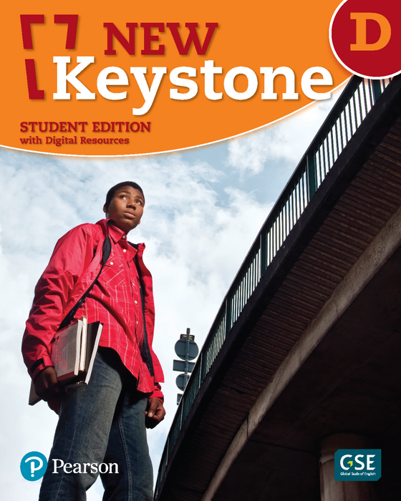

Unit One
Grandmother Spider Brings the Sun
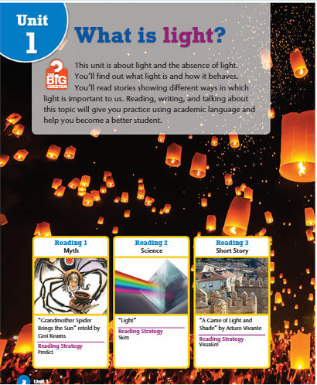

1- Vocabulary:
Literary Words: SBP (5)
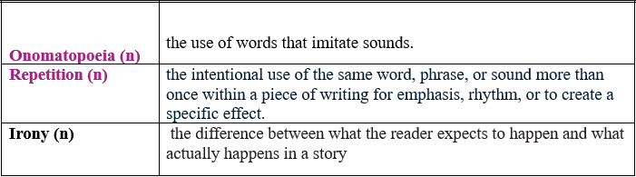

A) Identify the Device
- Read the following sentences. Decide whether each one shows onomatopoeia, irony, or repetition. Write the correct answer.
- "Boom! Crash! The thunder roared through the night." → ____________
- A pilot has a fear of heights. ______________
- "Work, work, work — that’s all he ever does." → ____________
- "The bees buzzed loudly in the garden." → ____________
- A police officer gets arrested. _____________________
- "Never give up. Never, never, never." → ____________
- Critical Thinking questions:

- Why might a writer choose to use onomatopoeia instead of regular verbs or adjectives?
________________________________________________________________
________________________________________________________________

- How does onomatopoeia contribute to the mood or tone of a passage? ________________________________________________________________
________________________________________________________________
________________________________________________________________
- How does irony influence the reader’s emotions or opinions about the events or characters?
________________________________________________________________
________________________________________________________________
- What effect does repetition have on the reader or listener?
________________________________________________________________
________________________________________________________________

- Academic Words: p (6)

Author (n) | someone who writes a book, story, article, or play
Culture (n) | the art, literature, music, beliefs, and practices of a particular group of people
Text (n) | the words in a printed piece of writing
Tradition (n ) | a belief, custom, or way of doing something that has existed for a long time

A) Fill in the blanks with the correct word (author, text, traditions, or culture).
- The ___________________ of The Secret Garden is Frances Hodgson Burnett.
- Language, music, and art are important parts of our _______________.
- To understand the meaning of a ______________ , we must read it carefully.
- Every year, we follow Jordanian ______________ like gathering for Mansaf on special occasions.
- Combine the following words to form compound words. Write the new words on the lines.

- High a. father 1. _________________
- Tooth b. school 2. _________________
- Motor c. brush 3.__________________
- grand d. cycle 4.___________________

- Suggest four more examples of compound nouns , use search engine if needed.

- 2. 3. 4.

- Write a dialogue between a teacher and a student using 15 words from the unit you have taken.
______________________________________________________________________________________________________________________________________________________________________________________________________________________________________________________________________________________________________________________________________________________________________________________________________________________________________________________________________________________________________________________________________________________________________________________________________________________________________________________________________________________________________________________________________________________________________________________________________________________________________________________________________________________________________________________________________________________________________________________________________________________________________________________________________________________________________________________________________________________________________________________________________________________________________________________________________________________________________________________________________________________

- Students’ Book Page 9 :

🌞 Comprehension & Critical Thinking Questions
- Why were the animals bumping into each other on Wolf’s side of the world?
_________________________________________________________________________
_________________________________________________________________________
- What solution did Wolf suggest to get light for their side of the world?
______________________________________________________________________________
______________________________________________________________________________
- What was Coyote’s idea instead?
____________________________________________________________________________

- What special ability did Possum believe made him the right animal for the task?
______________________________________________________________________________
- Why do you think the animals listened to Coyote even though he was known as a trickster?
______________________________________________________________________________
- What does Possum’s willingness to volunteer, despite being shy, tell us about his character?
______________________________________________________________________________
- Why might Wolf have thought a tunnel was “the best idea yet”?
______________________________________________________________________________
_____________________________________________________________________________
- Critical Thinking
- Do you think it was fair for the animals to try to take the sun without asking? Why or why not?

_______________________________________________________________________________

_______________________________________________________________________________
- If you were one of the animals, whose plan would you support — Wolf’s or Coyote’s? Defend your choice.

_______________________________________________________________________________________
_______________________________________________________________________________________
- What lesson can we learn about leadership from Wolf, Coyote, and Possum in this story?
_______________________________________________________________________________
_______________________________________________________________________________
- How might this story reflect traditions or values in a culture that told it (for example, about sharing, trickery, or courage)?
________________________________________________________________________________
________________________________________________________________________________

- Students’ Book Page 10 :

- What happened to Possum’s eyes when he first saw the sun?
______________________________________________________________________________
- Where did Possum decide to hide the piece of the sun?
______________________________________________________________________________

- What was the result of Possum carrying the sun in his tail?
_____________________________________________________________________________
- Where did Buzzard choose to hide the piece of the sun?
______________________________________________________________________________
- What happened to Buzzard’s feathers after he carried the sun?
______________________________________________________________________________
- Why do you think the storyteller explains Possum’s skinny tail and Buzzard’s bald head through this myth?
___________________________________________________________________________________________________________________________________________________________

- What does Buzzard’s attitude (“show-off”) tell us about his character before he failed?
_____________________________________________________________________________
_____________________________________________________________________________
- Why might the animals have trusted Buzzard even though he was boastful?
__________________________________________________________________________________

Critical Thinking
- What lesson can we learn from Possum’s attempt compared to Buzzard’s attempt?
______________________________________________________________________________

- Do you think Buzzard’s failure was caused more by his pride or by his plan? Clarify your reasoning.
______________________________________________________________________________
______________________________________________________________________________

- Students’ Book Page 11 :

- Why did Wolf doubt Grandmother Spider’s ability to succeed?
______________________________________________________________________________

- What did Grandmother Spider ask the animals to bring her?
_____________________________________________________________________________

- What does it suggest about Grandmother Spider’s character that she wanted to help “one more time” despite being old?

______________________________________________________________________________
- How might the other animals have felt when they saw such a small, slow creature volunteer?
_____________________________________________________________________________
_______________________________________________________________________________

Critical Thinking (Beyond the text)
- Do you think wisdom and experience can be more important than speed or strength? Give an example.
___________________________________________________________________________________
___________________________________________________________________________________
- If you were Wolf, would you allow Grandmother Spider to go? Why or why not?
____________________________________________________________________________________
____________________________________________________________________________________
- How does the storyteller use this part of the myth to show that even small or underestimated beings can make a difference? Could you relate this to an example from science ?
___________________________________________________________________________________
___________________________________________________________________________________
- What values about elders and community does this story reflect from the culture it might have come from?
____________________________________________________________________________________
___________________________________________________________________________________

- Students’ Book Page 12

- Why do you think the Sun Guards didn’t notice Grandmother Spider?
_________________________________________________________________________________
- What does this part of the story suggest about the advantages of being small or overlooked?
________________________________________________________________________________
- Why might the storyteller have made the Sun Guards so frightening by having fire and weapons?
__________________________________________________________________________________

Critical Thinking (Beyond the text)
- What qualities made Grandmother Spider succeed when Possum and Buzzard failed?
______________________________________________________________________________
______________________________________________________________________________
- Do you think the animals should be proud that it was the smallest and oldest among them who succeeded? Why or why not?__________________________________________________________________________ ________________________________________________________________________

- What lesson about problem-solving or leadership can modern readers learn from Grandmother Spider’s strategy?
____________________________________________________________________________________

- Students’ Book Page 13

- Who helped Grandmother Spider when the ball of light grew too big?
___________________________________________________________________________
- Where did the ball of light end up after it was squeezed out of the cave?
____________________________________________________________________________

Critical Thinking
- What lesson does this ending teach about cooperation and community? How can this be reflected on your daily life.
____________________________________________________________________________
- Do you think the animals could have succeeded without Grandmother Spider? Why or why not?
___________________________________________________________________________
___________________________________________________________________________
- If you were to retell this story for today’s world, what modern lesson could it teach (think about teamwork, respect for elders, or problem-solving)?
____________________________________________________________________________

3- Grammar:
Relative Pronouns

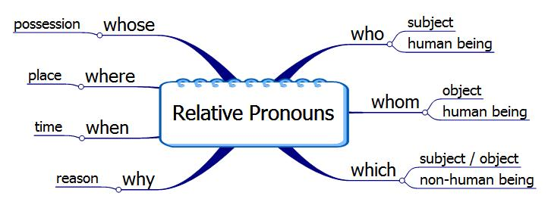

How to join sentences with relative pronouns?
The boy
The boy
e.g. She called . got the prize.
She called the boy who got the prize.
it
the T-Shirt.
e.g. I found . I bought yesterday.

I found the T-Shirt which I bought yesterday.

- Join the following sentences.

- This is the farm. It produces cotton.
________________________________________________________________________

- We invited the astronaut. The government awarded him a medal.
________________________________________________________________________
- This is the lady. Her car broke down yesterday.
________________________________________________________________________
4- I will visit my cousin. We like him the most.
__________________________________________________________________________
5- London is the city. It is most visited by tourists in UK.
_________________________________________________________________________
6- It is really a great house. The Simpsons live there.

- Choose the correct relative pronoun: (who, whom, which, whose, where, when, why)

1- I bought the car ______________ you told me about.
2- I don’t know the name of the boy _____________ left early.
3- She went with the girl ____________ car was lost.
4.The man ___________ you helped is our new teacher.
5.He is talking about the year 1945 ____________ the war occurred.
6- They talked about the house ____________ the party took place.
7- These were the reasons ___________ he decided to leave the country.
8- I admire parents_____________ devote themselves to their families.
9- The man____________ car you bought is a friend of mine.

- Use a suitable relative pronoun to join each of the following pairs of sentences.
- I will visit the hospital. It was built to help the poor.
__________________________________________________________________________
- He won the race. It was held in Dubai.
___________________________________________________________________________
- Paris has many tourist attractions. They are visited by people from all over the world.
__________________________________________________________________________
- This is the man. He saved your child from drowning.
__________________________________________________________________________
- We invited the astronaut. The government awarded him a medal.
__________________________________________________________________________
- This is the lady. Her car broke down yesterday.
__________________________________________________________________________
- These are the passengers. The passengers' luggage was lost.
__________________________________________________________________________

- These are the workers. The company will send them to work in Italy.
__________________________________________________________________________
- English is my favorite subject. It is spoken all over the world.
__________________________________________________________________________
- They caught the man. He committed a crime last week.
__________________________________________________________________________
- We saw some girls. Their clothes seemed so strange.
We saw __________________________________________________________________
12. I liked the pie. The pie you brought me.
I liked ____________________________________________________________________

Paragraph Writing Task
Task: Write a short paragraph (5–6 sentences) about a place, person, or object you know well. Use at least three relative clauses to give more details.
- Example:
  - "My cousin, who lives in Canada, is visiting us this summer."
  - "I have a phone that I use for studying and playing games."
__________________________________________________________________________________________________________________________________________________________________________________________________________________________________________________________________________________________________________________________________________________________________________________________________________________________________________________________________________________________________________________________________________________________________________________________________________________________________________________________________________________________________________________________________________________________

Question Tag

The main points of the tag questions are:
- A tag question is a short question that has two words (helping verb) and (sub pronoun) only with a question mark that follows the statement. (e.g. have you? / haven’t you?)

- Normally we use a positive question tag with a negative sentence:
Negative sentence | Positive tag question
Tom won’t be late, | will he?
They don’t like us, | do they?
That isn’t George over there, | is it?

- And normally we use a negative question tag with a positive sentence:
Positive sentence | Negative tag question
Ann will be here soon, | won’t she?
Tom should pass his exam, | shouldn’t he?
They were very angry, | weren’t they?

- Note Negative must be contracted (aren’t) not (are not)
- Note I am >>> aren’t I? (e.g. I am late, aren’t I?)

- Helping verbs are (be, have, do , modals)
- Be (is, are, am, was, were)

- Have (have, has, had)
- Do (do, does, did)
- Modals (will, shall, can, must, would, should, could, have to, has to, had to)

- Subject pronouns are (he, she, it, they, we, you, I)

- What should we do if we don’t have a helping verb?

Examples: - She walks on the wall easily, _________________?
- Sam cancelled the meeting, __________________?
- They use this machine daily, __________________?

Main verb | Analyzing the verb | The answer
walks | does + walk | doesn’t she?
cancelled | did + cancel | didn’t he?
use | do + use | don’t they?

- With the sentence that starts with the word (There)
Examples:
- There are some students, aren’t there?
- There is some milk in the fridge, isn’t there?

- Pay Attention to the verb (have)
- She has called you, hasn’t she?
- She has a car, doesn’t she?
- She has to clean her room, doesn’t she?

- They have used it, haven’t they?
- They have a nice garden, don’t they?
- They have to go now, don’t they?

- You had joined the team, hadn’t you?
- You had a big house, didn’t you?
- You had to submit the report, didn’t you?

- Add a question-tag to these sentences:

1. He is late this morning, _______________________?
2. The hotel was quite good, ________________________?
3. She cooks well, _______________________?
4. You can’t tell the difference, _________________________?
5. They always sleep after lunch, __________________________?
6. You’re coming with us, _______________________?

7. Mary plays football, ________________________?
8. You didn’t have any lessons this morning, _______________________?
9. Ann is on holiday, ______________________?
10. The students see it every day, ________________________?
11. Mr. Priestley doesn’t know your father, ______________________?
12. There are lots of cars here, ______________________?
13. I am disturbing you, _____________________?
14. Tom and Chris finish the work late, ________________________?
15. This isn’t very pleasant, _____________________?
16. She likes quiet places, ______________________?
17. Tom doesn’t play the piano, _______________________?
18. They didn’t hurt the child, _______________________?
19. There were two car accidents yesterday, _______________________?
20. Tourists will leave early, ________________________?
21. You haven’t got a computer, ________________________?
23 He didn’t have to choose one, _______________________?
24. He has your ticket, _______________________?
25. Everything is all right, _______________________?
- Two friends are at a restaurant. They are talking about the food, the place, the service, and their opinions.

Instructions:
- Write a dialogue of 6–8 exchanges between the two friends.
- Include question tags in at least half of the sentences.
- Make it realistic and fun.
_________________________________________________________________________________________________________________________________________________________________________________________________________________________________________________________________________________________________________________________________

Writing a Descriptive Essay

Brainstorming Ideas for the Essay
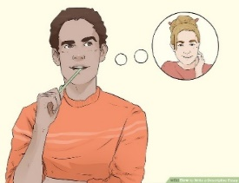
- Choose a person to describe. One option for a topic is to describe a person that you know well in your life. This could be a family member ,a famous person or a best friend.

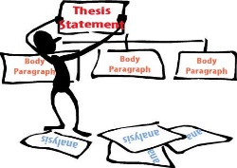
- Outline the essay in sections. Organize the essay by creating a brief outline. Do this in sections: introduction, body, and conclusion :

The introduction
Start with a "Lead sentence" to hook your reader :

The Body
- Physical Traits :
What does he/she look like from outside?
Tall / short / has a round face / has long black wavy hair / has brown eyes ….etc.

- Trait / personality:
What do you like about this person? Generous / helpful / friendly..loyal..etc.

- Characteristic #1
Examples and details of characteristic #1 ( show how )
- Characteristic # 2
Examples and details of characteristic # 2 ….etc

Conclusion: Wrap up the essay with a strong conclusion. Your conclusion should tie all the thoughts in your essay together. Restate your thesis statement in the conclusion and end with a strong final sentence. Do not add anything new to your essay in the conclusion.
.

Sample :

My Uncle Jack
Some people think that uncles are simply the brothers of our parents, but I am fortunate to have an uncle who is not only family but also a true friend and role model.
My uncle Jack is a striking man. He is tall and slim, with curly blond hair and sparkling hazel eyes that reflect his cheerful personality. He carries himself with confidence and always has a warm smile for everyone he meets.
Uncle Jack is calm, kind, and full of energy. He knows how to communicate with people of all ages and never speaks harshly or raises his voice. His sense of humor is remarkable—he can turn an ordinary moment into a memory filled with laughter through his amusing stories.
In addition to his wonderful personality, Uncle Jack is highly skilled in technology. He works at a service center, repairing mobile phones, laptops, and other digital devices. Although he is always busy, he remains patient and polite with everyone. He especially enjoys spending time with young people, valuing their fresh ideas and unique perspectives.
What I admire most about Uncle Jack is his generosity and willingness to share knowledge. He always makes time for me, explaining things patiently and helping me understand even difficult topics. Our conversations are never boring—they are informative, inspiring, and often full of laughter.
I hope that when I grow up, I can be like my uncle: knowledgeable, kind-hearted, and cheerful. His character is truly a model for me, and I am grateful to have him as both my uncle and my friend.

Your Turn

Task: Descriptive Essay
Write a well-structured essay (3–4 paragraphs) describing someone you admire or look up to.
- Introduction – State who the person is and explain why you admire them.
- Body Paragraphs – Describe the person’s appearance, personality, achievements, and actions. Use adjectives and examples to make your description vivid.
- Conclusion – Summarize why this person is important to you and what you have learned from them
Check your work using the checklist on the next page.
_____________________________________________________________________________________________________________________________________________________________________________________________________________________________________________________________________________________________________________________________________________________________________________________________________________________
___________________________________________________________________________ _____________________________________________________________________________________________________________________________________________________________________________________________________________________________________________________________________________________________________________________________________________________________________________________________________________________
______________________________________________________________________________________________________________________________________________________________________________________________________________________________________________________________________________________________________________________________________________________________________________________________________________________________________________________________________________________________________________________________________________________________________________________________________________________________________________________________________________________________________________________________________________________________________________________________________________________________________________________________________________________________________________________________________________________________________________________________________________________________________________________________________________________________________________________________________________________________________________
Good Luck

Descriptive Essay Checklist: A Person
Before Writing
[ ] Did I choose a person I know well or admire?
[ ] Do I have enough details to describe their appearance, personality, and impact?
Introduction
[ ] Did I introduce the person clearly?
[ ] Did I mention my relationship with them?
[ ] Did I include a thesis statement (what I will describe about them)?
Body Paragraph 1: Physical Appearance
[ ] Did I describe how the person looks (hair, eyes, height, clothing)?
[ ] Did I use adjectives and comparisons (like similes or metaphors)?
[ ] Did I include unique or memorable features?
Body Paragraph 2: Personality and Character
[ ] Did I describe their personality traits (kind, funny, strict, etc.)?
[ ] Did I give examples or short stories to show these traits?
[ ] Did I use descriptive language to make the person come alive?
Body Paragraph 3: Impact or Importance
[ ] Did I explain how this person has influenced me or others?
[ ] Did I share what I have learned from them?
[ ] Did I include how others see or feel about this person?
Conclusion
[ ] Did I summarize the main points?
[ ] Did I reflect on why this person is special to me?
[ ] Did I end with a strong, memorable closing sentence?
Final Check
[ ] Did I stay focused on describing the person?
[ ] Did I use clear and vivid language?
[ ] Did I check for spelling and grammar mistakes?

